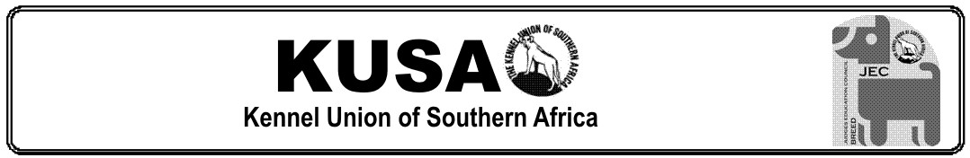

LEARNER’S PROOF OF SHADOW JUDGING
v. 2026

Copy this table and paste into new pages for each Shadow Judging session or use a new form for each.

SHOW:
DATE:
GROUP/BREED:
NAME OF LEARNER JUDGE:
NAME OF OFFICIATING JUDGE:
This is to confirm that ________________________________________________________________ shadowed my judging assignment and participated enthusiastically as stated above.

Learner Judge’s Signature: | Date:
SIGNED – OFFICIATING JUDGE: ___________________________________________________

Store these completed, signed forms in your Portfolio.

