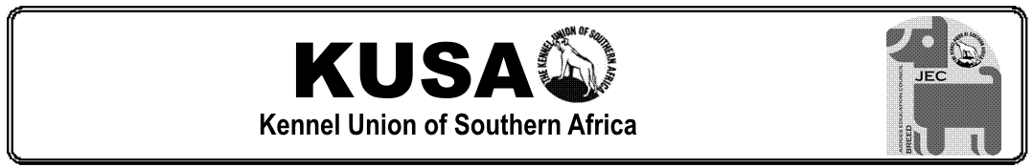

HANDS-ON PRACTICAL TEST FORM
v.2026
SHOW:
DATE: | GROUP: | TOTAL BREEDS JUDGED:
LEARNER JUDGE: |  | SIGNATURE:
OBSERVING JUDGE:

BREED : ___________________________________________________________________
PART 1 – HANDS-ON ASSESSMENT
PART 2 – WHY WERE THE DOGS PLACED IN THE ORDER
PART 3 – ASSESSMENT APPROVAL
APPROVED | OBSERVING JUDGE SIGNATURE:
NOT APPROVED | OBSERVING JUDGE SIGNATURE:

If not approved, reasons given to the judge.
Recommendations for further studies/assistance:

Observing Judge: Please discuss your Assessment with the Learner during Feedback session. As soon as possible after the Assessment, either scan and convert this form to Adobe PDF or retype in MS Word, then forward as an attachment in an email to each of the following: 1) the Learner and 2) jecassess@kusa.co.za and 3) jecjudges@kusa.co.za

