Proposed changes to Schedule 05M – Regulations for Flyball

- Amend 10.10.2 Flyball Box
Each team is to supply its own Flyball box and spare Flyball box that is to conform to the following specifications:
All boxes are to have a mechanical, not electrical, pedal release mechanism.
The boxes may be painted or decorated as the team wishes.
The ball, when released, must have a free, unobstructed flight of not less than 60cm from the point that the ball is released to the point the ball hits the ground, in the direction of the start/finish line or poles.
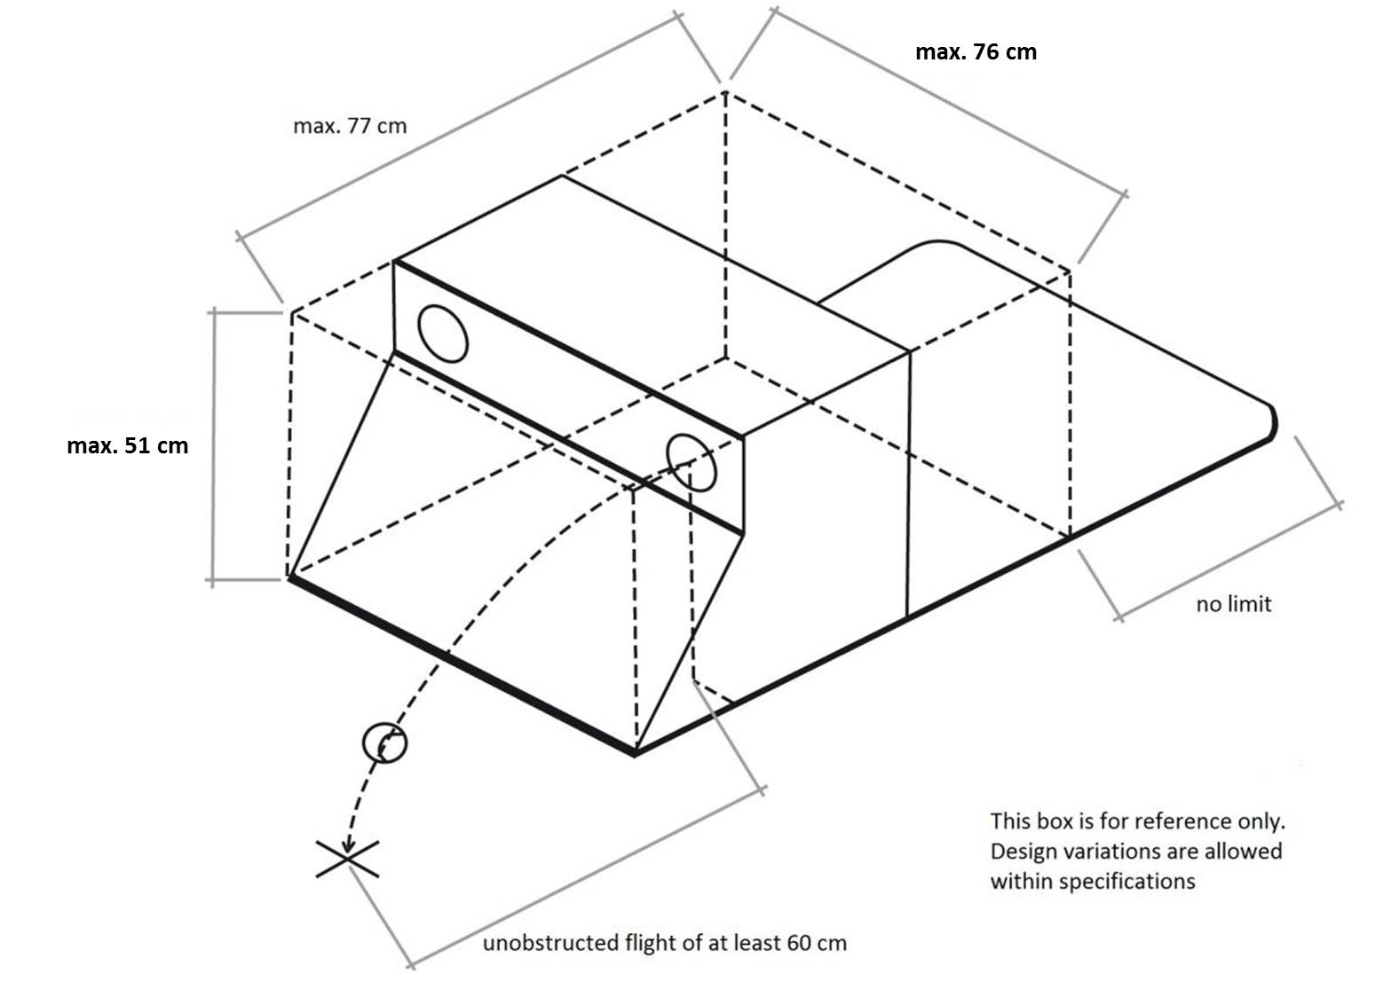
Boxes dimensions:
Width: shall not exceed (61cm) 76cm
Height: shall not exceed (46cm) 51cm
Depth: shall not exceed 77cm (excluding the platform the box loader uses to stand on. The platform has no limit, however, the total depth should ideally not exceed 120cm)
The dimensions include a release mechanism, but do not include any platform the box loader uses to hold the box in place.
Boxes should be constructed with the comfort and safety of the dog in mind. Sharp edges must be avoided and adequate padding and protection should be used. Any curved or flat front box may be used so long as the box is within the dimensions as above.

Motivation:

Box dimensions to be aligned with that of the Kennel Club and BFA (UK), UK Flyball League (UKFL), and U-FLI (United Flyball League International). This to allow greater safety measures for bigger dogs.

The Kennel Club: “The Kennel Club has recently approved the following change to the regulations for flyball, effective from 1st July 2018. Flyball boxes used for this competition will be of the commercially available flat fronted type. All boxes to have a mechanical release mechanism. When the ball is released it must have a free unobstructed flight of not less than 61cm (24”) from the box cup in a forward direction. Boxes shall not exceed 61 76cm (24 30”) in width, 45.7 50.8cm (18 20”) in height or 76.2cm (30”) in depth. The dimensions do not include any platform the box loader uses to hold the box in place. Alternative designs may be used provided the principles of safety are maintained.”

U-FLI: “U-FLI strives to maintain this welcoming environment by allowing a maximum box size of 20" high X 30" deep X 30" wide to accommodate larger dogs

UKFL: “Each team is responsible for providing its own Flyball box, which should be safe and fit for purpose. The Flyball box must meet the following specifications:
The box cannot exceed 30”(76cm) in width, nor exceed 20”(51cm) in height. The body of the box cannot exceed 30”(76cm) in depth, excluding the base upon which the box loader stands. The box shall not exceed these dimensions at any time during racing, excluding carrying handles and stakeholders.

Agreed and approved at the AGM of the NFSC (supported by NAPC, WC, DOGS)

- Semantic amendment of Schedule 5M point 16.11

AMEND

16.11 | Spare box malfunctions.  The box loader to indicate that the box has malfunctioned by standing in front of the box with both hands raised. The judge will check the box. If the judge finds a technical failure, the (heat) race will be (run again after the Flyball box is substituted with a spare box) forfeited. | Team forfeits race

Motivation: The sentence was copied from 16.10 and does not make sense as the spare box is already in use and cannot be substituted again.

Agreed and approved at the AGM of the NFSC (supported by NAPC, WC, DOGS)

- Electronic judges system (“EJS”)

AMEND
12.3 The start
12.3.1 The first dogs in each team will be released on the judge's whistle. Subsequent dogs will only be allowed to pass the start/finish line once the preceding dog has passed the start/finish line with any part of its body. The dog must return with the ball in its mouth, see regulation 12.1.
12.3.2 In instances where the Electronic Judging System is used, the start will be visual, acoustic or a combination of both.
Where a light tree is used to count down the start:

A sequence of at least 3 amber / yellow lights or 1 red and 2 amber / yellow lights will flash at one second intervals. The time will start once the green light lights up. The aim is for a team to release their start dog so that this dog crosses the start line as close as possible after the green light lights up.

A false start is indicated when the start dog crosses the start line before the green light lights up (also referred to an early start) and the judge will stop the race by blowing a whistle or verbally indicating to teams to stop.

Each team is allowed one false start per race. After the first false start, the race will start again.
If the same team causes a second false start (for that same heat), the starting dog must re-run again.

If a second false start is caused by the other team (their first false start), the heat will be stopped and restarted.

16. PENALTIES
Dogs that are faulted for any reason must re-run in the order that they were faulted after the fourth dog has run.
16.1 | a. In the event of using manual or electronic timers: If a dog or handler's feet cross the Start / Finish line before the start is signalled. | Dog reruns
 | b. In the event of using the EJS light tree to signal the start: If a dog('s) or handler's feet cross the Start / Finish line before the start is signalled, the heat will be stopped and restarted (one false start allowed per team per race) | No penalty
 | c. In the event of using the EJS light tree to signal the start and after the second false start: If a dog's or handler's feet cross the Start / Finish line before the start is signalled. | Dog reruns

Agreed and approved at the AGM of the NFSC (supported by NAPC, WC, DOGS)

- Wording of proposed Appendix (Used the FCI information and worded it in slightly better English)

NEW Appendix B – Electronic Judging System (“EJS”)

The Electronic Judging System (EJS) is used for calculating the time of the Flyball races and to properly evaluate the passes and starts. The system consists of at least of a semaphore with a starting sequence and two gates with sensors. A display shall be provided at the timing table showing the elapsed time for each lane.

The EJS sensor panels should be placed in such a way that the entering sensors are placed directly on the start/finish line with the exiting sensors placed closer to the box line. Sensor gates should be placed a minimum of 120 cm apart but not more than 150 cm apart.

The light tree (if used) shall be placed directly between the racing lanes, shall not create any obstruction and should be clearly visible for all judges and competitors, including the box loader.

Operation:

- The system must be in “ready” mode before the start of a heat;
- The judge will indicate when to start the system for a heat by pointing to the lane steward / timing table or designated person to activate the EJS;
- The system shall refuse to start the heat if the sensors are misaligned.
- The lane steward or designated person shall press the START button
- The system activates the sequence of red + yellow lights followed by the green light at 1.0 second intervals
- The green light shall signal the start of the timer.
- If a beam is broken before the start of the timer, a false start is indicated
- The beam column directly on the start/finish line shall be the line beam
- The beam column closest to the first hurdle shall be the passing beam.
- Once the timer has started, each time the line beam is broken ("safe" or not), an updated elapsed time shall be shown.
- Each time the passing beam is broken or cleared, the line beam shall be "safe" for 2 seconds.
- If the line beam is broken while not "safe", a pass fault shall be indicated for at least 2 seconds.
- The judge will indicate a heat completion to the teams as well as to the lane steward / timing table or designated person so that the EJS can be reset.
- Once a heat is completed, nothing will alter the displayed times (beam breaks are ignored).
- Once the judge and / or lane steward / timing table or designated person has recorded the times for each lane, the EJS is reset to indicate readiness for the next heat.
- The judge cannot start a new heat until the lane steward / timing table or designated person indicates that the system is ready.

Technical requirements:

The system must meet the following minimal requirements:

Physical sensors:

- the lowest beam shall not be higher than 203 mm from ground
- the highest beam shall not be lower than 711 mm
- the maximum vertical beam spacing is 101 mm
- passing fault sensors shall be 152 mm from the start/finish line towards the first hurdle
- if two columns of beams are used, the beams must be at the same heights and able to span at least 150 cm

Physical light tree:

• The bottom light shall be at least 60 cm above the ground
• There must have an independent light for each lane used to indicate any pass faults and/or false start.
• There must be a sequence of at least three yellow (or red and two yellow) lights directly above a green for the starting sequence.
• There should be an independent light for each dog used to indicate dog faults during each heat.
• Some indication should be provided that the system is ready for the judge to start a heat.

Accuracy/precision:

• The timing system shall time the heat to a thousandth of a second.
• The timing system shall display the time down to at least a hundredth of a second (xxx.xx).
• Rounding shall be used, if converting from timing in thousandths to display in hundredths
• A tie shall be indicated, if the measured times in the two lanes are equal and measured in hundredth of a second
• The timing system must be accurate to within 3m/s (all system latencies combined)
• The timing system shall be accurate to within 3m/s over 60 seconds (50 ppm).
• The timing system shall provide the same timing for both lanes to within 2m/s over 60 seconds.
• Sensors electrical latency shall not exceed 2m/s and if scanned, scan latency shall not exceed 1ms.
• System shall sample the sensors such that a solid object moving horizontally through the sensors at 15.25 m/s would be seen to break each beam in a separate sample or 1 sample m/s whichever is faster (i.e. horizontal spacing 152 mm, 15.25 m/s means the object will cross the two columns in .01 seconds -- .001 is smaller -- must sample at 1/m/s).

Motivation

Belgium: Starting electronically: FALSE START: If any part of the dog’s (paw, snout – in the air or on the ground) or handler’s body breaks the beam. The false start will be indicated by the lane steward or judge.

UKFL: The EJS will display three amber lights and be set at a one second sequence. The ETS sensor gates must be placed so that the entering sensors on the gates are directly on the start/finish line with the exit sensors on the gate being placed closest to the box line.

The ETS sensors gates should be placed of 5ft.(1.5m)

Agreed and approved at the AGM of the NFSC (supported by NAPC, WC, DOGS)

