Whippet
Posted in Hound Group
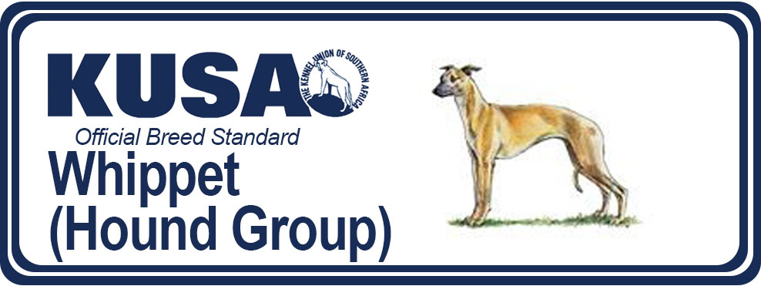
A Breed Standard is the guideline which describes the ideal characteristics, temperament and appearance of a breed and ensures that the breed is fit for function with soundness essential. Breeders and judges should at all times be mindful of features which could be detrimental in any way to the health, welfare or soundness of this breed.
WHIPPET
(Effective 31.03.2016)
GENERAL APPEARANCE:
Balanced combination of muscular power and strength with elegance and grace of outline. Built for speed and work. All forms of exaggeration should be avoided.
CHARACTERISTICS:
An ideal companion. Highly adaptable in domestic and sporting surroundings.
TEMPERAMENT:
Gentle, affectionate, even disposition.
HEAD AND SKULL:
Long and lean, flat on top, tapering to muzzle with slight stop, rather wide between the eyes, jaws powerful and clean-cut, nose black, in blues a bluish colour permitted, liver nose in creams and other dilute colours, in whites or parti-colour a butterfly nose permissible.
EYES:
Oval, bright, expression very alert.
EARS:
Rose shaped, small, fine in texture.
MOUTH:
Jaws strong with a perfect, regular and complete scissor bite i.e. upper teeth closely overlapping lower teeth and set square to the jaws.
NECK:
Long, muscular, elegantly arched.
FOREQUARTERS:
Shoulders well laid back with flat muscles. Moderate space between the shoulder blades at the withers. The upperarm is approximately of equal length to the shoulder, placed so that the elbow falls directly under the withers when viewed in profile. Forearms straight and upright with moderate bladed bone. Front not too wide. Pasterns strong with slight spring.
BODY:
Chest very deep with plenty of heart room. Well filled in front. Brisket deep. Broad, well muscled back, firm, somewhat long, showing graceful arch over the loin but not humped. Ribs well sprung. Loin giving impression of strength and power. Definite tuck up.
HINDQUARTERS:
Strong, broad across the thighs, with well developed second thighs. Stifles well bent without exaggeration with hocks well let down. Able to stand naturally over a lot of ground.
FEET:
Oval, well split up between toes, knuckles well arched, pads thick, nails strong.
TAIL:
No feathering. Long, tapering, reaching at least to the hock. When in action carried in a delicate curve not higher than the back.
GAIT/MOVEMENT:
Should possess great freedom of action. In profile should move with a long, easy stride whilst holding topline. The forelegs should be thrown forward and low over the ground. Hind legs should come well under the body giving great propelling power. General movement not to look stilted, high stepping, short or mincing. True coming and going.
COAT:
Fine, short, close in texture.
COLOUR:
Any colour or mixture of colours, except merle.
SIZE:
Desirable height: Dogs: 47-51 cms (18½ -20 ins) bitches: 44-47 cms (17½ -18½ ins)
FAULTS:
Any departure from the foregoing points should be considered a fault and the seriousness with which the fault should be regarded should be in exact proportion to its degree and its effect on the health and welfare of the dog and on the dog’s ability to perform its traditional work.

NOTE:
- Male animals should have two apparently normal testicles fully descended into the scrotum.
- Only clinically and functionally healthy dogs with breed typical conformation should be used for breeding.
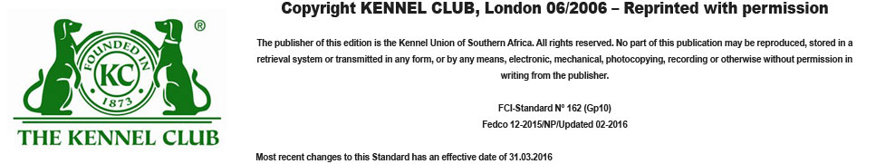

< Prev

