Shar Pei
Posted in Utility Group
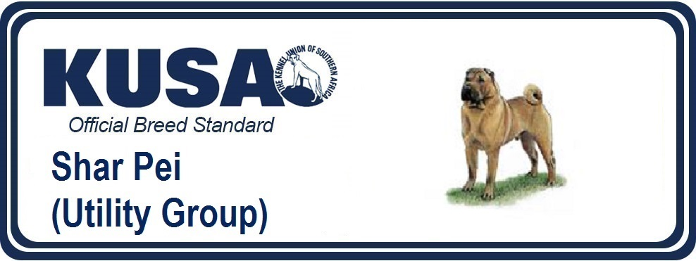
A Breed Standard is the guideline which describes the ideal characteristics, temperament and appearance of a breed and ensures that the breed is fit for function with soundness essential. Breeders and judges should at all times be mindful of features which could be detrimental in any way to the health, welfare or soundness of this breed.
UTILIZATION: Hunting and watch-dog.
BRIEF HISTORICAL SUMMARY: This Chinese breed has existed for hundreds of years in the provinces bordering the South China Sea. The town of Dialak in the province of Kwun Tung is probably the place of origin.
GENERAL APPEARANCE: Active, compact, short coupled and squarely built dog of medium size. Wrinkles over skull and withers, small ears and ‘hippopotamus’ muzzle impart to the Shar Pei a unique look. Dogs larger and more powerful than bitches.
IMPORTANT PROPORTIONS: The height of the Shar Pei from withers to ground is approximately equal to the length of the body, from point of shoulder to point of buttock, especially in males. The length from nose to stop is approximately equal to the length from stop to occiput.
BEHAVIOUR/TEMPERAMENT: Calm, independent, loyal, affectionate to his family.
HEAD:
Rather large in proportion to body. Wrinkles on forehead and cheeks continuing to form dewlap.
CRANIAL REGION:
Skull: flat, broad.
Stop: moderate.
FACIAL REGION:
Nose: large and wide, preferably black, but any colour conforming to general coat colour permissible. Wide opened nostrils.
Muzzle: a distinctive feature of the breed. Broad from root to tip of nose with no suggestion of tapering. Lips and top of muzzle well padded. Bulge at the base of the nose permissible.
Mouth: Tongue, roof of mouth, gums and flews - bluish black is preferred. Pink spotted tongue permissible. Solid pink tongue highly undesirable. In dilute-coloured dogs the tongue is solid lavender.
Jaws/Teeth: jaws strong with perfect scissor bite i.e. the upper teeth closely overlapping the lower teeth and set square to the jaws. Padding of lower lip should not be so excessive as to interfere with the bite.
Eyes: dark, almond-shaped with a scowling expression. Lighter colour permissible in dilute-coloured dogs. Function of eyeball or lid in no way disturbed by surrounding skin, folds or hair. Any sign of irritation of eyeball, conjunctiva or eyelids highly undesirable. Free from entropion.
Ears : Very small, rather thick, equilaterally triangular in shape, slightly rounded at tip and set high on the skull with tops tips pointing towards eyes; set well forward over eyes, wide apart and close to skull. Pricked ears highly undesirable.
NECK: Medium length, strong, set well on shoulders. The loose skin under the neck should not be excessive.
BODY: Folds of skin on body in mature dogs highly undesirable except on withers and base of tail, which show moderate wrinkling.
Topline: dips slightly behind withers; then it rises slightly over loin.
Back: short, strong.
Loin: short, broad, slightly arched.
Croup: rather flat.
Chest: broad and deep, brisket reaching below the elbow.
Underline: rises slightly under the loin.
TAIL: Thick and round at the root, tapering to a fine point. The tail is set very high, a characteristic feature of the breed. May be carried high and curved, carried in tight curl or curved over or to either side of the back. Lack of or incomplete tail highly undesirable.
LIMBS:
FOREQUARTERS
General appearance: Forelegs straight, moderate length, good bone. The skin on forelegs shows no wrinkle.
Shoulders: muscular, well laid and sloping.
Metacarpus (Pastern): slightly sloping, strong and flexible.
HINDQUARTERS
General appearance: Muscular, strong, moderately angulated, perpendicular to the ground and parallel to each other when viewed from the rear. Wrinkles on upper thighs, lower thighs, rear pasterns as well as the thickening of the skin on hocks undesirable.
Hocks: well let down.
FEET: Moderate size, compact, not splayed. Toes well knuckled. Hindfeet free from declaws.
GAIT/MOVEMENT: The preferred gait is trot. The gait is free, balanced, active with good forward reach and strong drive from the hindquarters. The feet tend to converge to a centre line when the speed increases. Stilted gait undesirable.
COAT:
Hair: a distinctive feature of the breed - short, harsh and bristly. The coat is straight and offstanding on the body but generally flatter on the limbs. No undercoat. The coat may vary in length from 1cm to 2.5cm. Never trimmed.
Colour: All solid colours acceptable except white. Tail and rear part of thighs frequently of a lighter colour. Darker shading down the back and on the ears permissible.
SIZE:
Height: 44-51cm at withers (17.5-20 ins.).
FAULTS:
Any departure from the foregoing points should be considered a fault and the seriousness with which the fault should be regarded should be in exact proportion to its degree and its effect upon the health and welfare of the dog.
SERIOUS FAULTS:
- Deviation from a scissor bite (as a transitor measure, a very slightly overshot mouth is permissible)
- Snipy muzzle
- Spotted tongue (except pink spotted tongue)
- Large ears
- Low set tail
- Coat longer than 2.5cm
ELIMINATING FAULTS
- Aggressive or overly shy.
- Any dog clearly showing physical or behavioural abnormalities shall be disqualified.
- Flat foreface with badly overshot bite; undershot bite
- Solid pink tongue
- Lower lip rolled in, interfering with the bite
- Round, bulging eye. Entropion, ectropion
- Skin, folds or hair disturbing the normal function of the eye
- Pricked ears
- Absence of tail; stumpy tail
- Heavy folds of skin on body (except withers and base of tail) and limbs
- Not a solid colour (albino, brindle, patches, spots, black and tan, saddled pattern)
NB:
Male animals should have to apparently normal testicles fully descended into the scrotum.
Only clinically and functionally and clinically healthy dogs with breed typical conformation should be used for breeding.
REMARK
Any artificial physical alteration to the Shar Pei (in particular lips and eyelids) eliminates the dog from competition.
