Schipperke
Posted in Utility Group
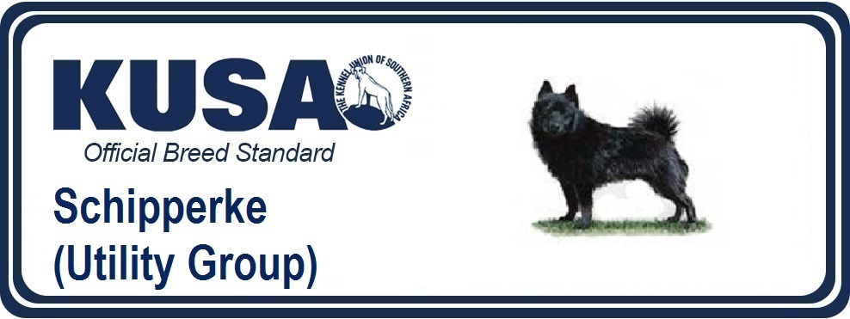
Breed Standard is the guideline which describes the ideal characteristics, temperament and appearance of a breed and ensures that the breed is fit for function with soundness essential. Breeders and judges should at all times be mindful of features which could be detrimental in any way to the health, welfare or soundness of this breed.
GENERAL APPEARANCE
Small, cobby, active dog, with sharp foxy expression.
CHARACTERISTICS
Intensely lively and alert
TEMPERAMENT
Amenable, intelligent and faithful.
HEAD & SKULL
Skull not round, but fairly broad, flat, with little stop. Muzzle moderate in length, fine but not weak, well filled under eyes. Nose black and small.
EYES
Dark brown, more oval than round, not full; bright, most expressive.
EARS
Moderate length, not too broad at base, tapering to a point. Carried stiffly erect and strong enough not to be bent otherwise than lengthways.
MOUTH
Jaws strong, with perfect, regular and complete scissor bite, i.e. upper teeth closely overlapping lower teeth and set square to the jaws.
NECK
Strong and full, rather short, set broad on shoulders, slightly arched.
FOREQUARTERS
Shoulders muscular and sloping. Legs perfectly straight, well under the body, bone in proportion to the body.
BODY
Chest broad and deep in brisket. Back short, straight and strong. Loins powerful, well drawn up from brisket.
HINDQUARTERS
Lighter compared with forequarters; muscular and well developed thighs, well rounded rump. Legs strong, muscular, hocks well let down.
FEET
Small, cat-like, and standing well on the toes.
TAIL
Previously customarily docked, or may be born tailless or with partial length or full tail.
Docked: very short
Naturally tailless – no discernible tail
Undocked: Full length tail tightly curled, carried over the back. Well covered with hair.
Fully coated partial length tail permissible but not desirable.
[*refer note below]
GAIT / MOVEMENT
Short, brisk stride, moving true fore and aft.
COAT
Abundant, dense and harsh; smooth on head, ears and legs; lying close on back and side; erect and thick round neck, forming a mane and frill; with good culottes on the back of thighs.
COLOUR
Usually black but other whole colours permissible.
SIZE
Weight about 5.5-7.5kg (12-16lb)
FAULTS
Any departure from the foregoing points should be considered a fault and the seriousness with which the fault should be regarded should be in exact proportion to its degree and its effect on health and welfare of the dog and on the dog’s ability to perform its traditional work.
NOTE
Male animals should have two apparently normal testicles fully descended into the scrotum.
*Regardless of the provisions of the current KUSA-adopted standard, docked or formerly docked breeds may be shown at all FCI- and KUSA-licensed shows in South Africa, whether their tails are docked, or natural. Under no circumstances are judges permitted to discriminate against exhibits on the grounds of docked, or natural tails and equal consideration for awards must be given to either. (Fedco 12/2017 Amend DR/02/2018)
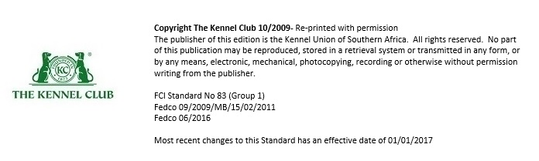

< PrevNext

