Poodle (Standard)
Posted in Utility Group
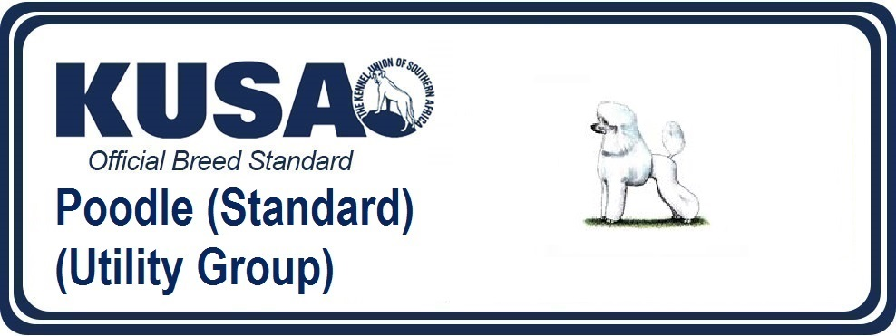
A Breed Standard is the guideline which describes the ideal characteristics, temperament and appearance of a breed and ensures that the breed is fit for function with soundness essential. Breeders and judges should at all times be mindful of features which could be detrimental in any way to the health, welfare or soundness of this breed.
GENERAL APPEARANCE:
Well balanced, elegant looking with very proud carriage.
CHARACTERISTICS:
Distinguished by a special type of clip for show activity and by a type of coat which does not moult.
TEMPERAMENT:
Gay spirited and good tempered.
HEAD & SKULL:
Long and fine with slight peak. Skull not broad, moderate stop. Foreface strong, well chiselled, not falling away under eyes; cheek bone and muscle flat. Lips tight-fitting. Chin well defined but not protruding. Head in proportion to size of dog.
EYES:
Almond shaped, dark, not set too close together, full of fire and intelligence. Eye colour see Colour Clause
EARS:
Leathers long and wide, set low, hanging close to face.
MOUTH:
Jaws strong with perfect, regular complete scissor bite, i.e. upper teeth closely overlapping lower teeth and set square to the jaws. A full set of 42 teeth is desirable.
NECK:
Well proportioned, of good length and strong to admit of the head being carried high and with dignity. Skin fitting tightly at the throat.
FOREQUARTERS:
Well laid back shoulders, strong and muscular. Legs set straight from shoulders, well-muscled.
BODY:
Chest deep and moderately wide. Ribs well sprung and rounded. Back short, strong, slightly hollowed; loins broad and muscular.
HINDQUARTERS:
Thighs well developed and muscular; well bent stifles, hocks well let down; hindlegs turning neither in nor out.
FEET:
Tight, proportionately small, oval in shape, turning neither in nor out, toes arched, pads thick and hard, well cushioned. Pasterns strong.
TAIL:
Previously customarily docked. Docked: set on rather high, carried at slight angle away from body, never curled or carried over back, thick at root. Undocked: Thick at root, set on rather high, carried away from the body and a straight as possible.
[*refer note below]
GAIT/MOVEMENT:
Sound, free and light movement essential with plenty of drive.
COAT:
Very profuse and dense; of good harsh texture. All short hair close, thick and curly. All traditional trims permissible in the show ring and the dogs judged on equal merit, as long as there is sufficient length to demonstrate colour and quality of coat.
COLOUR:
All solid colours. White and creams to have black nose, lips and eye rims, black toenails desirable. Browns to have dark amber eyes, dark liver nose, lips, eye rims and toenails. Apricots and reds to have dark eyes with black points or deep amber eyes with liver points. Blacks, silvers and blues to have black nose, lips, eye rims and toenails. Creams, apricots, reds, browns, silvers and blues may show varying shades of the same colour up to 18 months. Clear colours preferred. Non solid colours are highly undesirable and should be heavily penalised.
SIZE:
Poodles (Standard) over 38 cm (15 in).
FAULTS:
Any departure from the foregoing points should be considered a fault and the seriousness with which the fault should be regarded should be in exact proportion to its degree and its effect on health and welfare of the dog and on the dog’s ability to perform its traditional work.
NOTE:
Male animals should have two apparently normal testicles fully descended into the scrotum.
*Regardless of the provisions of the current KUSA-adopted standard, docked or formerly docked breeds may be shown at all FCI- and KUSA-licensed shows in South Africa, whether their tails are docked, or natural. Under no circumstances are judges permitted to discriminate against exhibits on the grounds of docked, or natural tails and equal consideration for awards must be given to either. (Fedco 12/2017 Amend DR/02/2018)
