Peruvian Hairless Dog Perro Sin Pelo Del Peru
Posted in Utility Group Change name below
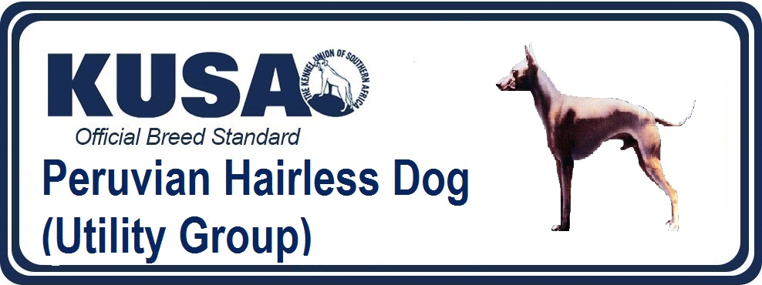
A Breed Standard is the guideline which describes the ideal characteristics, temperament and appearance of a breed and ensures that the breed is fit for function with soundness essential. Breeders and judges should at all times be mindful of features which could be detrimental in any way to the health, welfare or soundness of this breed.
UTILIZATION: Companion Dog
PREAMBLE: These dogs have been kept as a peculiarity because of their genetic nature, the procreation of dogs with and without hair in the same litter. Lost in the darkness of time the naked variety reached a major milestone when it was officially recognised as a breed native to Peru in 1985, during the ordinary Assembly of the FCI at Amsterdam city, thanks to the initiative of the Cynologist Ermanno Maniero, who did the first breed standard, it was possible that this was registered as a new breed under the name of Peruvian Hairless Dog with the number 310 of the nomenclature. The recognition of the hairless dog did not eradicate the coasted relative into oblivion. Disdained from any breeding program, its current recognition in the light of developments in the study of its genome emphasizes the genetic value of the breed and contributes to its development and preservation. The recognition of the coated variety, for show and for breeding, favours the expansion of genetic variability, improving the breed’s strength and attracts new breeders. Initially to be registered, the coated variety must be the product of two hairless dogs duly registered in a stud book or breeding record. The coated variety can only be mated to a hairless specimen of the breed and subsequently also for generations to come. The mating between coated specimens is banned, just like the registrations of these in any studbooks without duly registered parents.
BRIEF HISTORICAL SUMMARY: The Peruvian hairless dog, because of its particular nature, was the subject of obvious curiosity by the Peruvians from different times. Because of the allocation of different properties, they are seen on ceramics of different cultures pre-Incas like Vicus, Mochica, Chancay, Chancay with Tiahuanaco influence, Chimu and others where in many cases the hairless dog has replaced the puma, the snake or the hawk, standing with the greatest interest in the Chancay culture. As seen in these illustrations, the hairless dog makes its appearance in the archaeological periods of Pre-Inca times, from 300 BC until 1460 AD.
GENERAL APPEARANCE: Going by his general conformation, it is an elegant and slim dog, whose aspect expresses speed, strength and harmony without ever appearing coarse. There are two varieties, the hairless whose main feature is the absence of hair all over the body and the coated variety, that is entirely coated.
Another particular feature is that the dentition in the hairless variety is nearly always incomplete associated with the congenital alopecia.
IMPORTANT PROPORTIONS: The ratio between the height at the withers and the length of the body is 1:1; the females can be slightly longer than the males.
BEHAVIOUR/TEMPERAMENT: Noble and affectionate at home with those close to him, at the same time lively and alert; he might be wary of strangers and is a good watch dog.
HEAD: Of lupoid conformation.
CRANIAL REGION:
Skull: Mesocephalic. Orthoid, i.e. the upper axes of the skull and muzzle are parallel; a slight divergence is accepted. Seen from above, the skull is broad and the head tapers toward the nose. The superciliary arches are moderately developed. The occipital protuberance is barely marked.
Stop: Slightly marked (approximately 140°).
FACIAL REGION:
Nose: Good pigmentation, the colour of the nose must be in harmony with the different colours of the skin; in the different shades in the hairless variety and with the colour of the hair in the coated variety.
Muzzle: Seen in profile, the nasal bridge is straight.
Lips: They must be as tight as possible and close to the gums.
Jaws/Teeth: The incisors should fit in scissor bite. In the hairless variety the absence of one or more teeth is accepted. In the coated variety the dentition must be complete with teeth normally developed and in a normal position. The jaw is not strongly developed.
Cheeks: Developed without exaggeration.
Eyes: Alert and intelligent expression. The eyes must be of average dimensions, slightly almond shaped, neither deep-set nor prominent, normally and regularly placed, i.e. neither too close together nor too wide apart. The colour can vary from black, going through all shades of brown to yellow, in harmony with the skin colour in the naked variety and with the coat in the variety with hair. In any case, both eyes must be of the same colour. The colour of the eyelids may go from black to pink in subjects with light coloured face. The light pink colours are admitted but not sought after.
Ears: The ears must be pricked when the dog is attentive, whereas at rest, they are laid towards the back. The ears are of medium length; broad at the base, tapering progressively towards the tip, ending almost pointed. The ear set starts on the upper part of the skull to end laterally and obliquely. In erect position, the axes of the ears form a variable angle from 50° to near 90°.
NECK:
Upper profile: Curved (convex).
Length: Approximately the same length as the head.
Shape: Near to a truncated cone shape, supple, with good musculature.
Skin: Fine, smooth, elastic and really close to the subcutaneous tissues. No dewlap.
BODY: Mesomorphic.
Topline: Level, although certain subjects show a dorsal-lumbar convexity, which disappears at croup, level.
Withers: Barely accentuated.
Back: Straight, with well-developed back muscles often forming all along the back a muscular bi-convexity, which extends to the lumbar region.
Loin: Strong and well-muscled. Its length reaches approximately 1/5 of the height at the withers.
Croup: The superior profile is slightly convex, slanting approximately 40° to the horizontal. Solid and well-muscled giving a good push.
Chest: Seen from the front, the chest perimeter must have good amplitude, but without excess; reaching almost to the elbow. The ribs must be slightly sprung, never flat. The chest, measured behind the elbows, must exceed the height at the withers with approximately18%. Underline and belly: The lower profile presents an elegant and well marked line which goes from the lower part of the chest and rising to the belly which must be well tucked up, but without excess.
TAIL: The tail is set on low, thick at the root it tapers towards the tip. When excited, the dog can carry the tail raised in a loose curve above the backline, but never as curved as being rolled up. At rest, it hangs with a slight upward curve at the tip. The tail is sometimes carried tucked in towards the abdomen. In length it almost reaches the hock. Tail to be complete.
LIMBS
FOREQUARTERS:
General appearance: Well united with the body, seen from the front they are perfectly upright with the elbows not turned out. The angle at the shoulder/upper arm varies between 100° and 120°. Seen in profile, the angle is 15° to 20°.
Forefeet: Are semi-long and look like hare-feet. The pads are strong and heat-resistant. The inter-digital membranes are well developed. The black dogs have preferably black nails and the lighter coloured dogs light nails.
HINDQUARTERS:
General appearance: The muscles are rounded and elastic. The curve of the buttocks is well marked. The coxal-femoral angle varies between 120° and 130°. The femoral-tibial angle must be of 140°. Seen from behind the hindquarters must be upright.
Hind feet: Same as forefeet.
GAIT / MOVEMENT: Due to the angulations defined at the description of the limbs, some of these dogs move with shorter steps but faster and at the same time quite soft and flexible. The limbs, seen from front or behind must move in a single line (i.e. single tracking).
SKIN: The skin must be smooth and elastic all over the body, but can form a few rounded almost concentric lines on the head and round the eyes and the cheeks in the hairless variety. It has been verified that the internal and external temperature of the hairless dogs is exactly the same as that of other breeds (coated or not). The absence of hair leads to an immediate and direct emanation of heat, different from the coated subjects, where the heat filters through the coat by natural ventilation.
COLOUR:
The colour of the skin in the hairless variety can vary from black, slate black, elephant black, bluish black, the whole scale of greys (diluted black), all nuances of genetic blue, dark brown going to light blond. All colours can be either uniform or show pinkish or white patches on all parts of the body. White or pink spots must not cover more than 1/3 of the body. Solid colours are preferred.
COAT:
Hairless variety: Without hair, only very few hairs on the head and at the extremities of the legs and the tail are admitted, and sometimes sparse hair on the back. These hairs can be any colour or combination of colours.
Coated variety: Smooth, short and tight coat. The hair can be any colour or combination of colours.
SIZE AND WEIGHT:
There are three sizes in the males and females.
Small: 25–40cm.
Medium: 41–50cm.
Large: 51–65cm.
The weight is in relation to the size.
Small: 4–8kg.
Medium: 8–12kg.
Large: 12–30kg.
FAULTS:
Any departure from the foregoing points should be considered a fault and the seriousness with which the fault should be regarded should be in exact proportion to its degree and its effect upon the health and welfare of the dog.
Semi-erect ears, one or both.
Pincer bite.
Absence of PM1 in the coated variety.
White or pink spots covering more than 1/3 of the body in the hairless variety.
Presence of dewclaws.
DISQUALIFYING FAULTS:
Aggressive or overly shy dogs.
Any dog clearly showing physical or behavioural abnormalities shall be disqualified.
Over or undershot bite.
Deviated jaw (i.e. wry mouth).
More than one teeth missing in the coated variety.
Hanging or cropped ears.
Tongue normally hanging outside of the mouth (paralyzed).
Eyes of different colour (heterochromatic)
Tail-less, short tail or docked tail.
Presence of hair in the hairless variety on parts of the body not indicated in the standard.
Total or partial de-pigmented nose.
Height more than 65 cms and less than 25 cms.
Albinism
N.B:
Male animals should have two apparently normal testicles fully descended into the scrotum.
Only functionally and clinically healthy dogs, with breed typical conformation, should be used for breeding.



