Papillon
Posted in Toy Group
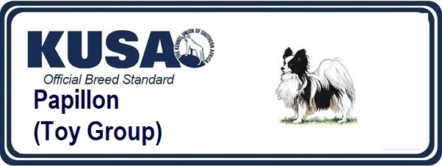
A Breed Standard is the guideline which describes the ideal characteristics, temperament and appearance of a breed and ensures that the breed is fit for function with soundness essential. Breeders and judges should at all times be mindful of features which could be detrimental in any way to the health, welfare or soundness of this breed.
GENERAL APPEARANCE
Dainty, well balanced little dog. An alert bearing and intelligent expression.
CHARACTERISTICS
The name ‘Papillon’ is derived from the shape and position of the ears. When erect they are carried obliquely like the spread wings of a butterfly, hence the name. When the ears are completely dropped this type is known as the ‘Phalene’ (Moth). Head markings should be symmetrical, about a narrow white, clearly defined blaze, which is desirable but not essential, to represent the body of a butterfly.
TEMPERAMENT
Lively, intelligent, friendly, with no aggression; always alert.
HEAD AND SKULL
Skull slightly rounded between ears, muzzle finely pointed and abruptly finer than the skull, accentuating well defined stop. Length from tip of nose to stop approximately one-third of length of head. Nose black.
EYES
Medium size, rounded, never bulging, dark with dark rims, placed rather low in skull.
EARS
Very large, mobile with rounded tips, heavily fringed; set towards back of head far enough apart to show slightly rounded shape of skull. Leathers firm but fine. When erect each ear should form an angle of approximately 45 degrees to head.
MOUTH
Jaws strong, with perfect regular and complete scissor bite i.e. upper teeth closely overlapping lower teeth and set square to the jaws. Lips thin, tight and dark in colour.
NECK
Medium length.
FOREQUARTERS
Shoulders well developed and sloping. Chest rather deep. Forelegs straight, slender and with strong fine boned. Elbows close to chest.
BODY
Fairly long with level topline; well sprung ribs, loin strong, of good length, slightly arched belly.
HINDQUARTERS
Well developed, well turned stifle. Legs when viewed from behind parallel.
FEET
Fine, fairly long, hare-like. Tufts of hair between toes extending far beyond them.
TAIL
Long, well fringed, set on high, arched over back with fringes falling to side to form plume.
GAIT/MOVEMENT
Light, free flowing, positive and free from any restriction. Viewed from in front or behind, legs and feet moving parallel to each other, with feet turning neither in nor out. Viewed from side, dog covering ground well with no hint of hackneyed action.
COAT
Abundant, flowing but without undercoat; long, fine, silky, falling flat on back and sides; profuse frill on chest; short and close on skull, muzzle and front parts of legs. Rear of forelegs to pasterns, tail and thighs covered with long hair.
COLOUR
White with patches, which may be any colour except liver. Tricolours, black and white with tan spots over eyes, tan inside ears, on cheeks, and under root of tail.
SIZE
Height 20 - 28 cms (8 - 11 in). Dog will appear slightly longer than high when properly furnished with ruff and hind fringes.
FAULTS
Any departure from the foregoing points should be considered a fault and the seriousness with which the fault should be regarded should be in exact proportion to its degree and its effect on health and welfare of the dog and on the dog’s ability to perform its traditional work.
NOTE
Male animals should have two apparently normal testicles fully descended into the scrotum.
