Japanese Spitz
Posted in Utility Group
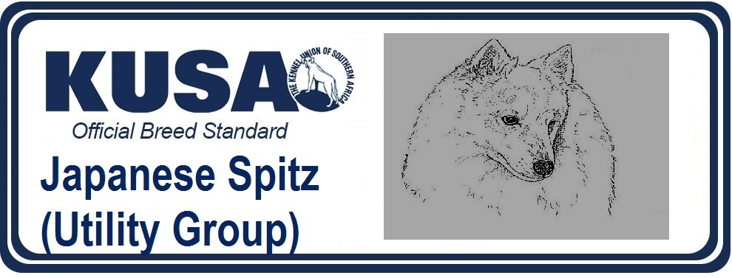A Breed Standard is the guideline which describes the ideal characteristics, temperament and appearance of a breed and ensures that the breed is fit for function with soundness essential. Breeders and judges should at all times be mindful of features which could be detrimental in any way to the health, welfare or soundness of this breed.
UTILIZATION: Companion Dog
BRIEF HISTORICAL SUMMARY: The origin of the Japanese Spitz is said to be the large-sized white German Spitz brought to Japan around 1920 via the continent of Siberia and northeast part of China. Around the year 1921 the breed was first exhibited at a dog show in Tokyo. Subsequently, in 1925, two pairs of white Spitz were imported from Canada, and until around 1936 imports came from Canada, the U.S., Australia and China. Eventually their offspring were cross bred to produce a better breed. After the Second World War the unified breed standard was established by the Japan Kennel Club in 1948 to be valid to the present.
GENERAL APPEARANCE: Covered with profuse pure white coat, with pointed muzzle, triangular pricked ears, and feathering tail over back. The constitution tough and the whole well balanced, and its harmonious beauty causing spirit and dignity peculiar to this breed and expressing elegance.
IMPORTANT PROPORTIONS: The ratio of height at withers to length of body is 10:11.
BEHAVIOUR/TEMPERAMENT: Intelligent, cheerful, keen in sense. Noisy not permitted.
HEAD:
Size in harmony with balance to body, and moderately broad and rounded.
CRANIAL REGION:
Skull: Forehead moderately developed. Rear part of skull broadest.
Stop: Defined.
FACIAL REGION:.
Nose: Small, round and black.
Muzzle: Pointed, the tip slightly round and well balanced. Lips tight and preferably black.
Jaws/Teeth: White and strong with scissors bite.
Eyes: Moderately large, almond-shaped, set slightly oblique, dark in colour. Black eye rims.
Ears: Set on high, small, triangular, pricked, facing forward and not too far apart.
NECK: Moderately long, muscles well developed.
BODY:
Withers: High.
Back: Straight and short.
Loins: Broad.
Chest: Wide and deep, ribs well sprung.
Belly: Well drawn up.
Tail: Set on high, moderately long, carried over back.
LIMBS:
FOREQUARTERS:
General appearance: Shoulders well sloping, forearms straight, elbows tight.
HINDQUARTERS:
General appearance: Muscular, stifle and hock moderately bent.
FEET: Cat feet. Pads thick and desirably black as well as the nails.
GAIT: Quick and active.
COAT
Hair: Outer coat straight and stand-off. Undercoat short, soft and dense. The foreface, ears, front of forearms and parts below hocks are short haired, and the rest covered with abundant long hair, especially from neck to shoulders and forechest covered with beautiful frill, and the tail also has long, profuse feathering.
Colour: Pure white.
SIZE
Height at withers: Dogs : 30 - 38 cm
Bitches : slightly smaller than Dogs.
FAULTS: Any departure from the foregoing points should be considered a fault and the seriousness with which the fault should be regarded should be in exact proportion to its degree and its effect upon the health and welfare of the dog.
Overshot or undershot mouth
Strongly curled tail
Shyness; noisiness.
DISQUALIFYING FAULTS
- Aggressive or overly shy dogs
- Any dog clearly showing physical or behavioural abnormalities shall be disqualified.
Drop ears
- Tail not carried on back.
NB
Males should have two apparently normal testicles fully descended into the scrotum.
Only clinically and functionally and clinically healthy dogs with breed typical conformation should be used for breeding.



