German Spitz (Mittel)
Posted in Utility Group
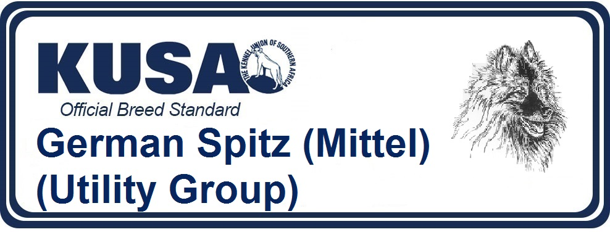
A Breed Standard is the guideline which describes the ideal characteristics, temperament and appearance of a breed and ensures that the breed is fit for function with soundness essential. Breeders and judges should at all times be mindful of features which could be detrimental in any way to the health, welfare or soundness of this breed.
UTILIZATION: Watch and companion dog.
BRIEF HISTORICAL SUMMARY: German Spitz are descendants of the stone age “Peat Dogs” (Torfhund). “Canis familiaris palustris Rüthimeyer” and the later Lake Dweller’s (Pfahlbau) Spitz; they are the oldest breed of dog in Central Europe. Numerous other breeds have been produced from them. In non German speaking countries, Wolfsspitz are known as Keeshonds and Toy Spitz as Pomeranians.
GENERAL APPEARANCE: Spitz breeds are captivating on account of their beautiful coats, made to stand off by plentiful undercoat. Particularly impressive is the strong, mane-like collar round the neck (ruff) and the bushy tail carried boldly over the back. The foxy head with alert eyes, the small pointed, closely set ears give the Spitz his unique characteristic, cheeky appearance.
IMPORTANT PROPORTIONS: The ratio of height at withers to body length is 1: 1.
BEHAVIOUR & CHARACTER: The German Spitz is always attentive, lively and exceptionally devoted to his owner. He is very teachable and easy to train. His distrust to strangers and lack of hunting instinct make him the ideal watchdog for home and farm. He is neither timid nor aggressive. Indifference to weather, robustness and longevity are his most outstanding attributes.
HEAD:
CRANIAL REGION: The Spitz’s medium size head, seen from above, appears broadest at the back and tapers in wedge shape to the tip of the nose.
Stop: Moderate to marked. Never abrupt.
FACIAL REGION
Nose: The nose is round, small and pure black; dark brown in brown Spitz.
Muzzle: The muzzle is not overlong and stands in pleasing proportion to the skull. (In Wolfspitz/Keeshond, Giant Spitz and Medium-size Spitz the ratio length of muzzle to length of the skull is approximately 2:3, in Miniature Spitz and Toy Spitz approximately 2:4).
Lips: The lips are not exaggerated, close fitting to the jaws and do not form any folds to the corner of the mouth. They are completely black in all colours; brown in brown Spitz.
Jaws/Teeth: The jaws are normally developed and show a complete scissor bite with 42 teeth, corresponding to the teeth formula of the dog i.e. the upper teeth closely overlapping the lower teeth and set square to the jaws. In Miniature and Toy (Pomeranian) Spitz the lack of a few pre-molars is tolerated. Pincer bite is permissible in all varieties of the German Spitz.
Cheeks: The cheeks are gently rounded, not protruding.
Eyes: The eyes are of medium size, longish shape, slightly slanting and dark. The eyelids are black in all shades of colour; dark brown in brown Spitz.
Ears: The small ears are set high and relatively close to each other, triangular and pointed; they are always carried upright, stiff at the tips.
NECK: The medium length neck is set broadly into the shoulders, slightly arched without throatiness and covered by a thick, profuse coat forming a large ruff.
BODY:
Topline: The topline starts at the tips of the erectly carried prick-ears and merges in a gentle curve with the short, straight back. The bushy, sweeping tail, which partially covers the back, rounds off the silhouette.
Withers/Back: The high withers drop imperceptibly into the shortest possible, straight, firm back.
Loin: Short-coupled, broad and strong.
Croup: The croup is broad and short, not falling away.
Chest: The deep chest is well sprung, the forechest well developed.
Underline and belly:The brisket reaches as far back as possible; the belly has only a slight tuck up.
TAIL: The tail is set on high and of medium length. It reaches upwards and rolls forward over the back, straight from the root. It lies firmly over the back and is covered with very bushy hair. A double curl at tip of tail is tolerated.
LIMBS:
FOREQUARTERS:
General appearance: Straight, rather broad front.
Shoulders: The shoulder-blade is long and well laid back. The shoulder is well muscled and firmly connected to the brisket. Upperarm: The upper arm, which is approximately the same length, forms an angle of 90 degrees to the shoulder blade.
Elbows: The elbow joint is strong, close fitting to the brisket and turns neither in nor out.
Forearm: The forearm is of medium length in relation to the body, sturdy and completely straight. The back of the forearm is well feathered.
Metacarpus (Pastern): The strong, medium length front pastern stands at an angle of 20 degrees from the vertical.
Front Feet: The front feet are as small as possible, round and closed, so called cat feet with well arched toes.
Toe nails and pads are black in all shades of colour, but dark brown in brown dogs.
HINDQUARTERS:
General appearance: The hindquarters are very muscular and abundantly feathered to the hocks. The hind legs stand straight and parallel.
Upper and Lower Thigh: Upper and lower thigh are of about equal length.
Stifle (knee): The stifle joint is strong with only moderate angulation and is turned neither in nor out in movement.
Hock / hock joint: The hock is of medium length, very strong and vertical to the ground.
Hind Feet: The hind feet are as small as possible, tightly closed with well arched toes, so called cat feet. The pads are coarse. The colour of nails and pads is as dark as possible.
GAIT/MOVEMENT: The German Spitz moves straight ahead with good drive, fluid and springy.
SKIN: The skin covers the body tightly without any wrinkles.
COAT:
Hair: The German Spitz has a double coat; long, straight, stand off top coat and short, thick, cotton-wool-like undercoat. Head, ears, front side of front and hind legs and the feet are covered by short, thick (velvety) hair. The rest of the body has a long rich coat. Not wavy, curly or corded, not parted on the back. Neck and shoulders are covered by a thick mane. The backside of the front legs is well feathered, the hind legs have ample feathering from croup to hocks. The tail is bushy.
COLOURS:
Black Spitz: In the black Spitz, the undercoat and skin must also be black and the colour on top must be a shining black without any white or other markings.
Brown Spitz: The brown Spitz should be uniformly dark brown.
White Spitz: The coat should be pure white without any trace of yellow in particular, which often occurs, especially on the ears.
Orange Spitz: The orange Spitz should be evenly coloured in the medium colour range.
Grey Shaded Spitz / Keeshond: Grey shaded is a silver grey with black hair tips. Muzzle and ears dark in colour, round the eyes well defined ‘spectacles’ shown as a delicately pencilled black line, slanting from outer corner of eye to lower corner of ear, coupled with distinct markings and shading forming expressive short eyebrow; mane and ring on shoulder lighter; fore and hindlegs without any black marking under the elbows or stifles, except slight pencilling on the toes; black tip of tail; underside of tail and trousers pale silver-grey.
Other Coloured Spitz: The terms “other colours” covers all shades of colour, such as: cream, cream sable, orange sable, black and tan and particolour (with white always as main colour). The black, brown, grey or orange patches must be distributed over the whole body.
SIZE:
Height at withers: Miniature Spitz 26 cm +/- 3cm
WEIGHT:
The German Spitz (Mittel) should have a weight corresponding to its size.
FAULTS: Any departure from the foregoing points should be considered a fault and the seriousness with which the fault should be regarded should be in exact proportion to its degree and its effect upon the health and welfare of the dog.
SEVERE FAULTS:
- Faults in construction.
- Head too flat. Distinct apple head.
- Flesh coloured nose, eyelids and lips.
- In Medium size Spitz missing teeth.
- Faults in movement.
- In grey-shaded Spitz distinct markings of the face.
DISQUALIFYING FAULTS:
- Aggressive or overly shy.
- Any dog clearly showing physical or behavioural abnormalities shall be disqualified.
- Gap in fontanel.
- Over or undershot bite.
- Ectropion or entropion.
- Semi pricked ears.
- Definite white patches in all - not White Spitz.
- Any colour that has the merle factor.

NB:
Male animals should have two apparently normal testicles fully descended into the scrotum.
Only functionally and clinically healthy dogs with breed typical conformation should be used for breeding.
