Dogo Presa Canario
Posted in Working Group Picture required – Lois to source and send Please change the name below as well to Presa Canario
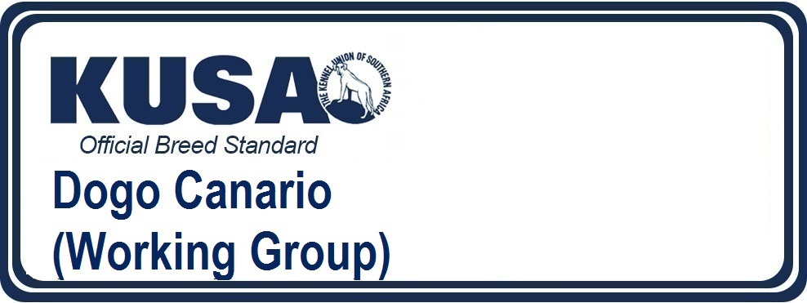
A Breed Standard is the guideline which describes the ideal characteristics, temperament and appearance of a breed and ensures that the breed is fit for function with soundness essential. Breeders and judges should at all times be mindful of features which could be detrimental in any way to the health, welfare or soundness of this breed.
UTILIZATION: Guard dog used for protection of cattle.
BRIEF HISTORICAL SUMMARY: A molossoid type dog, originating from Tenerife and Gran Canaria (Canary Islands). It is believed to be the result of matings between the “majorero”, a prehispanic dog indigenous to these islands, and other molossoids introduced to the Canary Islands. These matings produced an ethnical group of mastiff-type dogs, of moderately large size, brindle or fawn with white marking, with a specific molossoid morphology but yet agile and powerful, having a strong temperament, robust and lively, loyal character. During the XVI and XVII centuries, the number of these dogs increased considerably and numerous references to them in pre- Conquest historical texts, especially in the “Cedularios delCabildo” (municipal registers), which explain their duties essentially as guard dogs and protectors of cattle.
GENERAL APPEARANCE: A moderately large sized molossoid, with a rectilinear profile and black mask. Robust and well-proportioned.
IMPORTANT PROPORTIONS: The body is longer than the height at the withers; this characteristic is more noticeable in the female. Skull-foreface proportion is 60-40%. The width of the skull is 3/5 of the total length of the head. The distance from elbow to ground should be 50% of the height at the withers for males and a little less for females.
BEHAVIOUR/TEMPERAMENT: Calm appearance; attentive expression. Especially suited to guarding and traditionally used for herding cattle. Balanced temperament and very self-confident. Low and deep bark. Obedient and docile with family members, very devoted to its master, but can be suspicious of strangers. Confident attitude, noble and a little distant. When alert, the stance is firm with a vigilant attitude.
HEAD: Massive, brachycephalic and compact in appearance, covered with thick skin. The shape tends towards a slightly elongated cube. The cranial-facial lines are parallel or slightly converging.
CRANIAL REGION:
Skull: Slightly convex in anteposterior and transversal direction. Frontal bone tends to be flat. The width is almost identical to the length. Pronounced zygomatic arch, with well-developed cheek and jaw muscles, but not prominent, covered with loose skin. The occipital protuberance is only slightly marked.
Stop: The stop is pronounced, but not abrupt. The furrow between the frontal lobes is well defined and is about two thirds the size of the skull.
FACIAL REGION:
Nose: Wide, strong black pigmentation. In line with the muzzle. The nostrils are large to facilitate breathing.
Muzzle: Shorter than the skull, normally about 40% of the total length of the head. The width is 2/3 of that of the skull. Very wide base, narrowing slightly towards the nose. Bridge of the nose is flat and straight, without ridges.
Lips: The upper lip is pendulous, although not excessively. Seen from the front, the upper and lower lips come together to form an inverted V. The flews are slightly divergent. The inside of the lips is a dark colour.
Jaws/Teeth: Scissor bite or slightly undershot bite, max 2 mms. Pincer bite is admitted but not desirable due to the dental erosion produced. The dental arch is wide at the canines. The teeth are wide and solidly set. Large molars, small incisors, well developed canines.
Eyes: Slightly oval in shape, from medium to large in size. Set well apart, but neither sunken nor protruding. Eyelids are black and tight-fitting, never sagging. The colour varies from dark to medium brown, depending on the colour of the coat. They should never be light.
Ears: Medium sized, set well apart, with short and fine hair. They fall naturally on each side of the head. If folded, they are in the shape of a rose. They are set on slightly above eye level. Ears set too high and very close on the head are considered unusual. In countries were cropping is allowed, they must stand erect.
NECK: Shorter than the length of the head. Skin on the underside is loose, forming a slight dewlap. Solid and straight, it tends to be cylindrical and muscular.
BODY: Long, broad and deep.
Top line:Straight, without deformations and sustained by well developed but barely visible muscles. Rising slightly from the withers to the croup. The height at the croup is 1 – 2 cms more than the height at the withers.
Croup: Medium length, broad and rounded. Should not be long as this would limit movement. The female is usually broader.
Chest: With great capacity and well defined pectoral muscles. Seen from both the front and the side, it should be well let down to at least the elbow. Thoracic perimeter is usually equal to the height at the withers plus 45%. Well sprung ribcage.
Underline and belly: Slightly tucked up, never sagging. The flanks are only slightly pronounced.
TAIL: Thick base, tapering to the tip, down to the hock but no longer. Medium set on. In action it rises like a sabre, but without curling nor leaning towards the back. At rest it hangs straight with a slight curve at the tip.
LIMBS:
FOREQUARTERS:
Shoulder: Well laid back.
Upper arm: Well angulated, oblique.
Forearm: Well balanced, straight. Strong boned and well-muscled.
Elbow: Must be neither too close to the ribs nor sticking out.
Metacarpus (Pastern): Very solid and slightly sloping.
Forefeet: Cat feet with rounded toes, not too close together. Well developed and black pads. Nails are dark, white nails should be avoided, although they can occur in function of coat colour.
HINDQUARTERS:
General appearance: Seen from behind, strong and parallel, without deviation.
Thigh: Long and well muscled thighs.
Stifle (Knee): Angulation not very pronounced but should not be insufficient.
Metatarsus (Rear pastern): Always well let down.
Hind feet: Slightly longer than the front feet, otherwise identical.
GAIT / MOVEMENT: On the move, the Dogo Presa Canario is agile and supple and should cover a lot of ground. Long reach. The tail is carried low and the head is carried only a little above the level of the back. When alert, the head and tail are carried high.
SKIN: Thick and elastic. More loose on and around the neck. When alert, the skin on the head forms symmetrical wrinkles which fan out from the furrow between the front lobes.
COAT: Hair: Short, coarse, flat with no undercoat (it can appear on neck and on back of the thighs). Rather coarse to the touch. Very short and fine on the ears; slightly longer on the withers and on the back of thighs.
Colour: All shades of brindle, from warm dark brown to pale grey or blond. All shades of fawn to sandy. White marks are acceptable on the chest, at the base of the neck or throat, forefeet and toes of hind feet, but these should be kept to a minimum. The mask is always black, and should not spread above eye level.
SIZE AND WEIGHT:
Height at the withers: Males: 60 - 66 cms.
Females: 56 - 62 cms.
For very typical specimens, a tolerance of 2 cm. over or under these limits is accepted.
Weight:
Minimum: Males: 50 kgs.
Females: 40 kgs.
Maximum: Males: 65 kgs.
Females: 55 kgs.
FAULTS: Any departure from the foregoing points should be considered a fault and the seriousness with which the fault should be regarded should be in exact proportion to its degree and its effect upon the health and welfare of the dog.
Pincer bite.
SEVERE FAULTS: Any fault is considered severe when affecting the expression and limiting the type of the dog.
Incorrect head proportions.
Extremely convergent facial-cranial lines (over pronounced stop)
Loins and withers of the same height.
Incorrect position of limbs.
Square profile.
Triangular head, narrow (not cube shape).
Thin, curled or deformed tail. Set on high.
Saddle or roach back.
Light eyes (yellow), very close together or oblique, sunken or protruding.
Excessive undershot mouth.
Insufficient mask.
Missing teeth (except P1)
DISQUALIFYING FAULTS: Aggressive or overly shy dogs.
Any dog clearly showing physical or behavioural abnormalities shall be disqualified.
Total depigmented nose.
Unacceptable white marks.
Overshot mouth.
Croup lower than withers. Sloping topline.
Blue eyes or unmatched in colour.
Cropped tail.
N.B.: Male animals should have two apparently normal testicles fully descended into the scrotum.
Only functionally and clinically healthy dogs, with breed typical conformation should be used for breeding.
Note: CROPPED EARS – KUSA Schedule 2 Regulation 7
Any dog with cropped ears born within the jurisdiction of the KUSA, imported into it and cropped within it, shall not be registered or recorded by the Kennel Union and if any such dog is registered or recorded in contravention of this Regulation, upon discovery, its registration or recording shall be cancelled.
7.1. Any dog with ears cropped before importation into the KUSA area of jurisdiction is not eligible for competition at any Kennel Union event.
Please change the Copyright date below to 24/12/2018



