Chinese Crested
Posted in Toy Group
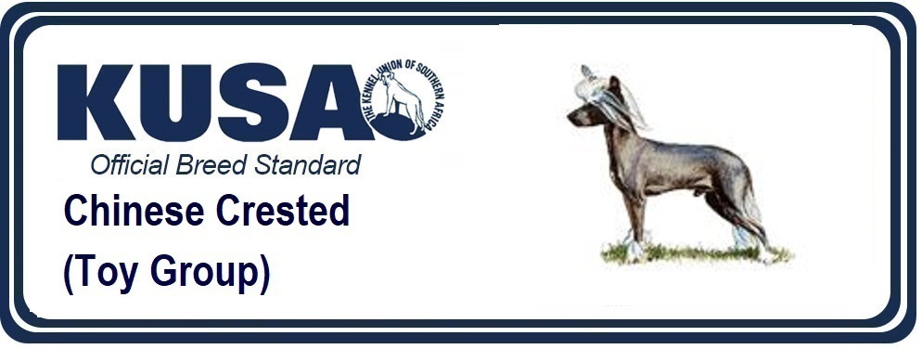
A Breed Standard is the guideline which describes the ideal characteristics, temperament and appearance of a breed and ensures that the breed is fit for function with soundness essential. Breeders and judges should at all times be mindful of features which could be detrimental in any way to the health, welfare or soundness of this breed.
GENERAL APPEARANCE:
A small, active and graceful dog; medium to fine boned, smooth hairless body, with hair on feet, head and tail only or covered with soft veil of hair.
CHARACTERISTICS:
Two distinct types of this breed; Deer type, racy and fine boned, and Cobby type, heavier in body and bone.
TEMPERAMENT:
Happy, never vicious.
HEAD & SKULL:
Slightly rounded and elongated skull. Cheeks cleanly chiselled, lean and flat, tapering into muzzle. Stop slightly pronounced but not extreme. Head smooth, without excess wrinkles. Distance from base of skull to stop equal to distance from stop to tip of nose. Muzzle tapering slightly but never pointed, lean without flews. Nose a prominent feature, narrow in keeping with muzzle. Any colour nose acceptable. Head presenting graceful appearance, with alert expression. Lips tight and thin. An ideal, crest begins at the stop and tapers off down neck. Long and flowing crest preferred, but sparse acceptable.
EYES:
So dark as to appear black. Little or no white showing. Medium size, almond in shape. Set wide apart.
EARS:
Set low; highest point of base of ear level with outside corner of eye. Large and erect, with or without fringe, except in Powder Puffs where drop ears are permissible.
MOUTH:
Jaws strong, with perfect, regular scissor bite, i.e. the upper teeth closely overlapping the lower teeth and set square to the jaws.
NECK:
Lean, free from throatiness, long and sloping gracefully into strong shoulders. When moving, carried high and slightly arched.
FOREQUARTERS:
Shoulders clean, narrow and well laid back. Legs long and slender, set well under body. Elbows held close to body. Pasterns fine, strong, nearly vertical. Toes turned neither in nor out.
BODY:
Medium to long. Supple. Chest rather broad and deep, not barrel-ribbed. Breast bone not prominent. Brisket extending to elbows; moderate tuck-up.
HINDQUARTERS:
Rump well-rounded and muscular, loins taut, stifles firm and long, sweeping smoothly into the well let-down hocks. Angulation of the rear limbs must be such as to produce a level back. Hind legs set wide apart.
FEET:
Extreme hare foot, narrow and very long, with unique elongation of small bones between joints, especially in forefeet, which almost appear to possess an extra joint. Nails any colour, moderately long. Socks ideally confined to toes, but not extending above top of pastern. Feet turning neither in nor out.
TAIL:
Set high, carried up or out when in motion. Long and tapering, fairly straight, not curled or twisted to either side, falling naturally when at rest. Plume long and flowing, confined to lower two-thirds of tail. Sparse plume acceptable.
GAIT / MOVEMENT:
Long, flowing and elegant with good reach and plenty of drive.
COAT:
No large patches of hair anywhere on body. Skin fine grained, smooth, warm to the touch. In Powder Puffs, coat consists of an undercoat with soft veil of long hair, veil coat a feature.
COLOUR:
Any colour or combination of colours.
SIZE:
Ideal height in Dogs: 28 - 33 cm (11 - 13 ins) at withers; Bitches: 23 - 30 cm (9 - 12 ins) at withers
Weight varies considerably, but should not be over 5.4 kg (12 lb).
FAULTS
Any departure from the foregoing points should be considered a fault and the seriousness with which the fault should be regarded should be in exact proportion to its degree and its effect on health & welfare of the dog and on the dog’s ability to perform its traditional work.
NB
- Male animals should have two apparently normal testicles fully descended into the scrotum.
- Only clinically and functionally healthy dogs with breed typical conformation should be used for breeding.
