Proposal to amend Schedule 5M (Regulations for Flyball)

Submitted by the National Flyball Sub-Committee
Insertions underlined and deletions in [struck through square brackets].
4.8 Runner: A person or team member whose purpose is to assist the team in anyway the team requires.
4.8.1 Conduct of the Runner:
4.8.1.1 Runners may not interfere with any teams running or judging except to do the following:
4.8.1.2 Set up knocked down jumps; this must be done with minimal interference with a team’s run.
4.8.1.3 To retrieve loose balls.
4.8.1.4 To record crosses / passes between running dogs.
4.8.1.5 To assist their team as the team may require.

4.8.2 No additional person besides the actual handler may release or assist the dog in navigating the course. An additional person to help catch the dog in the runback area, holding a dog or revving-up a dog/dogs before running is permitted within the limits of the maximum number of allowed persons in the ring as per 5.1.1.3.

4.8.3 An additional person other than the handler guiding a dog into the lane or running alongside the dog as it runs will not be permitted even if this person is outside the ring. In case of a first offense, the judge shall give a warning. Any offense thereafter will result in the loss of the heat.

Motivation: As per new FCI rule.
______________________________________________________________________________________

5.1.1.3 Optionally a team may have [a Runner and] up to three other participants in the ring to aid the team of which a maximum of two runners. A team may therefore have a maximum of 8 people in the ring (4 competing handlers, 3 support members either to check crosses, record times or runners and a box loader). At no time may these optional participants interfere with the judges, the opposing team, or physically aid the dogs competing as per regulation 4.8.

Motivation: It is not stipulated in the current rules how many additional people may be in the ring. Too many runners and helpers may interfere in the running of a competition. Based on information obtained from other countries, a maximum of 8 or 9 people (4 handlers, 4 or 5 assistants (runners, checking crosses and recording times) and a box loader are allowed.
______________________________________________________________________________________

10.10.2 Flyball Box:

Each team is to supply its own Flyball box and spare Flyball box that is to conform to the following specifications:

All boxes are to have a mechanical, not electrical, pedal release mechanism.

The boxes may be painted or decorated as the team wishes.

The ball, when released, must have a free, unobstructed flight of not less than 60cm from the point that the ball is released to the point the ball hits the ground, in the direction of the start/finish line or poles.
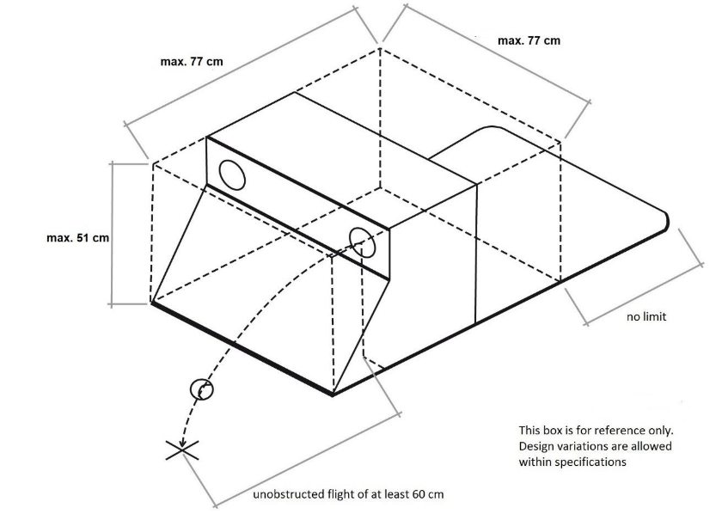
Boxes dimensions:

Width: shall not exceed 76 cm

Height: shall not exceed 51 cm

Depth: shall not exceed 77cm (excluding the platform the box loader uses to stand on. The platform has no limit, however, the total depth should ideally not exceed 120cm)

The dimensions include a release mechanism, but do not include any platform the box loader uses to hold the box in place.

Boxes should be constructed with the comfort and safety of the dog in mind. Sharp edges must be avoided, and adequate padding and protection should be used. Any curved or flat front box may be used so long as the box is within the dimensions

The addition of any object, that could be considered a potential training aid or prop, attached to the front elevation of the box, whether temporary or permanent, is not allowed. This does not include tape or a painted stripe / band on the front of the box if the surface is still flat following such application. Any attached object may only be used during warm-up and must be removed prior to the first race.

Motivation: As per the new FCI rule.
______________________________________________________________________________

12.3 The start
12.3.1 The first dogs in each team will be released on the judge's whistle. Subsequent dogs will only be allowed to pass the start/finish line once the preceding dog has passed the start/finish line with any part of its body. The dog must return with the ball in its mouth, see regulation [12.1.] 12.4.1

12.3.2 In instances where the Electronic Judging System is used, the start will be visual, acoustic or a combination of both.

Where a light tree is used to count down the start:

A sequence of at least 3 amber / yellow lights or 1 red and 2 amber / yellow lights will flash at one second intervals. The time will start once the green light lights up. The aim is for a team to release their start dog so that this dog crosses the start line as close as possible after the green light lights up. The first dog may not cross the start line with any part of its body before the timing of the race begins.
A false start is indicated when the start dog crosses the start line before the green light lights up (also referred to an early start). [and the judge will stop the race by blowing a whistle or verbally indicating to teams to stop.
Each team is allowed one false start per race. After the first false start, the race will start again. If the same team causes a second false start (for that same heat), the starting dog must re-run again.
If a second false start is caused by the other team (their first false start), the heat will be stopped and restarted] When a team has a false start, the first dog of the team has to re-run at the end.

Practice start: Only during their first two races of a tournament and upon entering the arena, may teams request a practice start from the judge before the warm-up period is over. The practice start will take place immediately after the warm-up period and prior to the first heat of the race. Only one dog per team may run a practice start and props are not permitted during practice starts.

16.1 | b) In the event of using the EJS light tree to signal the start: If a dog or handler's feet cross the Start / Finish line before the start is signalled, the [heat will be stopped and restarted (one false start allowed per team per race)] dog must re-run. | [No penalty]  Dog reruns
 | [c) In the event of using the EJS light tree to signal the start and after the second false start: If a dog's or handler's feet cross the Start / Finish line before the start is signalled.] | [Dog reruns]

Motivation: As per the new FCI rule which is only applicable when the EJS system is used and to level the playing fields as it would prevent teams deliberately false starting to tire the opposing team’s start dog.
______________________________________________________________________________________

16.17 | Should any hurdle be knocked down, [a dog is not to be penalised provided it clears the hurdle as though it were standing. (Team’s Runner may replace hurdle with minimal interference)]. the heat shall be stopped for safety reasons and the hurdle returned to the upright position. The heat will be re-run. | No penalty
16.18 | The heat shall [not] be stopped for broken boards/hurdles [unless the judge deems it necessary] to prevent injury to the running dogs. [Dogs must clear the hurdle as if it were standing. The hurdle must be replaced after the heat.] The heat will be re-run. | No penalty

Motivation: A fallen hurdle, even if falling flat, could be dangerous if a dog takes an incorrect line or tries to avoid a fallen hurdle. For safety reasons the rules are to be changed. This is also in line with most EU and UK rules.
______________________________________________________________________________________

