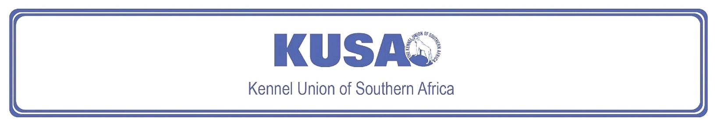
SKYE TERRIER
A breed standard is the guideline which describes the ideal characteristics, temperament and appearance including the correct colour of a breed and ensures that the breed is fit for function. Absolute soundness is essential. Breeders and judges should at all times be careful to avoid obvious conditions or exaggerations which would be detrimental in any way to the health, welfare or soundness of this breed. If a feature or quality is desirable it should only be present in the right measure. However, if a dog possesses a feature, characteristic or colour described as unacceptable, it must not be rewarded in the show ring.

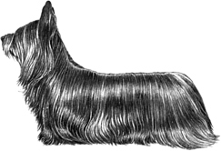
Most recent changes to this Standard have an effective date of 01/01/2017
ORIGIN | IIlustration courtesy of NKU Picture Library
Great Britain. | IIlustration courtesy of NKU Picture Library
UTILISATION | IIlustration courtesy of NKU Picture Library
Terrier. | IIlustration courtesy of NKU Picture Library
BRIEF HISTORICAL SUMMARY | IIlustration courtesy of NKU Picture Library
[ed. from FCI Breed Standard No. 75]  One of the oldest of Scottish breeds. The Skye was once known as the Terrier of the Western Isles, evolving into what we now call the Skye Terrier, with a mix of breeds behind him, including Cairn Terrier prototypes. One of the most famed of the breed was Greyfriars Bobby who, in Edinburgh, around 1858, took up a vigil at his master’s grave in Greyfriars Churchyard until he, too, died. Greyfriars Bobby was buried in | IIlustration courtesy of NKU Picture Library
unconsecrated ground in the churchyard, and his devotion is commemorated by a memorial plaque in the street and by a tablet on his grave. Although the majority of Skye Terriers are prick-eared, there is also a variety known as ‘drop-eared’, and then the ears hang flat against the skull.

GENERAL APPEARANCE
Long, low, with coat of good length; twice as long as high. Moves with seemingly effortless gait. Strong in quarters, body and jaw.

CHARACTERISTICS
Elegant and dignified.

TEMPERAMENT
A ‘one-man’ dog, distrustful of strangers, never vicious.

HEAD
Long and powerful, strength not sacrificed for extreme length. Moderate width at back of skull, tapering gradually with slight stop to strong muzzle. Nose black.
Eyes:
Brown, preferably dark brown, medium in size, close-set and full of expression.
Ears:
Prick or drop. When prick, gracefully feathered, not large, erect at outer edges and slanting towards each other at inner edge, from peak to skull. When drop, larger, hanging straight, lying flat and close at front.
Mouth:
Jaws strong and level with perfect, regular, scissor bite, i.e. upper teeth closely overlapping lower teeth and set square to the jaws.

NECK
Long and slightly crested.

FOREQUARTERS
Shoulders broad, close to body, chest deep, legs short and muscular.

BODY
Long and low, back level. Ribcage oval, deep and long. Short loin. Sides appear flattish due to straight-falling coat.

HINDQUARTERS
Strong, full, well-developed and well-angulated. Legs short, muscular, and straight when viewed from behind. No dewclaws.

FEET
Forefeet larger than hind, pointing truly forward. Pads thick, nails strong.

TAIL
When hanging, upper part pendulous, and lower half thrown back in a curve. When raised, a prolongation [ed. extension] of incline of back, not rising higher or curling up. Gracefully feathered.

GAIT / MOVEMENT
Legs proceed straight forward when travelling. When approaching, forelegs form a continuation of straight line of front, feet being same distance apart as elbows. Principal propelling power is furnished by hind legs that travel straight forward. Forelegs moving well forward, without too much lift. Whole movement termed free, active, and effortless, and gives a more-or-less fluid picture.

COAT
Double. Undercoat short, close, soft, and woolly. Outer coat reasonable length, hard, straight, flat, and free from curl, never impeding action. Hair on head shorter, softer, veiling forehead and eyes, but not obscuring vision. Mingling with side locks, surrounding ears like a fringe and allowing their shape to appear.

COLOUR
- Black, dark or light grey, fawn, cream: all with black points.
- Any self-colour allowing shading of same colour and lighter undercoat, so long as nose and ears are black.
* A small white spot on chest permissible.

SIZE
Height at withers:
Males: 25cm – 26cm (approx. 10” – 10½”); length from tip of nose to tip of tail 105cm (approx. 42”)
Females: slightly smaller in same proportions.

N.B. Male animals should have two apparently normal testicles fully descended into the scrotum. Only functionally and clinically healthy dogs, with breed typical conformation should be used for breeding.

FAULTS
Any departure from the foregoing points should be considered a fault and the seriousness with which the fault should be regarded should be in exact proportion to its degree and its effect upon the health and welfare of the dog, and on the dog’s ability to perform its traditional work.

©Copyright Kennel Club, London 09/2007 – Reprinted with permission

The publisher of this edition is the Kennel Union of Southern Africa. All rights reserved. No part of this publication may be reproduced, stored in a retrieval system or transmitted in any form, or by any means, electronic, mechanical, photocopying, recording or otherwise without permission in writing from the publisher.

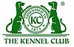 | When judging this breed at FCI International Shows, use:
 | FCI Standard No. 75: SKYE TERRIER
FCI Classification: Group 3 – Terriers.
Section 2 – Small-sized Terriers .
Without working trial.

