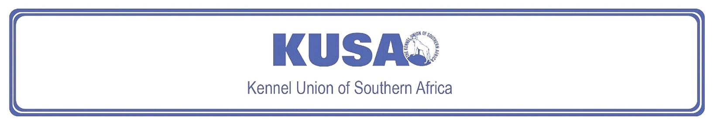
SEALYHAM TERRIER
A breed standard is the guideline which describes the ideal characteristics, temperament and appearance including the correct colour of a breed and ensures that the breed is fit for function. Absolute soundness is essential. Breeders and judges should at all times be careful to avoid obvious conditions or exaggerations which would be detrimental in any way to the health, welfare or soundness of this breed. If a feature or quality is desirable it should only be present in the right measure. However, if a dog possesses a feature, characteristic or colour described as unacceptable, it must not be rewarded in the show ring.

Most recent changes to this Standard have an effective date of 01/01/2025
ORIGIN
Great Britain.

UTILISATION
Terrier.

BRIEF HISTORICAL SUMMARY
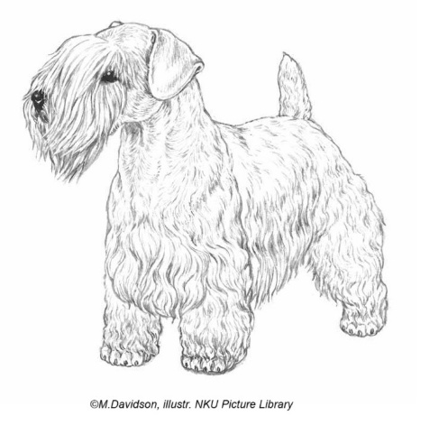
[ed. For interest, from Wikipedia: The Sealyham Terrier]:
The Sealyham Terrier is a rare Welsh breed that originated in Wales as
a working dog. It was developed in the mid-to-late-19th century by Capt.
John Edwardes at Sealyham House, Pembrokeshire. Following the First
World War, it surged in popularity and was associated with Hollywood stars
and members of the British Royal Family. Its numbers have dropped
significantly since then, with the breed listed as a Vulnerable Native Breed by the Kennel Club; an all-time low was recorded in 2008 when only 43 puppies were registered in the United Kingdom. This decline has been blamed on an influx of foreign and designer breeds, and the Sealyham's reduced usefulness as a working dog.

GENERAL APPEARANCE
Free-moving, active, balanced and of great substance in small compass. General outline oblong, not square.

BEHAVIOUR & TEMPERAMENT
Sturdy, game and workmanlike. Alert and fearless but of friendly disposition.

HEAD
Cranial Region:
Skull: Slightly domed and wide between ears.
Facial Region:
Nose: Black.
Muzzle: Punishing square jaws, powerful and long.
Jaws/Teeth: Teeth level and strong with canines fitting well into each other and long for size of dog.
Jaws strong with regular scissor bite, i.e. upper teeth closely overlapping the lower teeth and set square to the jaws.
Cheeks: Cheek bones not protruding.
Eyes:
Dark, well set, round, of medium size. Dark, pigmented eyerims preferred but unpigmented tolerated
Ears:
Medium-sized, slightly rounded at tip and carried at side of cheek.

NECK
Fairly long, thick and muscular on well laid shoulders.

BODY
Medium in length, flexible.
Back: Level.
Chest: Broad and deep, well let down between forelegs.
Ribs: Well sprung.

TAIL
Previously customarily docked.
Docked: Medium length. Thick with a rounded tip. Set in line with back and carried erect. Quarters should protrude beyond set of tail.
Undocked: Medium length of tail to give a general balance to the dog. Thick at root and tapering towards tip. Ideally carried erect, but not excessively over the back, and with no curl or twist. Quarters should protrude beyond set of tail.
[*refer note below]

LIMBS
Forequarters:
Forelegs short, strong and as straight as possible consistent with chest being well down.
- Shoulder: Point of shoulder in line with point of elbow.
- Elbow: Should be close to side of chest.
Hindquarters:
Notably powerful for size of dog.
- Thighs: Deep and muscular.
- Stifle: Well bent.
- Hocks: Strong, well bent and parallel to each other.

FEET
Round and catlike with thick pads. Feet pointing directly forward.
GAIT / MOVEMENT
Brisk and vigorous with plenty of drive.

COAT
Hair:
Long, hard and wiry topcoat with weather-resistant undercoat.
Colour:
All white or white with lemon, brown, blue or badger pied markings on head and ears.
Much black and heavy ticking undesirable.

SIZE & WEIGHT
Height at withers:
Height should not exceed 31 cm (12 ins) at shoulder.

Ideal Weight:
Dogs approximately: 9 kg (20 lbs),
Bitches approximately: 8,2 kg (18 lbs).
General conformation, overall balance, type and substance are main criteria.

N.B. Male animals should have two apparently normal testicles fully descended into the scrotum. Only functionally and clinically healthy dogs, with breed typical conformation should be used for breeding.

*Regardless of the provisions of the current KUSA-adopted standard, docked or formerly docked breeds may be shown at all FCI- and KUSA-licensed shows in South Africa, whether their tails are docked or natural. Under no circumstances are Judges permitted to discriminate against exhibits on the grounds of docked or natural tails, and equal consideration for awards must be given to either.

FAULTS
Any departure from the foregoing points should be considered a fault and the seriousness with which the fault should be regarded should be in exact proportion to its degree and its effect upon the health and welfare of the dog, and on the dog’s ability to perform its traditional work.

Disqualifying faults:
• Aggressive or overly shy dogs.
• Any dog clearly showing physical or behavioural abnormalities.

©Copyright FCI – Reprinted with permission

The publisher of this edition is the Kennel Union of Southern Africa. All rights reserved. No part of this publication may be reproduced, stored in a retrieval system or transmitted in any form, or by any means, electronic, mechanical, photocopying, recording or otherwise without permission in writing from the publisher.

 | FCI Standard No. 74: SEALYHAM TERRIER  FCI Classification: Group 3 – Terriers.  Section 2 – Small-sized Terriers .  Without working trial.

