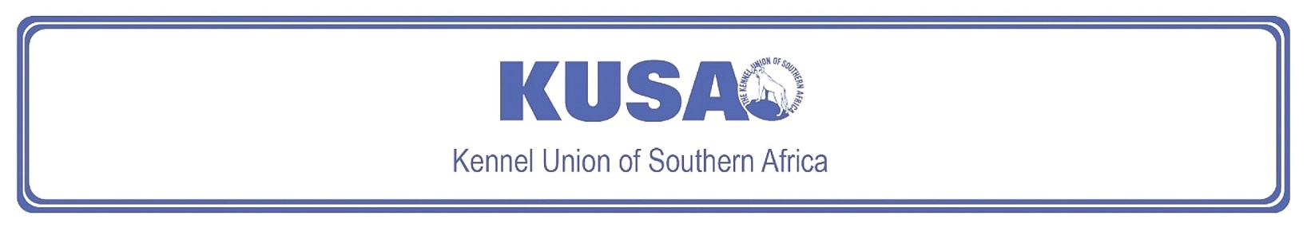
NORWICH TERRIER
A breed standard is the guideline which describes the ideal characteristics, temperament and appearance including the correct colour of a breed and ensures that the breed is fit for function. Absolute soundness is essential. Breeders and judges should at all times be careful to avoid obvious conditions or exaggerations which would be detrimental in any way to the health, welfare or soundness of this breed. If a feature or quality is desirable it should only be present in the right measure. However, if a dog possesses a feature, characteristic or colour described as unacceptable, it must not be rewarded in the show ring.

Most recent changes to this Standard have an effective date of 01/01/2025
ORIGIN
Great Britain.

UTILISATION
Terrier.

BRIEF HISTORICAL SUMMARY
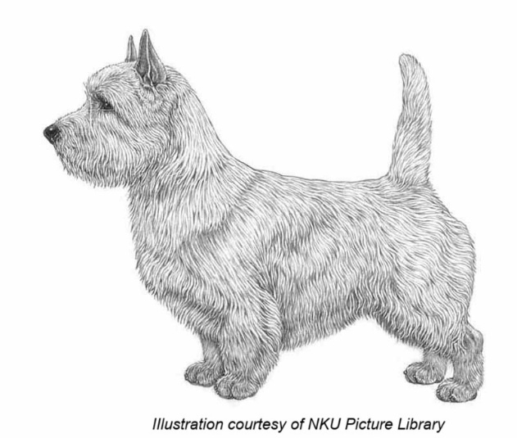
The Norwich and Norfolk Terrier take their names, obviously, from
the county and the city, though turning the clock back to the early
and mid -1800s there was no such distinction, this being just a
general farm dog. Glen of Imaals, red Cairn Terriers and Dandie
Dinmonts are among the breeds behind these East Anglian terriers
and from the resultant red progeny emerged the present Norwich and
Norfolk Terrier. A typical short-legged terrier with a sound, compact
body which has been used not only on fox and badger, but on rats as
well. He has a delightful disposition, is totally fearless but is not on e to start a fight. As a worker he does not give up in the face of a fierce adversary underground, and his standard’s reference to the acceptability of ‘honourable scars from fair wear and tear’ is a good indication of the type of dog.
The Norwich Terrier was accepted on the Kennel Club Breed Register in1932 and were known as the drop-eared Norwich Terrier (now known as the Norfolk Terrier) and prick-eared Norwich Terrier. The breeds were separated in 1964, and the drop-eared variety gained the name Norfolk Terrier.

GENERAL APPEARANCE
One of the smallest of the terriers. Low, keen dog, compact and strong with good substance and bone. Honourable scars from fair wear and tear not to be unduly penalised.
BEHAVIOUR & TEMPERAMENT
Lovable disposition, not quarrelsome, tremendously active with hardy constitution. Gay and fearless.

HEAD
Cranial Region:
Skull: Slightly rounded, wide, good width between ears.
Stop: Well defined.
Facial Region:
Muzzle: Wedge-shaped and strong. Length about one third less than measurement from occiput to bottom of stop.
Lips: Tight-lipped.
Jaws / Teeth: Jaws clean and strong. Rather large, strong teeth with perfect, regular scissor bite, i.e. upper teeth closely overlapping the lower teeth and set square to the jaws.
Eyes:
Relatively small, oval-shaped, dark, full of expression, bright and keen.
Ears:
Erect, set well apart on top of skull. Medium size with pointed tips. Perfectly erect when aroused, can be laid back when not at attention.

NECK
Strong of good length, commensurate with correct overall balance, flowing into well laid shoulders.
BODY
Compact.
Topline: Level.
Back: Short.
Loin: Short.
Chest: Ribcage long and well sprung. With good depth.

TAIL
Docking previously optional.
Docked: Medium docked. Set on high, completing perfectly level topline. Carried erect.
Undocked: Tail of moderate length to give a general balance to dog, thick at root and tapering towards tip, as straight as possible. Carried jauntily, not excessively gay, completing perfectly level topline
[*refer note below]
LIMBS
Forequarters:
Elbow: Close to body.
Forearm: Legs short, powerful and straight.
Metacarpus (Pastern): Firm and upright.
Hindquarters:
General appearance: Broad, strong and muscular.
Stifle (Knee): Well turned.
Metatarsus (Rear pastern): Hocks low-set, with great propulsion.
FEET
Rounded, well-padded and cat-like. Pointing straight forward standing and moving

GAIT / MOVEMENT
Forelegs should move straight forward when travelling; hind legs follow in their track; hocks parallel and flexing to show pads.

COAT
Hair:
Hard, wiry, straight, lying close to body, thick undercoat. Longer and rougher on neck forming a ruff to frame face. Hair on head and ears short and smooth, except for slight whiskers and eyebrows.
Colour:
All shades of red, wheaten, black and tan or grizzle. White marks or patches are undesirable.
SIZE
Height at withers:
- Ideal height at the withers: 25 cm (approx.9.8”).

N.B. Male animals should have two apparently normal testicles fully descended into the scrotum. Only functionally and clinically healthy dogs, with breed typical conformation should be used for breeding.

*Regardless of the provisions of the current KUSA-adopted standard, docked or formerly docked breeds may be shown at all FCI- and KUSA-licensed shows in South Africa, whether their tails are docked or natural. Under no circumstances are Judges permitted to discriminate against exhibits on the grounds of docked or natural tails, and equal consideration for awards must be given to either.

FAULTS
Any departure from the foregoing points should be considered a fault and the seriousness with which the fault should be regarded should be in exact proportion to its degree and its effect upon the health and welfare of the dog, and on the dog’s ability to perform its traditional work, and on the dog’s ability to perform its traditional work.
Disqualifying faults:
• Aggressive or overly shy dogs.
• Any dog clearly showing physical or behavioural abnormalities.

©Copyright FCI – Reprinted with permission

The publisher of this edition is the Kennel Union of Southern Africa. All rights reserved. No part of this publication may be reproduced, stored in a retrieval system or transmitted in any form, or by any means, electronic, mechanical, photocopying, recording or otherwise without permission in writing from the publisher.

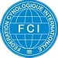 | FCI Standard No. 72: NORWICH TERRIER
FCI Classification: Group 3 – Terriers.

Section 2 – Small-sized Terriers .
Without working trial.

