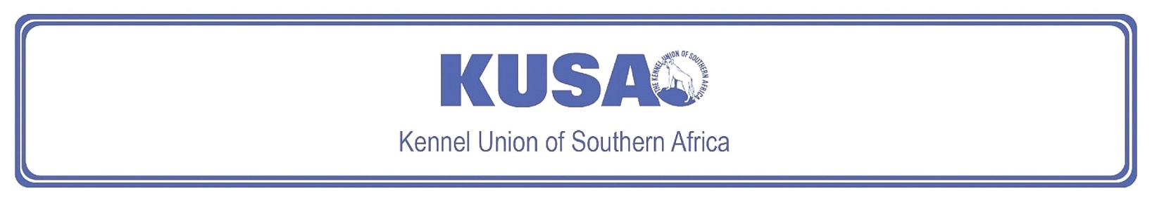
NORFOLK TERRIER
A breed standard is the guideline which describes the ideal characteristics, temperament and appearance including the correct colour of a breed and ensures that the breed is fit for function. Absolute soundness is essential. Breeders and judges should at all times be careful to avoid obvious conditions or exaggerations which would be detrimental in any way to the health, welfare or soundness of this breed. If a feature or quality is desirable it should only be present in the right measure. However, if a dog possesses a feature, characteristic or colour described as unacceptable, it must not be rewarded in the show ring.
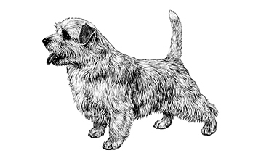
Most recent changes to this Standard have an effective date of 01/01/2017
ORIGIN | IIlustration courtesy of NKU Picture Library
Great Britain. | IIlustration courtesy of NKU Picture Library
UTILISATION | IIlustration courtesy of NKU Picture Library
Terrier. | IIlustration courtesy of NKU Picture Library
BRIEF HISTORICAL SUMMARY | IIlustration courtesy of NKU Picture Library
[ed. from FCI Breed Standard No. 272]  The Norfolk and Norwich Terrier take their names, obviously, from the county and the city, though turning the clock back to the early and mid-1800s there was no such distinction, this being just a general farm dog. Glen of Imaals, red Cairn Terriers, and Dandie Dinmonts are among the breeds behind these East Anglian Terriers and from the resultant red progeny, emerged the present Norwich and Norfolk Terrier. This typical | IIlustration courtesy of NKU Picture Library
short-legged Terrier with a sound, compact body has been used not only on fox and badger, but on rats as well. He has a delightful disposition, is totally fearless but is not one to start a fight. As a worker he does not give up in the face of a fierce adversary underground, and his standard’s reference to the acceptability of “honourable scars from fair wear and tear” is a good indication of the type of dog. The Norwich Terrier was accepted on the Kennel Club Breed Register in 1932, and was known as the drop-eared Norwich Terrier (now known as the Norfolk Terrier) and prick-eared Norwich Terrier. The breeds were separated in 1964 and the drop-eared variety gained the name Norfolk Terrier.

GENERAL APPEARANCE
Small, low, keen dog, compact, and strong, short back, good substance and bone. Honourable scars from fair wear and tear permissible.

CHARACTERISTICS
One of the smallest of Terriers, a ‘demon’ for its size. Lovable disposition, not quarrelsome, hardy constitution.

TEMPERAMENT
Alert and fearless.

HEAD
Skull broad, only slightly rounded with good width between ears. Muzzle wedge-shaped and strong; length of muzzle about one-third less than measurement from occiput to bottom of well-defined stop.
Eyes:
Oval-shaped, dark brown or black. Expression alert, keen and intelligent.
Ears:
Medium-sized, V-shaped, slightly rounded at tip, dropping forward close to cheek.
Mouth:
Tight-lipped, strong jaw; teeth strong and rather large; perfect scissor bite, i.e. upper teeth closely overlapping lower teeth and set square to the jaws.

NECK
Strong and of medium length.

FOREQUARTERS
Clean, well laid back shoulder blade, approximating in length to upper arm. Front legs short, powerful, and straight.
BODY
Compact, short back, level topline, well-sprung ribs.

HINDQUARTERS
Well-muscled, good turn of stifle, hocks well let down and straight when viewed from rear; great propulsion.

FEET
Round with thick pads.

TAIL
Docking of tail previously optional.
Docked: Medium docked, set level with topline and carried erect.
Undocked: Tail of moderate length to give a general balance to the dog, thick at the root and tapering towards the tip, as straight as possible, carried jauntily, but not excessively gay.
[*refer note below]

GAIT / MOVEMENT
True, low, and driving. Moving straight forward from shoulder. Good rear angulation showing great powers of propulsion. Hind legs follow track of forelegs, moving smoothly from hips. Flexing well at stifle and hock. Topline remaining level.

COAT
Hard, wiry, straight, lying close to body. Longer and rougher on neck and shoulders. Hair on head and ears short and smooth, except for slight whiskers and eyebrows. Excessive trimming undesirable.

COLOUR
- All shades of red, wheaten, black and tan, or grizzle.
* White marks or patches undesirable but permissible.

SIZE
Height at withers:
25cm (approx. 10”).

N.B. Male animals should have two apparently normal testicles fully descended into the scrotum. Only functionally and clinically healthy dogs, with breed typical conformation should be used for breeding.

*Regardless of the provisions of the current KUSA-adopted standard, docked or formerly docked breeds may be shown at all FCI- and KUSA-licensed shows in South Africa, whether their tails are docked or natural. Under no circumstances are Judges permitted to discriminate against exhibits on the grounds of docked or natural tails, and equal consideration for awards must be given to either.

FAULTS
Any departure from the foregoing points should be considered a fault and the seriousness with which the fault should be regarded should be in exact proportion to its degree and its effect upon the health and welfare of the dog, and on the dog’s ability to perform its traditional work.

©Copyright Kennel Club, London 09/2007 – Reprinted with permission

The publisher of this edition is the Kennel Union of Southern Africa. All rights reserved. No part of this publication may be reproduced, stored in a retrieval system or transmitted in any form, or by any means, electronic, mechanical, photocopying, recording or otherwise without permission in writing from the publisher.

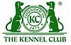 | When judging this breed at FCI International Shows, use:
 | FCI Standard No. 272: NORFOLK TERRIER
FCI Classification: Group 3 – Terriers.
Section 2 – Small-sized Terriers .
Without working trial.

