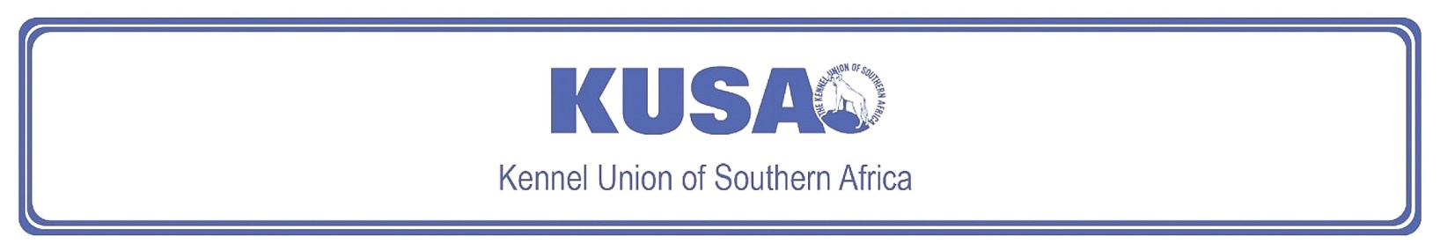
FOX TERRIER (WIRE)
A breed standard is the guideline which describes the ideal characteristics, temperament and appearance including the correct colour of a breed and ensures that the breed is fit for function. Absolute soundness is essential. Breeders and judges should at all times be careful to avoid obvious conditions or exaggerations which would be detrimental in any way to the health, welfare or soundness of this breed. If a feature or quality is desirable it should only be present in the right measure. However, if a dog possesses a feature, characteristic or colour described as unacceptable, it must not be rewarded in the show ring.

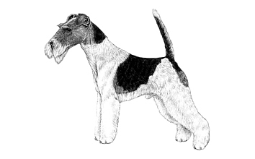
Most recent changes to this Standard have an effective date of 01/01/2017
ORIGIN | IIlustration courtesy of NKU Picture Library
Great Britain. | IIlustration courtesy of NKU Picture Library
UTILISATION | IIlustration courtesy of NKU Picture Library
Terrier. | IIlustration courtesy of NKU Picture Library
BRIEF HISTORICAL SUMMARY | IIlustration courtesy of NKU Picture Library
[ed. from FCI Breed Standard No. 12]  The Fox Terrier in both forms, Smooth and Wire, is from British origins and probably owes its existence to the same types of dog that produced both the Bull Terrier and the Black and Tan (now Manchester) Terrier. Uniformity of type was established in the late 1800s, and the original standard for the Fox Terrier was drawn up in 1876. One of the most lively and alert of Terriers, refinement to his present show excellence has not | IIlustration courtesy of NKU Picture Library
allowed him to become unsound. Capable of standing up to any amount of exercise, always ready to deal with rats, rabbits, and, of course, foxes.

GENERAL APPEARANCE
Active and lively, bone and strength in small compass, never cloddy or coarse. Conformation to show perfect balance; in particular, this applies to the relative proportions of skull and foreface, and similarly, height at withers and length of body from shoulder point to buttocks appear approximately equal. Standing like a short-backed hunter covering a lot of ground.

CHARACTERISTICS
Alert, quick of movement, keen of expression, on tiptoe of expectation at slightest provocation.

TEMPERAMENT
Friendly, forthcoming, and fearless.

HEAD
Topline of skull almost flat, sloping slightly and gradually decreasing in width towards eyes. Little difference in length between skull and foreface. If foreface is noticeably shorter head looks weak and unfinished. Foreface gradually tapering from eye to muzzle, and dipping slightly at its juncture with forehead, but not dished or falling away quickly below eyes, where it should be full and well made up. Excessive bony or muscular development of jaws undesirable and unsightly. Full and rounded contour of cheeks undesirable. Nose black.
Eyes:
Dark, full of fire and intelligence, moderately small, not prominent. As near circular in shape as possible. Not too far apart nor too high in skull, nor too near ears. Light eyes highly undesirable.
Ears:
Small, V-shaped ears of moderate thickness, flaps neatly folded over and dropping forward close to cheeks. Topline of folded ears well above level of skull. Prick, tulip, or rose ears highly undesirable.
Mouth:
Jaws strong with perfect, regular, and complete scissor bite, i.e. upper teeth closely overlapping lower teeth and set square to the jaws.

NECK
Clean, muscular, of fair length, free from throatiness, broadening to shoulders, presenting a graceful curve when viewed from side.

FOREQUARTERS
Seen from front, shoulders slope steeply down from junction with neck towards points that should be fine; viewed from side, long and well laid back and sloping obliquely backwards. Withers always clean-cut. Chest deep, not broad. Viewed from any direction, legs straight, bone strong right down to feet. Elbows perpendicular to body, working free of sides, carried straight when moving.

BODY
Back short, level, and strong without slackness; loin muscular, slightly arched. Brisket deep, front ribs moderately arched, rear ribs deep, well-sprung. Very short-coupled.

HINDQUARTERS
Strong, muscular, and free from droop or crouch. Thighs long and powerful. Stifles well-bent, turning neither in nor out. Hocks well let down, upright and parallel when viewed from rear. Combination of short second thigh and straight stifle highly undesirable.

FEET
Round, compact with small, tough, and well-cushioned pads, toes moderately arched. Turning neither in nor out.

TAIL
Previously customarily docked.
Docked: Set high. Carried erect, not over back or curled. Of good strength and fair length.
Undocked: Set high. Carried erect, not over back or curled. Of good strength and fair length to maintain a balanced appearance.
[*refer note below]

GAIT / MOVEMENT
Forelegs and hind legs move straight forward and parallel. Elbows move perpendicular to body, working free of sides. Stifles turning neither in nor out. Good drive coming from well-flexing hindquarters.

COAT
Dense, very wiry texture, 2cm (approx. 1”) on shoulder to 4cm (approx. 1½”) on withers, back, ribs, and quarters with undercoat of short, softer hair. Back and quarters harsher than sides. Hair on jaws crisp and of sufficient length to impart appearance of strength to foreface. Leg hair dense and crisp.

COLOUR
- White predominates with black, black and tan, or tan markings.
* Brindle, red, liver, or slate-blue marking undesirable.

SIZE
Height at withers:
Males: 39cm (approx. 15½”).
Females: Slightly less.
Weight:
Males: 8kg.
Females: Slightly less.

N.B. Male animals should have two apparently normal testicles fully descended into the scrotum. Only functionally and clinically healthy dogs, with breed typical conformation should be used for breeding.

*Regardless of the provisions of the current KUSA-adopted standard, docked or formerly docked breeds may be shown at all FCI- and KUSA-licensed shows in South Africa, whether their tails are docked or natural. Under no circumstances are Judges permitted to discriminate against exhibits on the grounds of docked or natural tails, and equal consideration for awards must be given to either.

FAULTS
Any departure from the foregoing points should be considered a fault and the seriousness with which the fault should be regarded should be in exact proportion to its degree and its effect upon the health and welfare of the dog, and on the dog’s ability to perform its traditional work.

©Copyright Kennel Club, London 09/2007 – Reprinted with permission

The publisher of this edition is the Kennel Union of Southern Africa. All rights reserved. No part of this publication may be reproduced, stored in a retrieval system or transmitted in any form, or by any means, electronic, mechanical, photocopying, recording or otherwise without permission in writing from the publisher.

 | When judging this breed at FCI International Shows, use:
 | FCI Standard No. 169: FOX TERRIER (WIRE)
FCI Classification: Group 3 – Terriers.
Section 1 – Large- and medium-sized Terriers .
Working trial optional.

