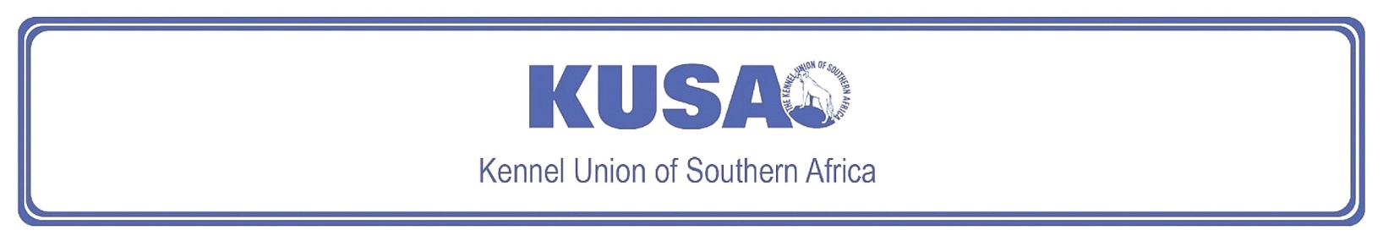
FOX TERRIER (SMOOTH)
A breed standard is the guideline which describes the ideal characteristics, temperament and appearance including the correct colour of a breed and ensures that the breed is fit for function. Absolute soundness is essential. Breeders and judges should at all times be careful to avoid obvious conditions or exaggerations which would be detrimental in any way to the health, welfare or soundness of this breed. If a feature or quality is desirable it should only be present in the right measure. However, if a dog possesses a feature, characteristic or colour described as unacceptable, it must not be rewarded in the show ring.

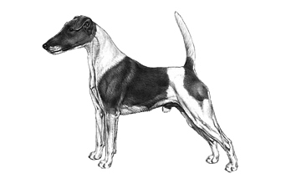
Most recent changes to this Standard have an effective date of 01/01/2017
ORIGIN | IIlustration courtesy of NKU Picture Library
Great Britain. | IIlustration courtesy of NKU Picture Library
UTILISATION | IIlustration courtesy of NKU Picture Library
Terrier. | IIlustration courtesy of NKU Picture Library
BRIEF HISTORICAL SUMMARY | IIlustration courtesy of NKU Picture Library
[ed. from FCI Breed Standard No. 12]  The Fox Terrier in both forms, Smooth and Wire, is from British origins and probably owes its existence to the same types of dog that produced both the Bull Terrier and the Black and Tan (now Manchester) Terrier. Uniformity of type was established in the late 1800s, and the original standard for the Fox Terrier was drawn up in 1876. One of the most lively and alert of Terriers, refinement to his present show excellence has not | IIlustration courtesy of NKU Picture Library
allowed him to become unsound. Capable of standing up to any amount of exercise, always ready to deal with rats, rabbits, and, of course, foxes.

GENERAL APPEARANCE
Active and lively; bone and strength in small compass; never cloddy or coarse. Neither leggy nor too short in the leg, standing like a well-made, short-backed hunter, covering a lot of ground.

CHARACTERISTICS
Alert, quick of movement, keen of expression, on tiptoe of expectation.

TEMPERAMENT
Friendly, forthcoming, and fearless.

HEAD
Skull flat, moderately narrow, gradually decreasing in width to eyes. A little stop is apparent, cheeks never full; jaws, upper and lower, strong and muscular, falling away only slightly below eyes. This portion of foreface is moderately chiselled, so as not to go down in a straight line like a wedge. Nose black.
Eyes:
Dark, moderately small, as nearly as possible circular in shape, but not prominent. Expression bright and intelligent.
Ears:
Small, V-shaped, and dropping forward close to cheek, not hanging by side of head. Fold of ear above level of skull. Leather of moderate thickness.
Mouth:
Jaws strong with a perfect, regular, and complete scissor bite, i.e. upper teeth closely overlapping lower teeth and set square to the jaws.

NECK
Clean and muscular, without throatiness, of fair length and gradually widening to shoulders.

FOREQUARTERS
Shoulders long and sloping, well laid back, fine at points, cleanly cut at withers. Legs from any angle must be straight, showing little or no appearance of an ankle in front. They should be strong in bone throughout.
BODY
Chest deep, not broad. Back short, level, and strong without slackness. Loin powerful, very slightly arched. Fore-ribs moderately sprung, back ribs deep.

HINDQUARTERS
Strong and muscular, quite free from droop or crouch; thighs long and powerful, hocks well let down, good turn of stifle.

FEET
Small, round, and compact. Soles hard and tough, toes moderately arched, and turning neither in nor out.

TAIL
Previously customarily docked.
Docked: Set-on rather high and carried gaily but not over back or curled. Of good strength.
Undocked: Set-on rather high and carried gaily but not over back. As straight as possible. Tail of moderate length to give balance to the dog.
[*refer note below]

GAIT / MOVEMENT
Fore- and hind legs carried straight forward and parallel. Elbows move perpendicular to body, working free of sides, stifles neither turning in nor out, and hocks not close. Good drive coming from well-flexing hindquarters.

COAT
Straight, flat, smooth, hard, dense, and abundant. Belly and underside of thighs not bare.

COLOUR
- White should predominate: all white, white with tan, black and tan, or black markings.
* Brindle, red, or liver markings highly undesirable.

SIZE
Height at withers:
Males: not exceeding 39cm (approx. 15”).
Females: slightly less.
Weight:
Males: 7.5 – 8kg.
Females: 7 – 7.5kg.

N.B. Male animals should have two apparently normal testicles fully descended into the scrotum. Only functionally and clinically healthy dogs, with breed typical conformation should be used for breeding.

*Regardless of the provisions of the current KUSA-adopted standard, docked or formerly docked breeds may be shown at all FCI- and KUSA-licensed shows in South Africa, whether their tails are docked or natural. Under no circumstances are Judges permitted to discriminate against exhibits on the grounds of docked or natural tails, and equal consideration for awards must be given to either.

FAULTS
Any departure from the foregoing points should be considered a fault and the seriousness with which the fault should be regarded should be in exact proportion to its degree and its effect upon the health and welfare of the dog, and on the dog’s ability to perform its traditional work.

©Copyright Kennel Club, London 09/2007 – Reprinted with permission

The publisher of this edition is the Kennel Union of Southern Africa. All rights reserved. No part of this publication may be reproduced, stored in a retrieval system or transmitted in any form, or by any means, electronic, mechanical, photocopying, recording or otherwise without permission in writing from the publisher.

 | When judging this breed at FCI International Shows, use:
 | FCI Standard No. 12: FOX TERRIER (SMOOTH)
FCI Classification: Group 3 – Terriers.
Section 1 – Large- and medium-sized Terriers .
Working trial optional.

