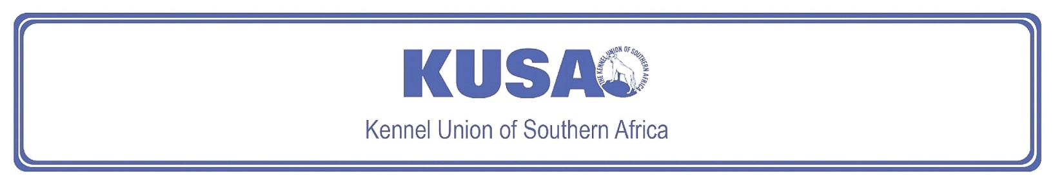
DANDIE DINMONT TERRIER
A breed standard is the guideline which describes the ideal characteristics, temperament and appearance including the correct colour of a breed and ensures that the breed is fit for function. Absolute soundness is essential. Breeders and judges should at all times be careful to avoid obvious conditions or exaggerations which would be detrimental in any way to the health, welfare or soundness of this breed. If a feature or quality is desirable it should only be present in the right measure. However, if a dog possesses a feature, characteristic or colour described as unacceptable, it must not be rewarded in the show ring.

Most recent changes to this Standard have an effective date of 01/01/2025
ORIGIN | 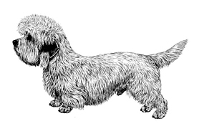  Illustration courtesy of NKU Picture Library
Great Britain.

UTILISATION
Terrier.

BRIEF HISTORICAL SUMMARY
[ed. For interest, from Wikipedia: The Dandie Dinmont Terrier]:
The Dandie Dinmont Terrier is named after a fictional character in Sir
Walter Scott's novel, “Guy Mannering”. This character, Dandie Dinmont,
is thought to be partly based on James Davidson, who is credited as the
originator of the modern breed. Davidson's dogs descended from earlier
Terrier-owning families in Northumberland. The breed is registered as a
Vulnerable Native Breed by the Kennel Club.

GENERAL APPEARANCE
Distinctive head with beautiful silky covering, with large, wise intelligent eyes offsetting long, low weaselly body. Short, strong legs; weatherproof coat.

BEHAVIOUR & TEMPERAMENT
Game, workmanlike Terrier. Independent, highly intelligent, determined, persistent, sensitive, affectionate and dignified.

HEAD
Head strongly made, large but in proportion to dog’s size, muscles showing extraordinary development, especially the maxillary.
Cranial Region:
Skull: Broad, narrowing towards eye, measuring about the same from inner corner of eye to back of skull, as from ear to ear. Forehead well domed; head covered with very soft, silky hair not confined to mere “topknot”.
Facial Region:
Nose: Black
Muzzle: In proportion to skull as three is to five. Top of muzzle has triangular bare patch pointing backwards to eyes from nose about 2,5 cm broad.
Cheeks: Gradually tapering towards deep and strongly made muzzle.
Jaws/Teeth: Jaws strong with a perfect, regular and complete scissor bite, i.e. upper teeth closely overlapping the lower teeth and set square to the jaws. Any deviation highly undesirable. Teeth very strong, especially canines which are extraordinary in size for a small dog. Canines fit well against each other, to give greatest available holding and punishing power. Inside of mouth black or dark coloured.
Eyes:
Rich dark hazel; set wide apart and low, large for a small dog, bright, full and round but not protruding.
Ears:
Pendulous, set well back, wide apart, low on skull, hanging close to cheek with very slight projection at base; broad at junction of head and tapering almost to a point, fore part of ear coming almost straight down from its junction with head to tip. Cartilage and skin of ear very thin. Length of ear, from 7 ½ -10 cm. Ears harmonise in colour with body colour. In a pepper dog, covered with soft, straight, dark hair (in some cases almost black).
In a mustard dog, hair mustard in colour, a shade darker than body but not black. Both should have a thin feather of light hair starting about 5 cm from the tip, and of nearly the same colour and texture as “topknot”, giving ear appearance of a distinct point. This may not appear until after age of two years.
NECK
Very muscular, well developed and strong, showing great power. Well set into shoulders.
BODY
Long, strong and flexible.
Back: Rather low at shoulders having slight downward curve and corresponding arch over loins, slight gradual drop from top of loin to root of tail. Backbone well muscled.
Chest: Well developed and well let down between forelegs.
Ribs: Well sprung and round.

TAIL
Rather short, from 20-25 cm, rather thick at root, getting thicker for about 10 cm and tapering off to a point.
Not twisted or curled in any way but with a curve like a scimitar, the tip when excited being in a perpendicular line with root of tail, set neither too high nor too low. When not excited carried gaily a little above body level.

LIMBS
Forequarters:
Forelegs short with immense muscular development and bone, set wide apart and chest coming well down between them. Bandy legs highly undesirable.
Shoulders: Well laid back but not heavy.
Forearm: To follow line of chest.
Hindquarters:
Hindlegs a little longer than forelegs; set rather wide apart, but not spread out in an unnatural manner.
Thighs: Well developed.
Stifles: Angulated.
Hocks: Well let down. Dewclaws, if present, customarily removed.
FEET
Forefeet: Pointing forward or slightly outward when standing.
Hindfeet: Round and well padded. Hindfeet smaller than forefeet. Nails dark but varying in shade according to colour of body. Flat or open feet highly undesirable.

GAIT / MOVEMENT
Strong, straight impulsion from rear, giving a fluent free and easy stride, reaching forward at the front. A stiff, stilted, hopping or weaving gait highly undesirable.
COAT
Hair:
Very important feature of the breed. Hair should be about 5 cm long. Double coat with a soft linty undercoat and a harder topcoat, not wiry but giving crisp feel to the hand. The coat should not “shed” down the back but should lie in pencils caused by the harder hair coming through the softer undercoat. The forelegs have feather about 5 cm long. Upper side of tail covered with wiry hair, underside not so wiry with neat feathering of softer hair.
Colour:
Pepper or mustard.
- Pepper: Ranges from dark bluish black to light silvery grey, intermediate shades preferred. Body colour coming well down shoulder and hips, gradually merging into colour of legs and feet which varies according to body colour from rich tan to pale fawn. Profuse silvery white “topknot”.
- Mustard: Varies from reddish brown to pale fawn. Profuse creamy white “topknot”, legs and feet of a darker shade than head.
In both colours feather on forelegs rather lighter than hair on fore part of leg. Some white hair on chest and white nails permissible. White feet undesirable. Hair on underside of tail lighter than on upperside, which should be darker colour than body.
WEIGHT
8-11 kg for dogs in good working condition. The lower weights preferred.

N.B. Male animals should have two apparently normal testicles fully descended into the scrotum. Only functionally and clinically healthy dogs, with breed typical conformation should be used for breeding.

FAULTS
Any departure from the foregoing points should be considered a fault and the seriousness with which the fault should be regarded should be in exact proportion to its degree and its effect upon the health and welfare of the dog, and on the dog’s ability to perform its traditional work.
Disqualifying faults:
• Aggressive or overly shy dogs.
• Any dog clearly showing physical or behavioural abnormalities.

©Copyright FCI – Reprinted with permission

The publisher of this edition is the Kennel Union of Southern Africa. All rights reserved. No part of this publication may be reproduced, stored in a retrieval system or transmitted in any form, or by any means, electronic, mechanical, photocopying, recording or otherwise without permission in writing from the publisher.

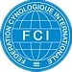 | FCI Standard No. 168: DANDIE DINMONT TERRIER
FCI Classification: Group 3 – Terriers.
Section 2 – Small-sized Terriers .
Without working trial.

