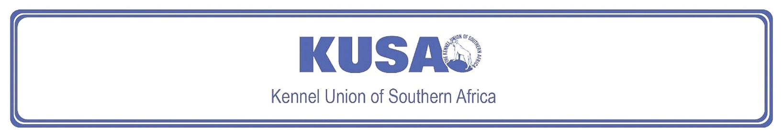
BORDER TERRIER
A breed standard is the guideline which describes the ideal characteristics, temperament and appearance including the correct colour of a breed and ensures that the breed is fit for function. Absolute soundness is essential. Breeders and judges should at all times be careful to avoid obvious conditions or exaggerations which would be detrimental in any way to the health, welfare or soundness of this breed. If a feature or quality is desirable it should only be present in the right measure. However, if a dog possesses a feature, characteristic or colour described as unacceptable, it must not be rewarded in the show ring.
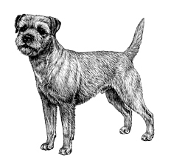
Most recent changes to this Standard have an effective date of 01/01/2017
ORIGIN | IIlustration courtesy of NKU Picture Library
Great Britain. | IIlustration courtesy of NKU Picture Library
UTILISATION | IIlustration courtesy of NKU Picture Library
Terrier. | IIlustration courtesy of NKU Picture Library
BRIEF HISTORICAL SUMMARY | IIlustration courtesy of NKU Picture Library
[ed. For interest, from Wikipedia: The Border Terrier]:  The Border Terrier is a British breed that originates from the area of the Anglo-Scottish border, and shares ancestry with the Dandie Dinmont and the Bedlington Terrier from the same area. The dogs were traditionally used in fox-hunting, and worked with the Border Hunt in Northumberland. | IIlustration courtesy of NKU Picture Library
GENERAL APPEARANCE | IIlustration courtesy of NKU Picture Library
Essentially a working Terrier. | IIlustration courtesy of NKU Picture Library
CHARACTERISTICS
Capable of following a horse, combining activity with gameness.

TEMPERAMENT
Active and game, as previously stated.

HEAD
Head like that of an otter: moderately broad in skull, with short, strong muzzle. Black nose preferable, liver- or flesh-coloured nose not a serious fault.
Eyes:
Dark with a keen expression.
Ears:
Small, V-shaped; of moderate thickness, and dropping forward close to the cheek.
Mouth:
Scissor bite, i.e. upper teeth closely overlapping lower teeth and set square to the jaws. Level bite acceptable. Undershot or overshot a major fault and highly undesirable.

NECK
Of moderate length.

FOREQUARTERS
Forelegs straight, not too heavy in bone.

BODY
Deep, narrow, fairly long. Ribs carried well back, but not oversprung, as the Terrier should be capable of being spanned by both hands behind the shoulder. Loins strong.

HINDQUARTERS
Racy.

FEET
Small with thick pads.

TAIL
Moderately short; fairly thick at base, then tapering. Set high, carried gaily, but not curled over back.

GAIT / MOVEMENT
Has the soundness to follow a horse.

COAT
Harsh and dense; with close undercoat. Skin must be thick.

COLOUR
- Red, wheaten, grizzle and tan, or blue and tan.

SIZE
Weight:
Males: 6 – 7kg.
Females: 5 – 6.5kg.

N.B. Male animals should have two apparently normal testicles fully descended into the scrotum. Only functionally and clinically healthy dogs, with breed typical conformation should be used for breeding.

FAULTS
Any departure from the foregoing points should be considered a fault and the seriousness with which the fault should be regarded should be in exact proportion to its degree and its effect upon the health and welfare of the dog, and on the dog’s ability to perform its traditional work.

©Copyright Kennel Club, London 09/2007 – Reprinted with permission

The publisher of this edition is the Kennel Union of Southern Africa. All rights reserved. No part of this publication may be reproduced, stored in a retrieval system or transmitted in any form, or by any means, electronic, mechanical, photocopying, recording or otherwise without permission in writing from the publisher.

 | When judging this breed at FCI International Shows, use:
 | FCI Standard No. 10: BORDER TERRIER
FCI Classification: Group 3 – Terriers.
Section 1 – Large- and medium-sized Terriers .
Without working trial.

