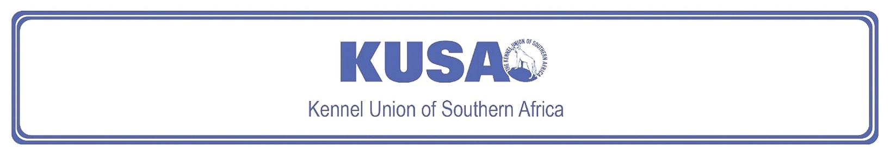
SEALYHAM TERRIER
A Breed Standard is the guideline that describes the ideal characteristics, temperament, and appearance of a breed, and ensures that the breed is fit for function, with soundness essential. Breeders and Judges should, at all times, be mindful of features that could be detrimental in any way to the health, welfare, or soundness of this breed.

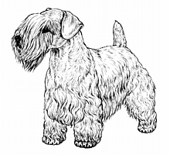
Most recent changes to this Standard have an effective date of 01/01/2018
ORIGIN | IIlustration courtesy of NKU Picture Library
Great Britain. | IIlustration courtesy of NKU Picture Library
UTILISATION | IIlustration courtesy of NKU Picture Library
Terrier. | IIlustration courtesy of NKU Picture Library
BRIEF HISTORICAL SUMMARY | IIlustration courtesy of NKU Picture Library
[ed. For interest, from Wikipedia: The Sealyham Terrier]:  The Sealyham Terrier is a rare Welsh breed that originated in Wales as a working dog. It was developed in the mid-to-late-19th century by Capt. John Edwardes at Sealyham House, Pembrokeshire. Following the First World War, it surged in popularity and was associated with Hollywood stars and members of the British Royal Family. Its numbers have dropped significantly since then, with the breed listed as a Vulnerable Native Breed | IIlustration courtesy of NKU Picture Library
by the Kennel Club; an all-time low was recorded in 2008 when only 43 puppies were registered in the United Kingdom. This decline has been blamed on an influx of foreign and designer breeds, and the Sealyham's reduced usefulness as a working dog.

GENERAL APPEARANCE
Free-moving, active, balanced, and of great substance in small compass. General outline oblong, not square.

CHARACTERISTICS
Sturdy, game, and workmanlike.

TEMPERAMENT
Alert and fearless, but of friendly disposition.

HEAD
Skull slightly domed and wide between ears. Cheek bones not prominent. Punishing square jaw, powerful and long. Nose black.
Eyes:
Dark, well-set, round, of medium size. Dark, pigmented eye-rims preferred, but unpigmented tolerated.
Ears:
Medium-sized, slightly rounded at tip, and carried at side of cheek.
Mouth:
Teeth level and strong with canines fitting well into each other and long for size of dog. Jaws strong with regular scissor bite, i.e. upper teeth closely overlapping lower teeth and set square to the jaws.

NECK
Fairly long, thick, and muscular, on well-laid shoulders.

FOREQUARTERS
Forelegs short, strong, and as straight as possible, consistent with chest being well let down. Point of shoulder in line with point of elbow, which should be close to side of chest.

BODY
Medium in length, level, and flexible, with ribs well-sprung. Chest broad and deep, well let down between forelegs.
HINDQUARTERS
Notably powerful for size of dog. Thighs deep and muscular with well-bent stifle. Hocks strong, well-bent and parallel to each other.

FEET
Round and cat-like with thick pads. Feet pointing directly forward.

TAIL
Previously customarily docked.
Docked: Medium length. Thick with a rounded tip. Set in line with back and carried erect. Quarters should protrude beyond set of tail.
Undocked: Medium length of tail to give a general balance to the dog. Thick at root and tapering towards tip. Ideally carried erect, but not excessively over the back, and with no curl or twist. Quarters should protrude beyond set of tail.
[*refer note below]

GAIT / MOVEMENT
Brisk and vigorous with plenty of drive.

COAT
Long, hard, and wiry topcoat with weather-resistant undercoat.

COLOUR
- All white or white with lemon, brown, blue, or badger-pied markings on head and ears.
* Much black and heavy ticking undesirable.

SIZE
Height at withers:
Should not exceed 31cm (approx.12”).
Weight:
Males: approx. 9kg.
Females: approx. 8kg.
General conformation, overall balance, type, and substance are main criteria.

N.B. Male animals should have two apparently normal testicles fully descended into the scrotum. Only functionally and clinically healthy dogs, with breed typical conformation should be used for breeding.

*Regardless of the provisions of the current KUSA-adopted standard, docked or formerly docked breeds may be shown at all FCI- and KUSA-licensed shows in South Africa, whether their tails are docked or natural. Under no circumstances are Judges permitted to discriminate against exhibits on the grounds of docked or natural tails, and equal consideration for awards must be given to either.

FAULTS
Any departure from the foregoing points should be considered a fault and the seriousness with which the fault should be regarded should be in exact proportion to its degree and its effect upon the health and welfare of the dog, and on the dog’s ability to perform its traditional work.

©Copyright Kennel Club, London 09/2007 – Reprinted with permission

The publisher of this edition is the Kennel Union of Southern Africa. All rights reserved. No part of this publication may be reproduced, stored in a retrieval system or transmitted in any form, or by any means, electronic, mechanical, photocopying, recording or otherwise without permission in writing from the publisher.
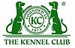 | When judging this breed at FCI International Shows, use:
 | FCI Standard No. 74: SEALYHAM TERRIER
FCI Classification: Group 3 – Terriers.
Section 2 – Small-sized Terriers .
Without working trial.

