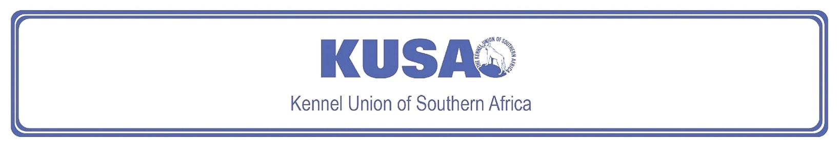
NORWICH TERRIER
A Breed Standard is the guideline that describes the ideal characteristics, temperament, and appearance of a breed, and ensures that the breed is fit for function, with soundness essential. Breeders and Judges should, at all times, be mindful of features that could be detrimental in any way to the health, welfare, or soundness of this breed.
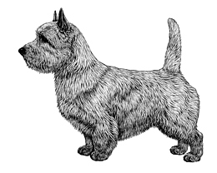
Most recent changes to this Standard have an effective date of 01/01/2018
ORIGIN | IIlustration courtesy of NKU Picture Library
Great Britain. | IIlustration courtesy of NKU Picture Library
UTILISATION | IIlustration courtesy of NKU Picture Library
Terrier. | IIlustration courtesy of NKU Picture Library
BRIEF HISTORICAL SUMMARY | IIlustration courtesy of NKU Picture Library
[ed. from FCI Breed Standard No. 72]  The Norwich and Norfolk Terrier take their names, obviously, from the county and the city, though turning the clock back to the early and mid-1800s, there was no such distinction, this being just a general farm dog. Glen of Imaals, red Cairn Terriers, and Dandie Dinmonts are among the breeds behind these East Anglian Terriers and from the resultant red progeny emerged the present Norwich and Norfolk Terrier. The typical | IIlustration courtesy of NKU Picture Library
short-legged Terrier with a sound, compact body has been used not only on fox and badger, but on rats as well. He has a delightful disposition, is totally fearless but is not one to start a fight. As a worker he does not give up in the face of a fierce adversary underground, and his standard’s reference to the acceptability of “honourable scars from fair wear and tear” is a good indication of the dog’s type. The Norwich Terrier was accepted on the Kennel Club Breed Register in 1932, and was known as the drop-eared Norwich Terrier (now known as the Norfolk Terrier) and prick-eared Norwich Terrier. The breeds were separated in 1964 and the prick-eared variety gained the name Norwich Terrier.

GENERAL APPEARANCE
Small, low, keen dog, compact, and strong with good substance and bone. Honourable scars from fair wear and tear not to be unduly penalised.

CHARACTERISTICS
One of the smallest of the Terriers. Lovable disposition, not quarrelsome, tremendously active with hardy constitution.

TEMPERAMENT
Gay and fearless.

HEAD
Skull broad and slightly rounded, with good width between ears. Well-defined stop. Muzzle wedge-shaped and strong. Ratio of muzzle length to skull length is 2 : 3.
Eyes:
Relatively small, oval-shaped, dark, full of expression, bright and keen.
Ears:
Erect, set well apart on top of skull. Medium size with pointed tips. Perfectly erect when aroused, can be laid back when not at attention.
Mouth:
Tight-lipped, jaws clean and strong. Rather large, strong teeth with perfect, regular scissor bite, i.e. upper teeth closely overlapping lower teeth and set square to the jaws.

NECK
Strong, of good length, commensurate with correct overall balance, flowing into well-laid shoulders.

FOREQUARTERS
Legs short, powerful, and straight; elbows close to body. Pasterns firm and upright.

BODY
Short back, compact with good depth. Rib cage long, and well-sprung, with short loin. Level topline.

HINDQUARTERS
Broad, strong, and muscular, well-turned stifle. Low-set hock with great propulsion.

FEET
Rounded, well-padded and cat-like. Pointing straight forward standing and moving.

TAIL
Docking previously optional.
Docked: Medium docked. Set high, completing perfectly level topline. Carried erect.
Undocked: Tail of moderate length to give a general balance to dog, thick at root and tapering towards tip, as straight as possible, carried jauntily, not excessively gay, completing perfectly level topline.
[*refer note below]

GAIT / MOVEMENT
Forelegs should move straight forward when travelling; hind legs follow in their track; hocks parallel and flexing to show pads.

COAT
Hard, wiry, straight, lying close to body, thick undercoat. Longer and rougher on neck forming a ruff to frame face. Hair on head and ears short and smooth, except for slight whiskers and eyebrows.

COLOUR
- All shades of red, wheaten, black and tan, or grizzle.
* White marks or patches are undesirable.

SIZE
Height at withers:
25cm (approx. 10”)

N.B. Male animals should have two apparently normal testicles fully descended into the scrotum. Only functionally and clinically healthy dogs, with breed typical conformation should be used for breeding.

*Regardless of the provisions of the current KUSA-adopted standard, docked or formerly docked breeds may be shown at all FCI- and KUSA-licensed shows in South Africa, whether their tails are docked or natural. Under no circumstances are Judges permitted to discriminate against exhibits on the grounds of docked or natural tails, and equal consideration for awards must be given to either.

FAULTS
Any departure from the foregoing points should be considered a fault and the seriousness with which the fault should be regarded should be in exact proportion to its degree and its effect upon the health and welfare of the dog, and on the dog’s ability to perform its traditional work.

©Copyright Kennel Club, London 09/2007 – Reprinted with permission

The publisher of this edition is the Kennel Union of Southern Africa. All rights reserved. No part of this publication may be reproduced, stored in a retrieval system or transmitted in any form, or by any means, electronic, mechanical, photocopying, recording or otherwise without permission in writing from the publisher.
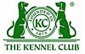 | When judging this breed at FCI International Shows, use:
 | FCI Standard No. 72: NORWICH TERRIER
FCI Classification: Group 3 – Terriers.
Section 2 – Small-sized Terriers .
Without working trial.

