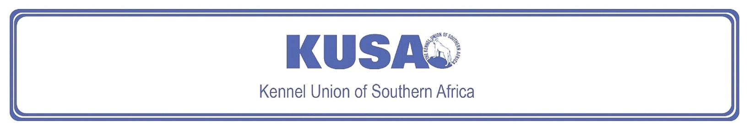
DANDIE DINMONT TERRIER
A Breed Standard is the guideline that describes the ideal characteristics, temperament, and appearance of a breed, and ensures that the breed is fit for function, with soundness essential. Breeders and Judges should, at all times, be mindful of features that could be detrimental in any way to the health, welfare, or soundness of this breed.

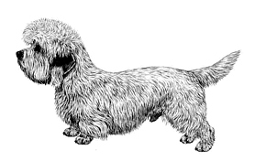
Most recent changes to this Standard have an effective date of 01/01/2018
ORIGIN | IIlustration courtesy of NKU Picture Library
Great Britain. | IIlustration courtesy of NKU Picture Library
UTILISATION | IIlustration courtesy of NKU Picture Library
Terrier. | IIlustration courtesy of NKU Picture Library
BRIEF HISTORICAL SUMMARY | IIlustration courtesy of NKU Picture Library
[ed. For interest, from Wikipedia: The Dandie Dinmont Terrier]:  The Dandie Dinmont Terrier is named after a fictional character in Sir Walter Scott's novel, “Guy Mannering”. This character, Dandie Dinmont, is thought to be partly based on James Davidson, who is credited as the originator of the modern breed. Davidson's dogs descended from earlier Terrier-owning families in Northumberland. The breed is registered as a Vulnerable Native Breed by the Kennel Club. | IIlustration courtesy of NKU Picture Library
GENERAL APPEARANCE
Distinctive head with beautiful silky covering, with large, wise, intelligent eyes, offsetting long, low, weaselly body. Short, strong legs; weatherproof coat.

CHARACTERISTICS
Game, workmanlike Terrier.

TEMPERAMENT
Independent, highly intelligent, determined, persistent, sensitive, affectionate, and dignified.

HEAD
Head strongly made; large, but in proportion to dog's size, muscles showing extraordinary development, especially the maxillary. Skull broad, narrowing towards eye, measuring about the same from inner corner of eye to back of skull as from ear to ear. Forehead well-domed; head covered with very soft, silky hair not confined to mere topknot. Cheeks gradually tapering towards deep and strongly made muzzle. Muzzle in proportion to skull as three is to five. Top of muzzle has triangular bare patch pointing backwards to eyes from nose about 2.5cm (approx. 1”) broad. Nose black.
Eyes:
Rich dark hazel; set wide apart and low, large for a small dog, bright, full, and round but not protruding.
Ears:
Pendulous, set well back, wide apart, low on skull, hanging close to cheeks with very slight projection at base; broad at junction of head and tapering almost to a point, fore part of ear coming almost straight down from its junction with head to tip. Cartilage and skin of ear very thin. Length of ear, from 7.5cm – 10cm (approx. 3” – 4”). Ears harmonise in colour with body colour. In a pepper dog, covered with soft, straight, dark hair (in some cases almost black). In a mustard dog, hair mustard in colour, a shade darker than body but not black. Both should have a thin feather of light hair starting about 5cm (approx. 2”) from the tip, and of nearly the same colour and texture as topknot, giving ear the appearance of a distinct point. This may not appear until after the age of 2 years.
Mouth:
Jaws strong with a perfect, regular, and complete scissor bite, i.e. upper teeth closely overlapping lower teeth and set square to the jaws. Any deviation highly undesirable. Teeth very strong, especially canines, which are extraordinary in size for a small dog. Canines fit well against each other to give greatest available holding and punishing power. Inside of mouth black or dark-coloured.

NECK
Very muscular, well-developed, and strong, showing great power. Well set into shoulders.

FOREQUARTERS
Shoulders well laid back but not heavy. Forelegs short with immense muscular development and bone, set wide apart and chest coming well down between them. Forearms to follow line of chest with feet pointing forward or slightly outward when standing. Bandy legs highly undesirable.

BODY
Long, strong, and flexible; ribs well-sprung and round, chest well-developed and well let down between forelegs; back rather low at shoulders having slight downward curve and corresponding arch over loins, slight gradual drop from top of loin to root of tail. Backbone well-muscled.

HINDQUARTERS
Hind legs a little longer than forelegs; set rather wide apart, but not spread out in an unnatural manner; thighs well-developed. Stifles angulated, hocks well let down. Dewclaws, if present, customarily removed.

FEET
Round and well-padded. Hind feet smaller than forefeet. Nails dark but varying in shade according to colour of body. Flat or open feet highly undesirable.

TAIL
Rather short, 20cm – 25cm (approx. 7½” – 9½”), rather thick at root, getting thicker for about 10cm (approx. 4”), and tapering off to a point. Not twisted or curled in any way, but with a curve like a scimitar, the tip, when excited, being in a perpendicular line with root of tail, set neither too high nor too low. When not excited, carried gaily a little above body level.

GAIT / MOVEMENT
Strong, straight impulsion from rear, giving a fluent, free, and easy stride, reaching forward at the front. A stiff, stilted, hopping, or weaving gait highly undesirable.

COAT
Very important feature of the breed. Hair should be about 5cm (approx. 2”) long. Double coat with a soft, linty undercoat and a harder topcoat, not wiry but giving crisp feel to the hand. The coat should not shed down the back, but should lie in ‘pencils’ caused by the harder hair coming through the softer undercoat. The forelegs have feather, about 5cm (approx. 2”) long. Upper side of tail covered with wiry hair, underside not so wiry with neat feathering of softer hair.

COLOUR
- Pepper or mustard.
  - Pepper: Ranges from dark bluish black to light silvery grey, intermediate shades preferred. Body colour coming well down shoulder and hips gradually merging into colour of legs and feet which varies according to body colour from rich tan to pale fawn. Profuse silvery white topknot.
  - Mustard: Varies from reddish brown to pale fawn. Profuse creamy white topknot, legs and feet of darker shade than head.
* In both colours, feather on forelegs rather lighter than hair on forepart of leg.
* Some white hair on chest and white nails permissible.
* White feet undesirable.
* Hair on underside of tail lighter than on upper side which should be darker colour than body.

SIZE
Height at withers:
20cm – 28cm (approx. 7” – 11”).
Length from withers to root of tail should not be more than twice the height, but preferably 2.5cm – 5cm less.
Weight:
8kg – 11kg for dogs in good working condition.
The lower weights preferred.

N.B. Male animals should have two apparently normal testicles fully descended into the scrotum. Only functionally and clinically healthy dogs, with breed typical conformation should be used for breeding.

FAULTS
Any departure from the foregoing points should be considered a fault and the seriousness with which the fault should be regarded should be in exact proportion to its degree and its effect upon the health and welfare of the dog, and on the dog’s ability to perform its traditional work.

©Copyright Kennel Club, London 09/2007 – Reprinted with permission

The publisher of this edition is the Kennel Union of Southern Africa. All rights reserved. No part of this publication may be reproduced, stored in a retrieval system or transmitted in any form, or by any means, electronic, mechanical, photocopying, recording or otherwise without permission in writing from the publisher.
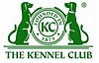 | When judging this breed at FCI International Shows, use:
 | FCI Standard No. 168: DANDIE DINMONT TERRIER
FCI Classification: Group 3 – Terriers.
Section 2 – Small-sized Terriers .
Without working trial.

