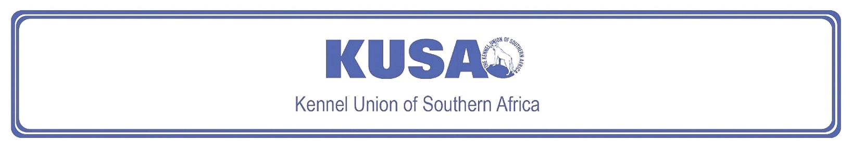
AMERICAN STAFFORDSHIRE TERRIER
A breed standard is the guideline which describes the ideal characteristics, temperament and appearance including the correct colour of a breed and ensures that the breed is fit for function. Absolute soundness is essential. Breeders and judges should at all times be careful to avoid obvious conditions or exaggerations which would be detrimental in any way to the health, welfare or soundness of this breed. If a feature or quality is desirable it should only be present in the right measure. However, if a dog possesses a feature, characteristic or colour described as unacceptable, it must not be rewarded in the show ring.

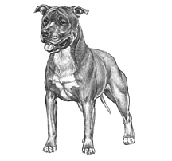
Most recent changes to this Standard have an effective date of 01/05/2003
ORIGIN | IIlustration courtesy of NKU Picture Library
United States of America. | IIlustration courtesy of NKU Picture Library
UTILISATION | IIlustration courtesy of NKU Picture Library
Terrier. | IIlustration courtesy of NKU Picture Library
BRIEF HISTORICAL SUMMARY | IIlustration courtesy of NKU Picture Library
[ed. For interest, from Wikipedia: The American Staffordshire Terrier]:  Some varieties of Bull-and-Terrier from the British Isles began to find their way into America as early as 1850. The name ‘Staffordshire Terrier’ was approved because the ancestors of the breed originally came from Staffordshire, England. The name of the breed was revised in 1969 to American Staffordshire Terrier, to distinguish it from the British Staffordshire Bull Terrier, which had, by then, completely different breed type. Breed selection was based entirely on conformation and | IIlustration courtesy of NKU Picture Library
established breed standards that, for decades, have transformed the American Staffordshire Terrier into a much different breed from the American Pit Bull Terrier.

GENERAL IMPRESSION
The American Staffordshire Terrier should give the impression of great strength for his size, a well put together dog; muscular, but agile and graceful, keenly alive to his surroundings. He should be stocky, not long-legged or racy in outline. His courage is proverbial.

HEAD
Medium length, deep through, broad skull, very pronounced cheek muscles, distinct stop; and ears are set high.
Ears:
Cropped or uncropped, the latter preferred.
Uncropped ears should be short and held rose or half-prick. Full drop to be penalised.
[*refer note below]
Eyes:
Dark and round, low down in skull and set far apart. No pink eyelids.
Muzzle:
Medium length, rounded on upper side to fall away abruptly below eyes. Jaws well-defined. Underjaw to be strong and have biting power. Lips close and even, no looseness. Upper teeth to meet tightly outside lower teeth in front.
Nose:
Definitely black.

NECK
Heavy, slightly arched, tapering from shoulders to back of skull. No looseness of skin. Medium length.

BODY
Shoulders:
Strong and muscular with blades wide and sloping

Back:
Fairly short. Slight sloping from withers to rump with gentle, short slope at rump to base of tail. Loins slightly tucked.

Body:
Well-sprung ribs, deep in rear. All ribs close together. Forelegs set rather wide apart to permit chest development. Chest deep and broad.

TAIL
Short in comparison to size, low set, tapering to a fine point; not curled or held over back. Not docked.

LEGS
The front legs should be straight, large, round-boned; pastern upright. No semblance of bend in front. Hindquarters well-muscled, let down at hocks, turning neither in nor out. Feet of moderate size, well-arched and compact.

GAIT
Must be springy, but without roll or pace.

COAT
Short, close, stiff to the touch, and glossy.

COLOUR
Any colour, solid, parti-colour, or patched is permissible, but all-white, more than 80% white, black and tan, and liver not to be encouraged.

SIZE
Height at withers:
Males: approx. 46cm – 48cm (approx. 18” – 19”)
Females: approx. 43cm – 46cm (approx. 17” – 18”) is preferable.
Height and weight should be in proportion.

N.B. Male animals should have two apparently normal testicles fully descended into the scrotum. Only functionally and clinically healthy dogs, with breed typical conformation should be used for breeding.

Note: Cropped ears – KUSA Schedule 2 Regulation 7:
“Any dog with cropped ears born within the jurisdiction of the KUSA, imported into it and cropped within it, shall not be registered or recorded by the Kennel Union, and if any such dog is registered or recorded in contravention of this Regulation, upon discovery, its registration or recording shall be cancelled.
7.1. Any dog with ears cropped before importation into the KUSA area of jurisdiction is not eligible for competition at any Kennel Union event.”

FAULTS
Any departure from the foregoing points should be considered a fault and the seriousness with which the fault should be regarded should be in exact proportion to its degree and its effect upon the health and welfare of the dog, and on the dog’s ability to perform its traditional work.

Faults to be penalised are:
- Dudley nose.
- Light or pink eyes.
- Tail too long or badly carried.
- Undershot or overshot mouth.

©Copyright AKC – Reprinted with permission

The publisher of this edition is the Kennel Union of Southern Africa. All rights reserved. No part of this publication may be reproduced, stored in a retrieval system or transmitted in any form, or by any means, electronic, mechanical, photocopying, recording or otherwise without permission in writing from the publisher.
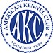
  When judging this breed at FCI International Shows, use:
  FCI Standard No 286: AMERICAN STAFFORDSHIRE TERRIER
  FCI Classification: Group 3 – Terriers.
  Section 3 – Bull-type Terriers.
  Without working trial

