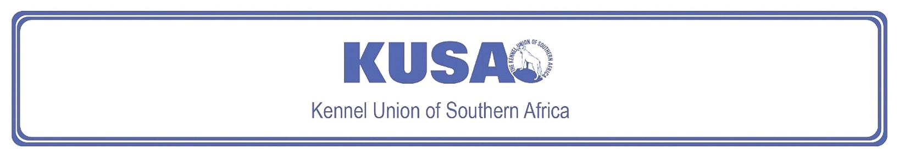
AIREDALE TERRIER
A breed standard is the guideline which describes the ideal characteristics, temperament and appearance including the correct colour of a breed and ensures that the breed is fit for function. Absolute soundness is essential. Breeders and judges should at all times be careful to avoid obvious conditions or exaggerations which would be detrimental in any way to the health, welfare or soundness of this breed. If a feature or quality is desirable it should only be present in the right measure. However, if a dog possesses a feature, characteristic or colour described as unacceptable, it must not be rewarded in the show ring.

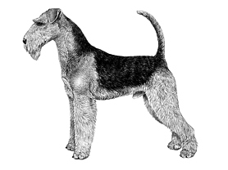
Most recent changes to this Standard have an effective date of 01/01/2021
ORIGIN | IIlustration courtesy of NKU Picture Library
Great Britain. | IIlustration courtesy of NKU Picture Library
UTILISATION | IIlustration courtesy of NKU Picture Library
Terrier. | IIlustration courtesy of NKU Picture Library
BRIEF HISTORICAL SUMMARY | IIlustration courtesy of NKU Picture Library
[ed. from FCI Breed Standard No. 7]  The Airedale Terrier is a native of Great Britain, from the county of Yorkshire, at which, it is reputed, the Airedale Show gave the breed its name. Many ‘Waterside Terriers’ from the valleys of the rivers, Wharfe, Calder, and Aire, were exhibited at this show, making up a large entry. He is the largest of all the Terrier breeds, and encompasses all the  characteristics of this group of dogs. He is also known as the King of | IIlustration courtesy of NKU Picture Library
Terriers. The Airedale Terrier has remarkable scenting powers and has been used in Africa, India, and Canada for tracking; has aided the Red Cross in times of war, and has seen service with the police and in the armed forces of both Britain and Russia.

GENERAL APPEARANCE
Largest of the Terriers; a muscular, active, fairly cobby dog, without suspicion of legginess or undue length of body.

CHARACTERISTICS
Keen of expression, quick of movement, on the tiptoe of expectation at any movement. Character denoted and shown by expression of eyes, and by carriage of ears and erect tail.

TEMPERAMENT
Outgoing and confident, friendly, courageous, and intelligent. Alert at all times; not aggressive, but fearless.

HEAD
Skull long and flat, not too broad between ears, and narrowing slightly to eyes. Well-balanced, with no apparent difference in length between skull and foreface. Free from wrinkles, with stop hardly visible; cheeks level and free from fullness. Foreface well-filled up before eyes, not dish-faced or falling away quickly below eyes, but a delicate chiselling prevents appearance of wedginess or plainness. Upper and lower jaws deep, powerful, strong, and muscular, as strength of foreface is greatly desired. No excess development of the jaws, to give a rounded or bulging appearance to the cheeks, as ‘cheekiness’ is undesirable. Lips tight, nose black.
Eyes:
Dark in colour, relatively small, not prominent, full of Terrier expression, keenness, and intelligence. Light or bold eye highly undesirable.
Ears:
V-shaped with a side carriage; small, but not out of proportion to size of dog. Topline of folded ear slightly above level of skull. Pendulous ears, or ears set too high, undesirable.
Mouth:
Teeth strong. Jaws strong. Scissor bite, i.e. upper teeth closely overlapping lower teeth and set square to the jaws preferable, but vice-like bite acceptable. An overshot or undershot mouth undesirable.

NECK
Clean, muscular, of moderate length and thickness, gradually widening towards shoulders, and free from throatiness.

FOREQUARTERS
Shoulders long, well laid back, sloping obliquely, shoulder blades flat. Forelegs perfectly straight, with good bone. Elbows perpendicular to body, working free of sides.

BODY
Back short, strong, straight, and level, showing no slackness. Loins muscular. Ribs well-sprung. In short-coupled and well ribbed up dogs, there is little space between ribs and hips. When dog is long in couplings some slackness will be shown here. Chest deep (i.e. approximately level with elbows) but not broad.

HINDQUARTERS
Thighs long and powerful with muscular second thigh, stifles well-bent, turned neither in nor out. Hocks well let down, parallel with each other when viewed from behind.

FEET
Small, round, compact, with a good depth of pad, well-cushioned, and toes moderately arched, turning neither in nor out.

TAIL
Previously customarily docked.
Docked or undocked, the tail is set on high and carried gaily. Good strength and substance.
[*refer note below]

GAIT / MOVEMENT
Legs carried straight forward. Forelegs move freely, parallel to the sides. When approaching, forelegs should form a continuation of the straight line of the front, feet being same distance apart as elbows. Propulsive power is furnished by hind legs.

COAT
Hard, dense, and wiry, not so long as to appear ragged. Lying straight and close, covering body and legs; outercoat hard, wiry, and stiff, undercoat shorter and softer. Hardest coats are crinkling or just slightly waved; curly or soft coat highly undesirable.

COLOUR
- Body saddle black or grizzle as is top of the neck and top surface of tail. All other parts tan.
* Ears often a darker tan, and shading may occur round neck and side of skull.
* A few white hairs between forelegs acceptable.

SIZE
Height at withers:
Males: 58cm – 61cm (approx. 23” – 24”).
Females: 56cm – 59cm (approx. 22” – 23”).

N.B. Male animals should have two apparently normal testicles fully descended into the scrotum. Only functionally and clinically healthy dogs, with breed typical conformation should be used for breeding.

*Regardless of the provisions of the current KUSA-adopted standard, docked or formerly docked breeds may be shown at all FCI- and KUSA-licensed shows in South Africa, whether their tails are docked or natural. Under no circumstances are Judges permitted to discriminate against exhibits on the grounds of docked or natural tails, and equal consideration for awards must be given to either.

FAULTS
Any departure from the foregoing points should be considered a fault and the seriousness with which the fault should be regarded should be in exact proportion to its degree and its effect upon the health and welfare of the dog, and on the dog’s ability to perform its traditional work.

©Copyright Kennel Club, London 09/2007 – Reprinted with permission

The publisher of this edition is the Kennel Union of Southern Africa. All rights reserved. No part of this publication may be reproduced, stored in a retrieval system or transmitted in any form, or by any means, electronic, mechanical, photocopying, recording or otherwise without permission in writing from the publisher.

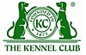 | When judging this breed at FCI International Shows, use:
 | FCI Standard No. 7: AIREDALE TERRIER
FCI Classification: Group 3 – Terriers.
Section 1 – Large- and medium-sized Terriers .
Working trial optional.

