KUSA
Kennel Union of Southern Africa

CANDIDATE’S OPEN-BOOK WORKSHEET

CANDIDATE: | DATE:
ASSESSOR:
APPROVED / NOT YET APPROVED:

PART 2
CANINE PHYSIOLOGY

This workbook contains exercises, the answers to which you will find in your Study Guide: Canine Phyiology (presented on the KUSA website in 6 parts for easy downloading). The purpose of this workbook is to serve as an aid to your studies. It is suggested that you first read through your study material in order to gain a broad understanding of the content. While the content is still fresh in your mind, start working through the worksheets. Try to stay fully involved in your work because that which you do practically is a lot clearer to remember than that which you simply read.

Before you start, save this MS Word document in a suitable folder on your computer by adding your name to the title. [Open-book Workbook – Part 1 – John Smith.docx] (or .doc). Please do not save the document as a pdf or any other type of file format.

Take care to follow all the instructions in each exercise. You will need to either type your answer in the provided space, or cut and paste the given symbol where requested. If you have difficulty working with MS Word, please feel free to contact your assigned Assessor so that solutions (or lessons) can be offered. It is a good idea, if not already so, that you become reasonably proficient in the MS Word programme since it is the one you will be expected to use for most of your documentation going forward.

When done, you need to forward both Parts 1 & 2 to your assigned Assessor for marking. You will be required to earn 100% in order to gain examination entrance. Why such a high pass mark?.... well, because the answers are all in front of you, so it ought to be easy peasy to transfer them….. once you have found them!

When it comes time to start studying for your exam, make notes as you work and find keywords that you need to memorise. Use mnemonics and mind maps to help you study. You must study the whole content in the study guide because the examination covers all the content. See the study guide, “How to Prepare for the Examinations” for some valuable guidelines on what to expect and how to brush up your study skills.
Some of these labels are correct, some are not!

Where the label is correct, simply copy and paste this next to the number. If the label is incorrect, type in the correct term next to the number.

1. |  | 11. |  | 21. |  | 31.
2. |  | 12. |  | 22. |  | 32.
3. |  | 13. |  | 23. |  | 33.
4. |  | 14. |  | 24. |  | 34.
5. |  | 15. |  | 25. |  | 35.
6. |  | 16. |  | 26. |  | 36.
7. |  | 17. |  | 27. |  | 37.
8. |  | 18. |  | 28. |  | 38.
9. |  | 19. |  | 29. |  | 39.
10. |  | 20. |  | 30. |  | 40.
Identify the coat textures
Type your answer in the spaces provided.

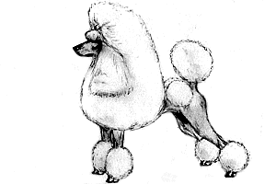 | 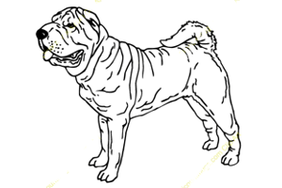 | 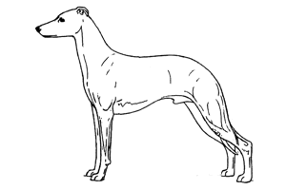
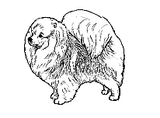 | 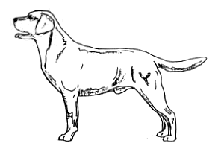 | 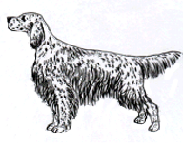
Identify the coat patterns
Type your answer in the spaces provided.

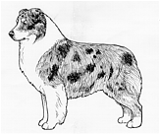 | 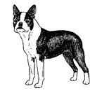 | 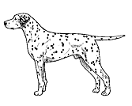
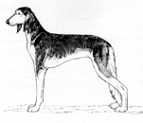 | 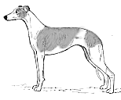 | 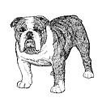

What is the name given to the unique coat distributions of our  National Dog?  …… …. and ….. …. | 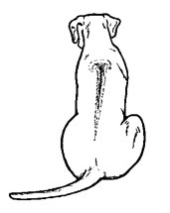
A few more “quickie” coat questions
Type your answer in the spaces provided.

What is bloom in a coat? | Which two types of coat will you find in a double coat? | Coat functionality refers to…?

Why is correct colour essential in some breeds? | What is one of the traditional reasons Rough Collies were bred to have a mane of hair? | What colour is Blenheim?

Where will you find the points on a black and tan dog, eg. a Dobermann? | Which breed has bracelets when shown in a traditional clip? | Name three breeds that are referred to as hairless.

In breed standards, the colour red may be described in many different terms. What are they? | Coat quality refers to….? | Why does the Cocker Spaniel’s coat texture need to be silky?

During grooming, a Poodle is ……, while an Airedale Terrier is ……… | What is the name given to the shock of tied-up hair on a Shih Tzu? | What do we call a coat that comprises only a top coat?

It’s all about expression
Name the type of eye and mention a breed with that eye shape

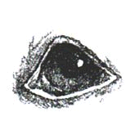 | 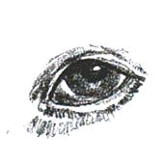 | 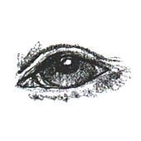 | 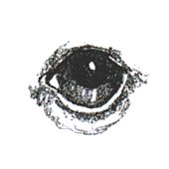

Copy and paste this next to the eye shapes that are considered faulty or undesirable?

protruding eyes
deep-set eyes
hawk eyes
beady eyes
obliquely-set eyes
bird of prey eyes

What is the difference between Ectropion and Entropion? Type in your explanation.

Name the type of ear and mention a breed with that ear shape

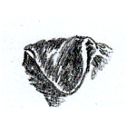 | 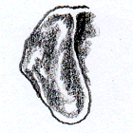 | 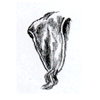 | 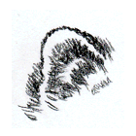
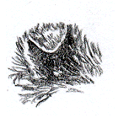 | 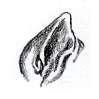 | 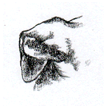 | 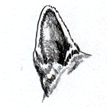

Heads – the defining feature of breed type
Name the type of head and mention a breed with that head shape

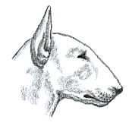 | 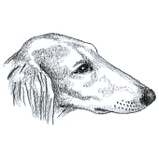 | 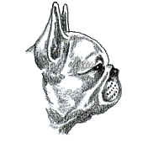 | 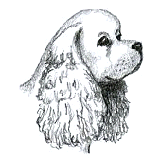

Now find the type of head these breeds possess. Type in your answer.

Dobermann
Pembroke Welsh Corgi
Great Dane
Border Terrier
English Setter
Dachshund
Bedlington Terrier

Copy and paste this next to the head shapes that are considered faulty or undesirable in most breeds?

filled face
blocky head
apple head
coarse head
frog face
dry head

Name and describe these main three types of head planes that the breed standards prescribe.
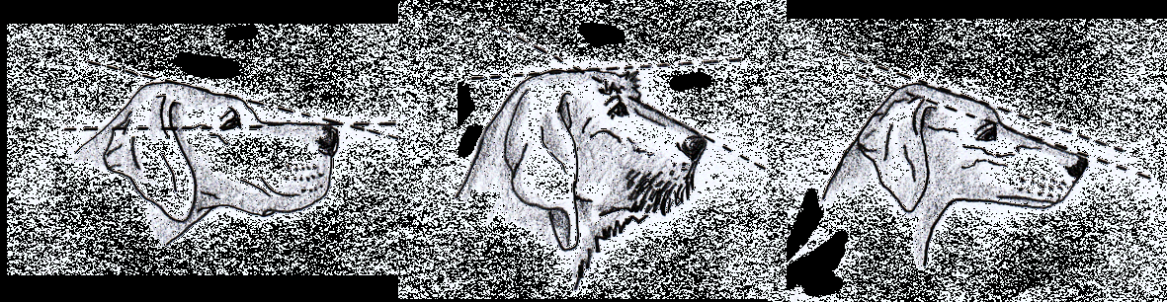
1 2 3
1
2
3

Playing it close to the chest
Type in the anatomical names in the spaces provided.
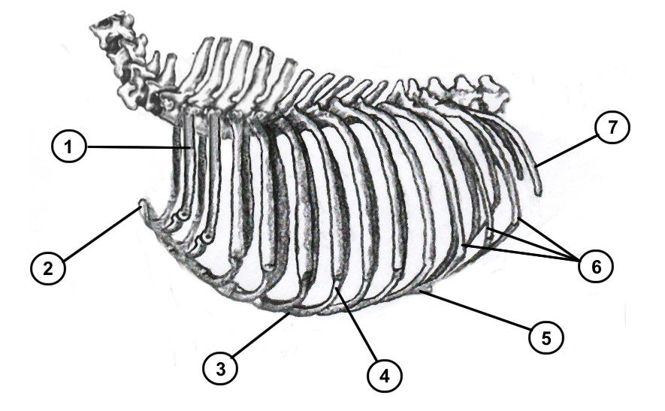
1
2
3
4
5
6
7

Now, find and type in the terms to the definitions.

the longer the ribcage, the greater the capacity
excessive flatness, leaving little heart and lung room
the ribcage falls far short of the elbow at the brisket
how deep is the measurement between withers and brisket?
the ribs develop in adulthood to the level of the elbow
the ribcage is egg-shaped as viewed from the front
the ribs arch roundly from their attachment to the vertebrae
the ribcage is narrower than the oval-shaped chest
the shape of the ribcage after the ribs emerge from their join at the vertebrae

Can you relate the text in your study guide to this illustration? Drag the point of the arrow to the correct position in the diagram.

diaphragm abdomen thorax
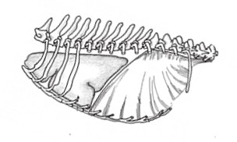

Best foot forward
Type in the names of these foot shapes.
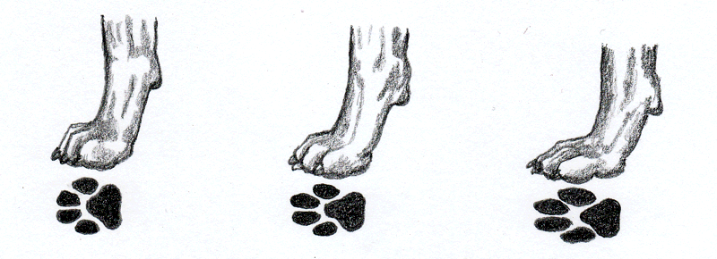

Now, find the type of foot and give an example of a breed with this foot shape.

regardless of the shape of the foot, the toes are widely separated
marked, strongly developed webbing for swimming purposes
long feet, where the two inner toes are considerably longer than the outer toes
the impression left by the foot is not round
round and compact with well-arched toes tightly cupped together
oval-shaped, firm and compact, joined with firm webbing between the toes

Type in your answer.

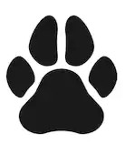 | What are these called?
 | What is this called?

What are you evaluating here? Is this dog putting its best foot forward? Explain in the box and mention the extremes of movement.

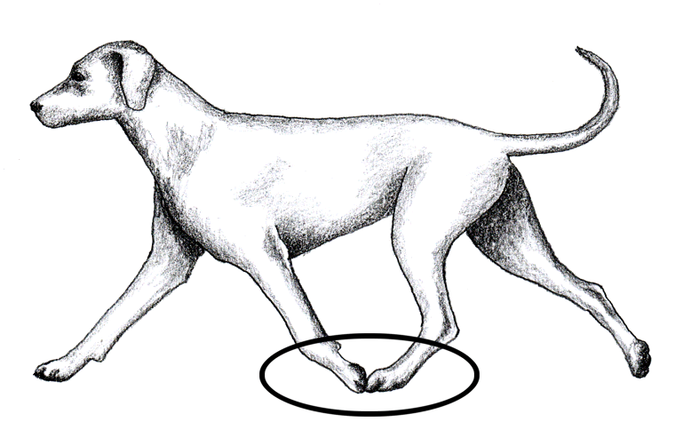

At the tail end
Name the type of tail and mention a breed with that tail shape.

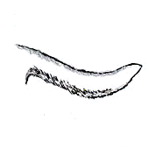 | 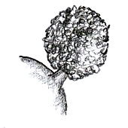 | 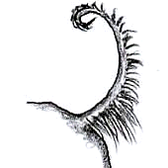 | 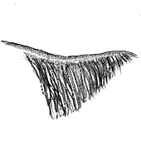

The way the tail is carried in action is called … …
The way the tail is joined to the sacral region is called the … …

Give the types of tail you are likely to find on these breeds:

Old English Sheepdog
Lhasa Apso
Basset Hound
Staffordshire Bull Terrier
Chihuahua
Pomeranian
Briard
Scottish Terrier
Shih Tzu
Chinese Crested

Give the terms that describe these croup settings.

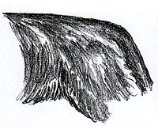 | 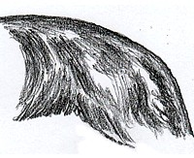 | 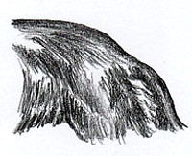 | 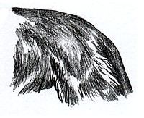

Staying with the rear end, name these hind movement problems and find the normal one.
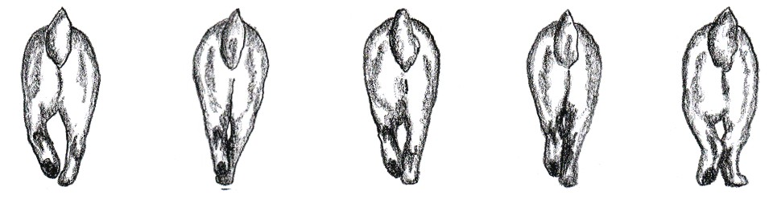
1 2 3 4 5
Here we go again!

Where the label is correct, simply copy and paste this next to the number. If the label is incorrect, type in the correct term next to the number.
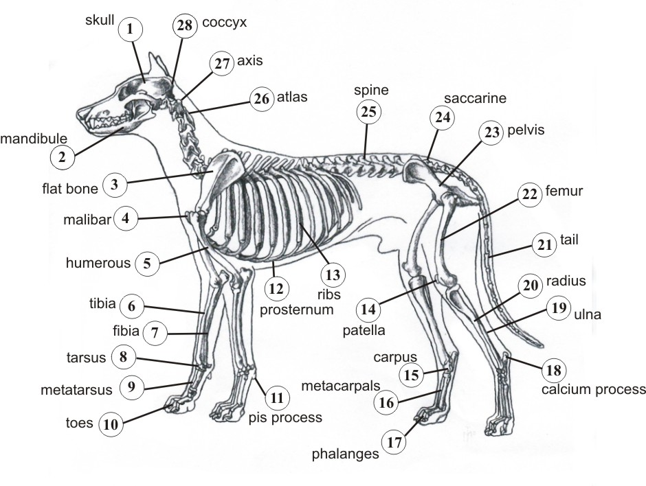

1, |  | 2. |  | 3.
4. |  | 5. |  | 6.
7. |  | 8. |  | 9.
10. |  | 11. |  | 12.
13. |  | 14. |  | 15.
16. |  | 17. |  | 18.
19. |  | 20. |  | 21.
22. |  | 23. |  | 24.
25. |  | 26. |  | 27.
28.

