KUSA
Kennel Union of Southern Africa

CANDIDATE’S OPEN-BOOK WORKSHEET

CANDIDATE: | DATE:
ASSESSOR:
APPROVED / NOT YET APPROVED:

PART 1
KUSA REGULATIONS / JUDGING TECHNIQUE / ON BEING A JUDGE

This workbook contains exercises, the answers to which you will find in your Study Guides and/Schedules on the KUSA website. The purpose of this workbook is to serve as an aid to your studies. It is suggested that you first read through your study material in order to gain a broad understanding of the content. While the content is still fresh in your mind, start working through the worksheets, one section at a time. Try to stay fully involved in your work because that which you do practically is a lot clearer to remember than that which you simply read.

Before you start, save this MS Word document in a suitable folder on your computer by adding your name to the title. [Open-book Workbook – Part 1 – John Smith.docx] (or .doc). Please do not save the document as a pdf or any other type of file format.

Take care to follow all the instructions in each exercise. You will need to either type your answer in the provided space, or cut and paste the given symbol where requested. If you have difficulty working with MS Word, please feel free to contact your assigned Assessor so that solutions (or lessons) can be offered. It is a good idea, if not already so, that you become reasonably proficient in the MS Word programme since it is the one you will be expected to use for most of your documentation going forward.

When done, you need to forward both Parts 1 & 2 to your assigned Assessor for marking. You will be required to earn 100% in order to gain examination entrance. Why such a high pass mark?.... well, because the answers are all in front of you, so it ought to be easy peasy to transfer them….. once you have found them!

When it comes time to start studying for your exam, make notes as you work and find keywords that you need to memorise. Use mnemonics and mind maps to help you study. You must study the whole content in the study guide because the examination covers all the content. See the study guide, “How to Prepare for the Examinations” for some valuable guidelines on what to expect and how to brush up your study skills.

SECTION 1: RULES & REGULATIONS

You will find the content for these exercises in the following schedules on the KUSA website:
https://www.kusa.co.za/index.php/documents/constitution-schedules
or navigate to About KUSA in the main menu, and select Constitution and Schedules.

This is also the content that you need to study for your examination:

- Schedule 03: Regulations for Championship Shows [only Clauses 7- 9, 16 - 26, 30 - 32, 34, 37, 38, 42.1., and Appendix.1 ]
- Schedule 04: Regulations for Non-Championship Shows [only Clauses 11 – 12, 14 – 15 ]
- Schedule 10: Rules & Regulations – KUSA Breed Judges’ Learning Programme [the whole schedule]
- Schedule 10 Appendix 1: Group Course [the whole schedule]

Good luck, and enjoy working through these exercises!

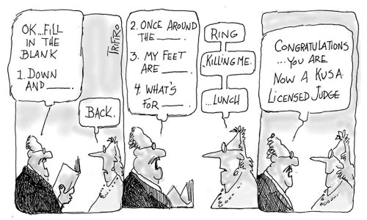

Making your places at championship shows

Type your answers next to the A. in the blocks
Q. How many dogs must be placed in the Group finals?

A.
Q. How can a dog earn a 2-point CC?

A.
Q. Which dogs should be in the ring when you are considering your CC winner?

A.
Q. True or false? Baby Puppies are not eligible for CC, but are eligible for BOB.

A.

Q. In which order must the dogs in a class be judged?

A.

Q. True or false? At championship shows, the winners in both sexes of the Baby Puppy, Minor Puppy and Puppy classes compete for Best Puppy in Breed.

A.

Q. Which dogs could potentially be in the line-up for BOB?

A.

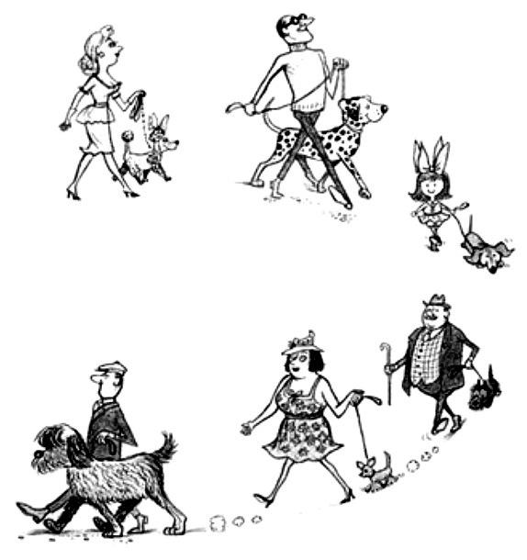

Q. How many Puppies must you place in the Puppy Group?

A.

Q. True or false? If you withhold a CC, you must award an RCC instead.

A.

Q. True or false? If you are short-listing dogs in the group finals, it’s a good idea to pull out 5 dogs to keep the exhibitors guessing.

A.

Q. You withheld the Dog CC, the only bitch is a Baby Puppy, and there are no Champions. Which one will get BOB?

A.

Q. When are your awards considered final?

A.
Q. Are you allowed to withhold a Best Puppy award at a championship show?

A.

What are you signing?

When you add your signature to the Challenge Certificate (CC), what are you actually declaring? Type in the declaration in the space below.

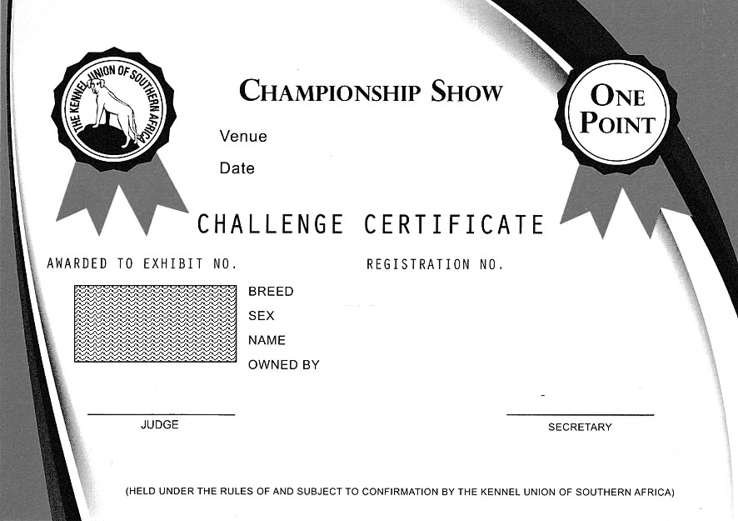

What makes a dog a champion?

Type in the missing numerals and phrases.

A dog may be declared a champion if it has earned a sufficient number of Challenge Certificates, the points of which amount to … … or more in aggregate provided that:
1 not more than … … of the minimum … … points were gained in one centre,
2 at least … … point was gained after the dog was … … months of age,
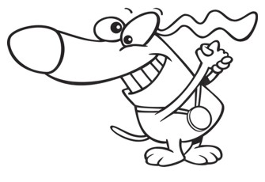
3 the balance of the points was awarded after the dog was … … months of age,
4 the above condition shall apply to all breeds with the exception
of those breeds … ….

A day in the Terrier ring

Type the answers to these scenario questions or select the most appropriate option by copying and
pasting this .

The Ring Steward greets the exhibitors and announces, “Please welcome your Judge for the day, Mr Archie Bawlde from the UK.”

- While Mr Bawlde was judging an entry of only one Border Terrier in the breed. The partner of one of the dogs was trying to attract the dog from outside the ring by playing with a squeaky toy. Mr Bawlde warned the person not to do that, but she did it again, so he withheld the award. Did Mr Bawlde do the right thing?

Yes, he had already given a verbal warning not to do that.
No, he should have allowed the person outside the ring to help get the dog alert.

- Exhibitors at ringside were shocked when Mr Bawlde took his breed standards out and began reading them in the ring. Did Mr Bawlde do the right thing?

Yes, any Judge is permitted to consult breed standards to check on details if necessary.
No, Judges are not permitted to take any documents into the ring at all.

- While Mr Bawlde was judging Bull Terriers, one of the exhibits shook up a cloud of white chalk, so he excused the dog from the ring and instructed the handler to brush out all of the chalk before continuing to judge the dog. Did Mr Bawlde do the right thing?

Yes, excessive chalk must be brushed out before judging.
No, he could have continued judging and wiped the white chalk off his hands and clothing without complaint.

- Mr Bawlde placed a dog 2nd in the Junior Class. The dog returned to compete as the only exhibit in the SA Bred Class where it was placed 1st. When the class winners are called for CC, was that dog eligible to stand for this award?

Yes, because it was a different class.
No, because it was a beaten dog.

- After Mr Bawlde had judged the Open Class, he sensed from the body language that the 2nd placed exhibitor was unhappy with the result. Later, he awarded the CC to the Open Class winner but, when 2nd in the Open Class was called to challenge for the RCC, he heard “withdrawn” from the exhibitor’s gazebo. Mr Bawlde carried on judging and later made a report on the exhibitor’s conduct to the Show Manager. Did Mr Bawlde do the right thing?

Yes, it was important to have the incident reported.
No, he should have demanded that the exhibitor returned to the ring, stopping the judging until it happened.

- After Mr Bawlde had awarded a dog, another exhibitor started bad-mouthing him because her dog was not awarded. After the class, she stormed back into the ring and confronted Mr Bawlde on why her dog didn’t win. He then critiqued the dog for all to hear so that she and everyone else could understand why he didn’t place the dog. Did Mr Bawlde do the right thing?

Yes, he did the correct thing because it explained why he made the decision.
No, KUSA Judges are not permitted to critique a dog in public, unless at a Specialty Show.

- Just before judging the Veteran Class, one of the exhibitors rushed over to warn Mr Bawlde and the Ring Steward of a handler clash in that class, so Mr Bawlde judged the Open Class first before going back to judge the Veteran Class. Did Mr Bawlde do the right thing?

Yes, this was the best way to avoid a hold-up and save time.
No, rules do not allow changing the order of judging.

- Half-way through judging, the Ring Steward excused herself and was replaced by a substitute. Shortly thereafter, she appeared in the ring, showing a dog. Mr Bawlde continued judging all the dogs in the class. Did Mr Bawlde do the right thing?

Yes, because he is showing complete impartiality.
No, he should have explained tactfully that she would need to withdraw from competition.

- While he was judging, Mr Bawlde came across a dog who he suspected was suffering Kennel Cough. However, Mr Bawlde carried on judging and turned his face away in case he picked up the germs. Did Mr Bawlde do the right thing?

Yes, because he is not a Vet and could not be sure of the dog’s diagnosis.
No, because he should have had the Show Manager call for the Veterinarian on duty to examine the dog.

- Mr Bawlde encouraged the Ring Steward to hurry the marshalling of dogs because he wanted to finish judging the Terriers in time for the start of the Hound Group Specialty at the same venue in which he wanted to show his dog. Did Mr Bawlde do the right thing?

Yes, because Judges must, in any case, judge swiftly at a rate of 25 dogs an hour.
No, because a Judge may not handle a dog on the same day as he/she is judging.

- While judging the Puppy Group Finals, Mr Bawlde decided to place only two puppies because there were five puppies in the line-up. Did Mr Bawlde do the right thing?

Yes, he was being tactful. With five puppies in the line-up, one exhibitor would have been embarrassed and very disappointed if four puppies had been placed.
No, the rules state that four puppies must be placed unless there are fewer than four in the line-up.

Breed classes

Type in the definitions for each of these breed classes. In the left column, indicate with a * which of these classes is compulsory at a show.

 | Baby Puppy
* | Minor Puppy
* | Puppy
* | Junior
* | Graduate
* | Open
 | Champions
 | SA Bred
 | Veterans
 | Neuter Dog
 | Members
 | Breeders
 | Working Dog
 | Maiden
 | Novice
 | Imported
 | Namibian Bred
 | Visitors
 | Local
 | Progeny
 | Brace
 | Team

SECTION 2 - JUDGING TECHNIQUE

You will find the content for these exercises in Study Guide, Judging Technique on the KUSA website: When you access your Member’s Portal, you will find a tab name “Judge’s Forms and Guides”. Please orientate yourself with this section of your portal since you will need to access forms and study guides throughout your various levels of study. You will find all forms and guides pertaining to Level 1 under the relevant sub-heading.

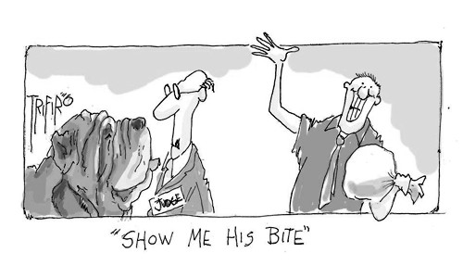

Approaching a dog in the ring

Consult your study guide to type in the missing words and phrases

Your demeanour should … …. Never let a dog sense you are … … and never back off in a state of nervous anxiety.
As you approach the dog, … …, and ask if you may examine the dog.
With your right hand, … …, as you talk to him and give a few encouraging words.
When you have finished looking at the overall presentation, … … from your vantage position toward the dog’s diagonal front.
A wet-fish, slack hand indicates to the dog that you are … …, which may even be true!
Take a few seconds to … … to gain an overall impression of the dog’s structure.
Avoid … … – look at the dog just … … of his eyes and set him at ease first before you examine eye shape and colour.
… … in a reassuring manner until he settles, then proceed to examine the dog in silence.
If you really want to put your hand out to them, … …, then extend your fingers palm upwards.
Chow Chow and Shar Pei have … …, so you need to approach directly from the front.
The purpose of talking to the handler is not to … …, but rather to … ….
Your touch must be … …, and it should exude control and confidence .
Allow sufficient time for the handler to … ….
You may … … if it is okay to touch the dog.
Avoid rushing over to the dog … … in a forceful manner.
Too … … and could send a message that you are nervous.
It is really not necessary to … … for the dog to smell you.
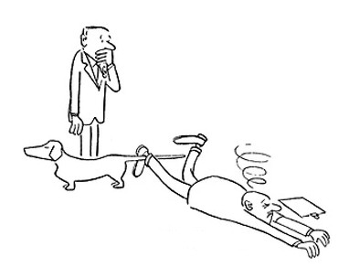
Never … … – not on initial evaluation and not later during your decision-making process!

The five essentials of breed judging

What are the five essentials of breed judging? Type them into the boxes below.

1 2 3 4 5
Type
Balance
Condition
Temperament
Soundness

Now type in the missing words in each of these definitions.

A dog in proportion is a dog with … …
… … is as unique to a breed as its description of type.
Breed … … is what makes a breed what it is.
… … refers to the well-being of the dog.
This is the word used to describe the manner in which dogs … …

Examining the bite

When judging, you should know the standard procedure for evaluating the bite. Match the procedure to the breeds mentioned here. Type the breed name in the accompanying boxes.

Chow Chow …. Pekingese …. Dobermann …. Rottweiler …. Saluki …. Pug

check the colour of the gums and palate
counting all the teeth is a prerequisite
gently pass your thumb between lips to check slight underbite bite
check the colour of the tongue
it is not necessary to examine the dentition at all
open the front lips to check for a scissor bite
open front lips to look for a scissor bite

Examining the dog

While there are several ways to examine a dog, can you describe what the judge is looking at in these illustrations?

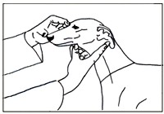 | 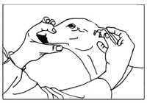 | 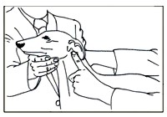
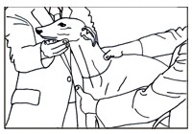 | 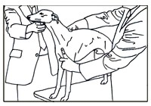 | 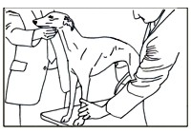
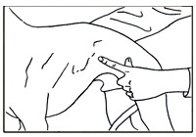 | 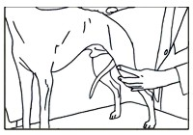 | 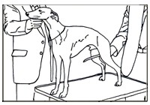

SECTION 3 – ON BEING A JUDGE

You will find the content for these exercises in the Study Guide, On Being a Judge: Ring Management and Etiquette on the KUSA website: When you access your Member’s Portal, you will find a tab name “Judge’s Forms and Guides”. Please orientate yourself with this section of your portal since you will need to access forms and study guides throughout your various levels of study. You will find all forms and guides pertaining to Level 1 under the relevant sub-heading.

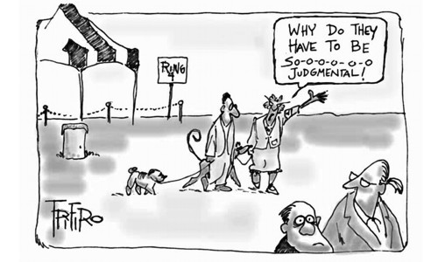

On being a judge

Match the concepts (on the left) to the excerpts from the study guide (on the right) by selecting, picking up the arrow head, and dragging it to the correct box.

Making quick decision
Self-evaluation
Judging the dog on the day
Preparation is key
Using personal preference
Integrity and impartiality
Beware of hobby horses
you will only be granted one opportunity to prove this valuable quality
the starting point of a culture of life-long study and research

it contributes towards building consistency of action
Beware of speed wobbles
pack away your personal hang-ups
they don’t get any better the longer you look at them

Ignore all knowledge of a dog’s previous achievements or advertising campaigns
your personal opinion must be based on your interpretation of the breed standard – not a fantasy
experience is built in layers over time
know and find those characteristics that make the breed what it is

Know your breed standards

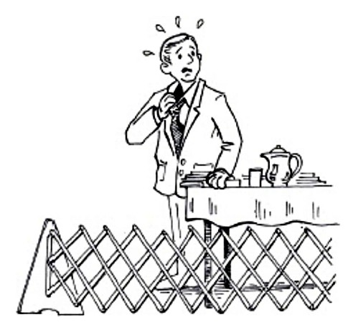

Beware of feeding the gossip mongers!

Which of these judges that are being gossiped about made the wrong or right moves?
Copy and paste or in the boxes

“OMG!!! She drove to the showgrounds with two of the exhibitors and then awarded them the Group!”

“OMG!!! Did you see her gorgeous outfit! That stunning flared skirt catching the wind, with the chiffon blouse showing just a hint of her bronzed body underneath? And that stunning jewellery!”

“OMG!!! He was hanging out in her gazebo for ages before going into the ring. And was eating her cookies!”

“OMG!!! She drives me mad when she untags herself from my Facebook posts about my dog just before the show!”

“OMG!!! Just as well the judge’s flight landed late on the morning of the show and the starting time was delayed, because I was also late and I would have missed my class if we didn’t eventually start an hour later!”

“OMG!!! She could have worn a hat and sunglasses, but kept applying sun block during the day instead!”

“OMG!!! I asked him what’s wrong with my dog and why he didn’t award it. He turned his back on me and said, “Madam, you need to accept my choices because I am the judge and my decision is final.”

“OMG!!! He nearly killed me! We ran around that ring 8 times and then he said we were all so good, he couldn’t make up his mind!”

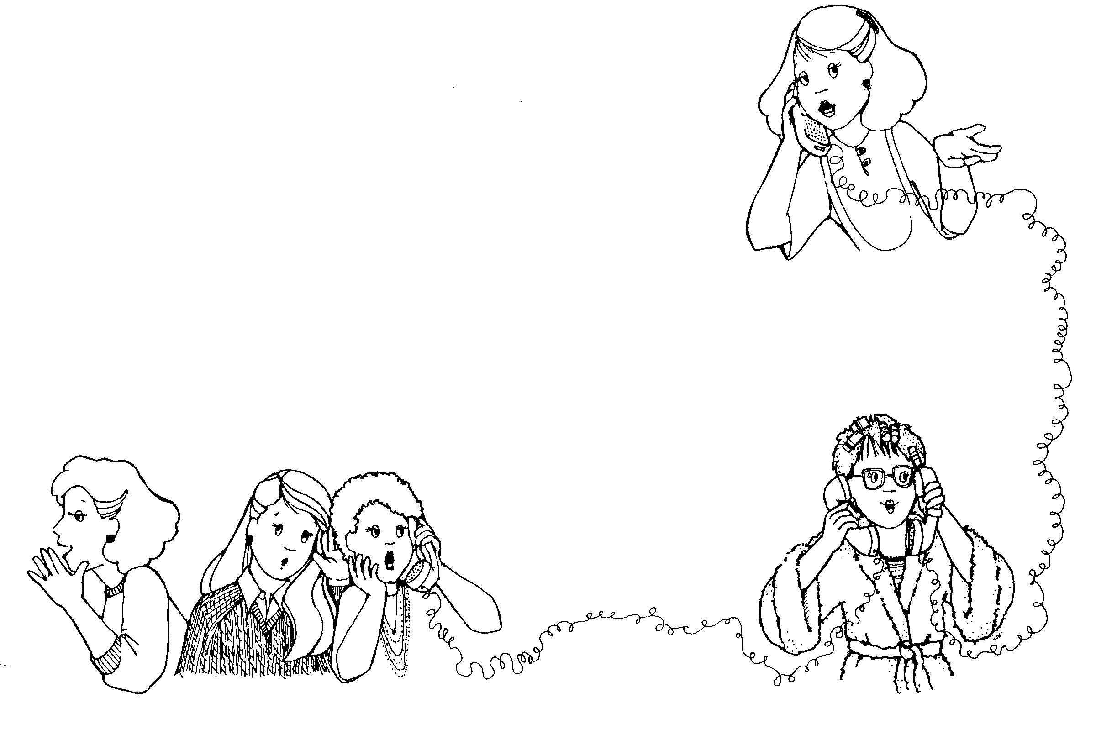

“OMG!!! Thank heavens I whispered in his ear that my dog is tired because it has just arrived from the States – at least he gave it BOB!”

“OMG!!! We have known each for years and years, but she addressed me as “ma’am” in the ring! WTF?

Essential qualities of a judge

Type in the desired essential quality in the space alongside its definition.

You will lose the respect of exhibitors if you treat them gruffly or grumpily.

It is impossible to please everyone so you can’t take criticism to heart.

The reward is the personal satisfaction that you have done a good job.

Unhappiness and irritation are never good companions while you are judging

You are able to deal with whatever situations are thrown at you.

Knowledge and understanding is the only equipment you need in order to judge.

Ethical issues

Type in True or False alongside these statements.

While you cannot enter your dog under a close family member, it is acceptable to enter your dog in another group at the same show where the family member is judging.

KUSA considers that there is no harm in judges continuing the activities of breeding and exhibiting as well as judging, and there is no rule against showing your dog under friends, and vice versa.

Immediately before an appointment, it is acceptable to entertain exhibitor friends that will enter under you, but make sure you don’t post photos on Facebook of your entertainment.

Observation is a good learning tool, so it is a good idea if you observe the judging of a group you are appointed to judge the next day.

Do’s and don’ts of judging
If you were offering advice to a novice judge, which action deserves a “Do” , and which is a “Don’t” ?

Treat all judging contracts as business contracts.
You are in charge, so make sure you win an argument with an exhibitor.
Respond to a judging invitation and return the signed contract within 14 days.
Use point scores, advertising campaigns, and a dog’s last wins to help your judging decisions.
Keep careful records of all your judging appointments.
Protect your reputation as a top-quality judge by withdrawing from a previously-contracted appointment in favour of a more attractive appointment elsewhere.
Confirm that all your judging duties and concessions are included in your contract.
Spend a little extra time (within reason) being patient and understanding with nervous or young dogs, giving them an extra chance if necessary.
Pay attention to crowd applause and cheering, which will help you to identify the winning dog.
It’s acceptable to join an exhibitor in his gazebo, as long as it is after your judging.
Show that you’re enjoying your task. Smile.
Don’t be wussy about a dog that is growling or threatening to bite you. You are in charge and you should challenge the dog and demonstrate your superiority.
Praise an exhibit and show great interest, tell them how wonderful their dog is, so they will remember and appreciate your comment even though you don’t award them.
Judge all dogs in a consistent manner.
Explain to exhibitors why you made your decisions, even if they don’t ask for your justification.
Keep abreast with the KUSA Constitution and Schedules, Judging Rules and Regulations, and breed standards.
You can prove your independence and superior knowledge by denying a top-winning dog a win.
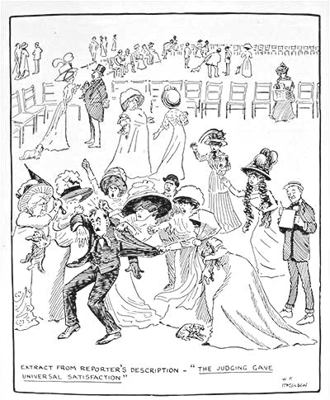
You can boost entries for a club by enticing exhibitors to enter under you by telling them how marvellous their dogs are.

Keeping time and timetables

Copy and paste the in the most appropriate option. NB. The judging time restrictions refer to the 2019 Judges’ Learning Programme.
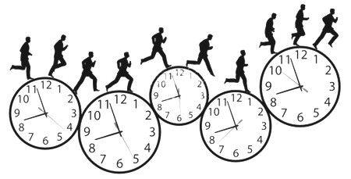
Within how many days must you return your signed judging contract?
How long do you need to wait before you judge a group at an open show and the same group at a championship show in the same province?

1 month
3 months
6 months

10
14
30

Are you permitted to accept a championship judging appointment in Durban during the first weekend of May if you are contracted to judge at a non-championship show in Gauteng in the last weekend of April?

If the non-championship show where you are judging starts at 10.00am, what time should you get there?
at least 9.30am
at least 7.00am
at least 9.55am

in different provinces?
in the same province?
What is the judging time restriction between two non-championship shows…

yes
no

none
1 month
3 months

none
1 month
3 months

first semester
second semester

On what date do you need to register for the examination in….

Managing your ring

Your ring has been set up for your judging, but some of the equipment has been placed in unfavourable positions. You can’t move the gazebo and ring perimeter, but you can reposition the equipment to suit your ring management and judging procedure. Select, drag, rotate (if desired) and drop the elements to the positions you would prefer. Your plan should reflect the way you would like to arrange your ring logically and conduct your judging. Also drag and drop the waiting dogs icons to show where you will position the dogs that are waiting to be examined (assuming you have a large class) Then, briefly explain your judging procedure: how you want the dogs to enter, what pattern(s) you will to request to show gait, and where you will position all class winners for the CC and BOB line-ups.

Key to the elements:
waiting dogs

judge ramp judging table admin table gazebo place markers

path of sun

My judging procedure:

