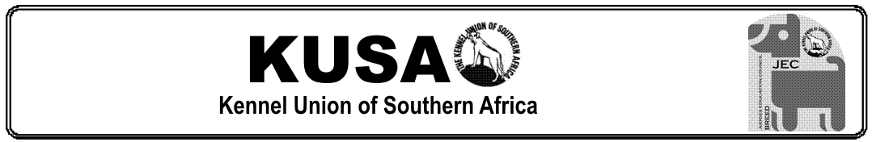

CANDIDATE’S OPEN-BOOK WORKSHEET
JUNIOR SHOWMANSHIP COURSE

CANDIDATE: | DATE:
ASSESSOR:
APPROVED / NOT YET APPROVED:

This workbook contains exercises, the answers to which you will find in your Study Guides and Schedules on the KUSA website. The purpose of this workbook is to serve as an aid to your studies. It is suggested that you first read through your study material in order to gain a broad understanding of the content. While the content is still fresh in your mind, start working through the worksheets, one section at a time. Try to stay fully involved in your work because that which you do practically is a lot clearer to remember than that which you simply read.

Before you start, save this MS Word document in a suitable folder on your computer by adding your name to the title. [Open-book Workbook – John Smith.docx] (or .doc). Please do not save the document as a pdf or any other type of file format.

Take care to follow all the instructions in each exercise. You will need to either type your answer in the provided space, or cut and paste the given symbol where requested. If you have difficulty working with MS Word, please feel free to contact your assigned Assessor so that solutions (or lessons) can be offered. It is a good idea, if not already so, that you become reasonably proficient in the MS Word programme since it is the one you will be expected to use for most of your documentation going forward.

When done, you need to forward your completed worksheet to your assigned Assessor for marking. You will be required to earn 100% in order to gain examination entrance. Why such a high pass mark?.... well, because the answers are all in front of you, so it ought to be easy-peasy to transfer them….. once you have found them!

When it comes time to start studying for your exam, make notes as you work and find keywords that you need to memorise. Use mnemonics* and mind maps to help you study. You must study the whole content in the study guide because the examination covers all the content. See the study guide, “How to Prepare for the Examinations” for some valuable guidelines on what to expect and how to brush up your study skills.
* A memory tool that helps you remember content, eg, acronyms, images, codes, key phrases, etc.

SECTION 1: RULES & REGULATIONS

You will find the content for these exercises in the following schedules on the KUSA website:
https://www.kusa.co.za/index.php/documents/constitution-schedules
or navigate to About KUSA in the main menu, and select Constitution and Schedules.

This is also the content that you need to study for your examination:

- Schedule 03: Regulations for Championship Shows [only Clauses 7, 14, 15, 16, 18, 19, 20, 26, 31, 34, 35, 37, 38, 40, and Appendix.1 ]
- Schedule 04: Regulations for Non-Championship Shows [only Clauses 11 – 12, 14 – 15 ]
- Schedule 10: Regulations – KUSA Breed Judges’ Learning Programme [the whole schedule]
- Schedule 10 Appendix 2: Junior Showmanship Course [the whole schedule]

Good luck, and enjoy working through these exercises!

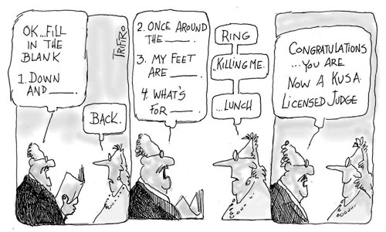

Abiding by the rules

Type your answers next to the A. in the blocks
Q. What should you do if you suddenly fall ill shortly before your judging appointment?

A.
Q. If a Child Handler is not present and ready at ringside after having being called three times, what must the Ring Steward do?

A.
Q. A Junior Handler showing a German Shepherd Dog is handling the dog on an extendor lead to allow the dog to move out with full reach and drive. Is this permitted?

A.

Q. Should you encourage a Junior Handler to take the lead off certain breeds in the Gundog Group in order to present them more effectively?

A.

Q. Are the names of the Child and Junior Handlers entered on the judge’s sheets?

A.

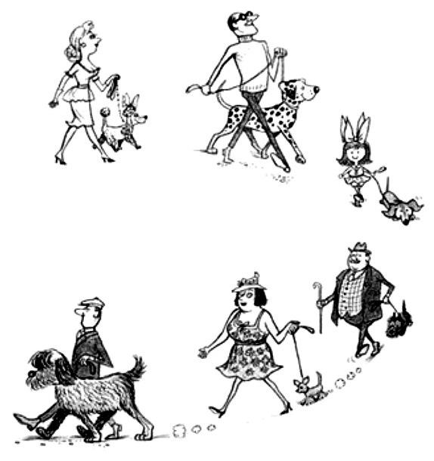

Q. If a dog handled by a Junior Handler bites you during examination, what should you do?

A.

Q. Is a Handler permitted to handle a dog that you own in a Junior Showmanship class that you are not judging on the same day?

A.

Q. Is a dog handled by a Handler in the Junior Showmanship classes also required to be entered in a breed class?

A.
Q. What is the minimum permissible age of a dog handled by a Child Handler in the Junior Showmanship classes?

A.
Q. Are you permitted to allow swopping of dogs in the Child Handler classes?

A.

A day in the Junior Showmanship ring
Select the most appropriate option by copying and pasting this .

The Ring Steward greets the exhibitors and announces, “Please welcome your Judge for the day, Mr Archie Bawlde from the UK.”

- While Mr Bawlde was judging a promising entry of Child Handlers, the father of one of the children was trying to attract the dog from outside the ring by playing with a squeaky toy and frequently offered advice on how to keep the dog well presented. Mr Bawlde warned the parent not to do that, but he did it again, so he excused the Child Handler. Did Mr Bawlde do the right thing?

Yes, he had already given a verbal warning to stop doing that.
No, he should have allowed the person outside the ring to help the Child Handler.

- One of the Junior Handlers in Mr Bawlde’s class was handling a West Highland White Terrier. As she moved the dog, it began to shake up a cloud of white chalk, so he excused the dog from the ring and instructed the Handler to brush out all of the chalk before continuing to judge. Did Mr Bawlde do the right thing?

Yes, excessive chalk must be brushed out before judging.
No, he could have continued judging and wiped the white chalk off his hands and clothing without complaint.

- After Mr Bawlde had awarded a Child Handler, his mother, at ringside, started bad-mouthing him because her child had not been awarded. After the class, she stormed into the ring and confronted Mr Bawlde on why her child didn’t win. He then critiqued the child’s handling for all to hear so that she and everyone else could understand why he didn’t place the child. Did Mr Bawlde do the right thing?

Yes, he did the correct thing because it explained why he made the decision.
No, KUSA Judges are not permitted to make verbal critiques in public, unless at a Specialty Show.

- While he was judging a Junior Showmanship Class, Mr Bawlde came across a dog who he suspected was suffering Kennel Cough. However, Mr Bawlde carried on judging and turned his face away in case he picked up the germs. Did Mr Bawlde do the right thing?

Yes, because he is not a Vet and could not be sure of the dog’s diagnosis.
No, because he should have had the Show Manager call for the Veterinarian on duty to examine the dog.

- Mr Bawlde encouraged the Ring Steward to hurry the marshalling of dogs and Handlers because he wanted to finish judging Junior Showmanship in time for the start of the Hound Group Specialty at the same venue in which he wanted to show his dog. Did Mr Bawlde do the right thing?

Yes, because Judges must, in any case, judge swiftly.
No, because a Judge may not handle a dog on the same day at the same venue where he/she is judging.

Handler classes

Fill in the age classifications in the appropriate boxes.


OPEN HANDLERS

Age:
JUNIOR HANDLERS

Age:
CHILD HANDLERS

Age:
Do the judging principles of Junior Showmanship hold for all levels of handler classes?
(Bold your answer in black)

YES | NO | OCCASIONALLY

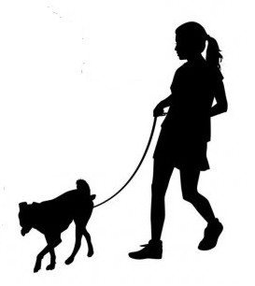
Q. If a child turns 11 in March of a particular year, what are his options regarding which age class to enter and what is the restriction thereafter?

A.

Keeping time and timetables

Copy and paste the in the most appropriate option. NB. The judging time restrictions refer to the 2019 Judges’ Learning Programme.
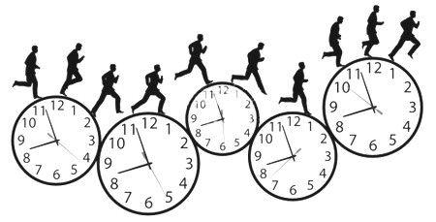
Within how many days must you return your signed judging contract?
How long do you need to wait before you judge Junior Showmanship at a non-championship show and the same at a championship show in the same province?

1 month
3 months
6 months

10
14
30

Are you permitted to accept a championship judging appointment in Durban during the first weekend of May if you are contracted to judge at a non-championship show in Gauteng in the last weekend of April?

If the non-championship show where you are judging starts at 10.00am, what time should you get there?
at least 9.30am
at least 7.00am
at least 9.55am

in different provinces?
in the same province?
What is the judging time restriction between two non-championship shows…

yes
no

none
1 month
3 months

none
1 month
3 months

second semester

On what date do you need to register for the examination in….

first semester

SECTION 2 - JUDGING TECHNIQUE

You will find the content for these exercises in Study Guide, Judging Junior Showmanship on the KUSA website: When you access your Member’s Portal, you will find a tab name “Judge’s Forms and Guides”. Please orientate yourself with this section of your portal since you will need to access forms and study guides throughout your various levels of study. You will find all forms and guides pertaining to Level 1 under the relevant sub-heading.

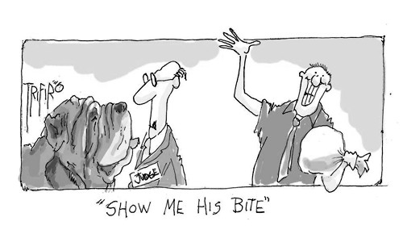

What makes a good Junior Showmanship Judge?

Consult your study guide to type in the missing words and phrases, then identify to which of the four essential qualities of a good Junior Showmanship Judge the quote refers.

Give clear .. .. and avoid confusion. Make yourself understood by word and gesture and avoid .. ..
The Handler must have complete .. ..
There can be no thoughts of .. .., friendships, external .. .., nor any assumptions or prior knowledge
Know what you want to .. .. so that you know what routine to follow
Treat all entrants the same, allotting .. .. to each exhibitor.
Judges should teach by example, displaying .. ..
Bitches in season .. .. enter showmanship classes.
If the Handler performs an action incorrectly because you gave unclear instructions, it will be .. .. fault
The judge should organise the class so that .. ..
Judges are not permitted to .. .., but it is acceptable to
.. ..
Always encourage sufficient space between handlers to avoid .. ..
When swopping dogs during the Junior and Open Handlers’ Classes, always
.. .. of the process.
The .. .. is the sole person in charge of the ring.
It is important to bear in mind the enormity of the responsibility and act in a
.. ..

What is evaluated?

What are the four skills the Judge needs to evaluate? Type them into the boxes below.

1 2 3 4

Now type in the missing words in each of these key elements and indicate to which each category the statements refer (enter the appropriate number 1, 2, 3, or 4)

Table and ramp dogs should be positioned .. .. without .. ..
The Handler should have full lead control of the dog at all times, yet he/she should try to keep it .. ..
The Handler should be dressed neatly and appropriately for the .. .. and the .. ...
Handlers presenting .. .. breeds should be expected to have a .. .. for evaluation.
The Handler must show an awareness of .. .. and must .. ..
Be fair in your evaluation and never turn your judging into a performance of .. .. with the aim of .. .. them.
You should not allow .. .. to take place while the Handlers are exhibiting in the ring.
Handlers should be alert to .. .., realising that the .. .. of their dogs is important.
The Handler is expected to behave .. .. in the ring – .. .. must not receive favourable acknowledgement.
Supporting the dog’s .. .. is an important part of presentation and must be performed
.. .. as if in the breed ring.
The Handler’s movement should be .. .., paced at .. ..
While stacking the dog, evaluate how .. .. the Handler .. .. the dog for the first impression.
Look for the Handler that has a .. .. of dogs.

Examining the bite

Although you will expect the Handlers to show the bite, you should know the standard procedure for evaluating the bite. Match the procedure to the breeds mentioned here. Type the breed name in the accompanying boxes.

Chow Chow …. Pekingese …. Dobermann …. Rottweiler …. Saluki …. Pug

check the colour of the gums and palate
counting all the teeth is a prerequisite
gently pass your thumb between lips to check slight underbite bite
check the colour of the tongue
it is not necessary to examine the dentition at all
open the front lips to check for a scissor bite
open front lips to look for a scissor bite

While evaluating how the Handler shows the bite, what should you observe?
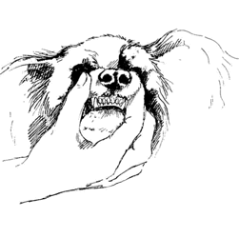
The Handler should..

Getting to grips with the jargon

Match the terms (on the left) to the explanations (on the right) by selecting, picking up the arrow head, and dragging it to the correct box.

Ring procedure
Stringing up
Lead dangling
Using food
Left about turn
Set up / stack
Free-stacking
baiting or rewarding the dog with food or treats whilst in the ring
a lead which whilst not tight, still allows control of the dog
getting too close to other dogs and handlers
Loose lead
keeping the lead so tight that it causes pain and discomfort for the dog
placing the dog in the required body position for that breed
the end of the lead hanging loosely from the hand
allowing the dog to stand naturally, without touching the dog
a variety of skills in the ring related to the efficient presentation of the dog
the dog and handler turn anticlockwise and return on the same line
Crowding

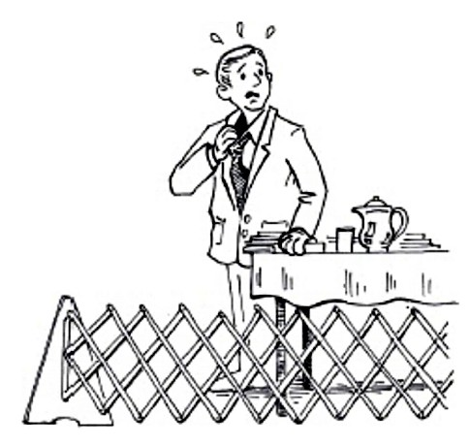

Beware of feeding the gossip mongers!

Which of these judges that are being gossiped about made the wrong or right moves?
Copy and paste or in the boxes

“OMG!!! She awarded the handler who hardly baited or attracted her dog and looked like an understatement
in the ring!

“OMG!!! Did you see her gorgeous outfit! That stunning flared skirt catching the wind, with the chiffon blouse showing just a hint of her bronzed body underneath? And that stunning jewellery!”

“OMG!!! Did you see how he awarded the girl who kept looking up during his gaiting to check where he was?

“OMG!!! She drives me mad when she untags herself from my Facebook posts about my kid’s outstanding handling
skills!”

“OMG!!! She expected my child to know how to stack my neighbour’s dog according to specific breed traditions! For heaven’s sake! What’s the difference? How can he be expected to know about breeds we don’t own?”

“OMG!!! She dumped my kid because he couldn’t control Fluffy today. Oh please! Fluffy was just being playful!”

“OMG!!! She told my daughter she should not chat to the other handlers in the class and that she should concentrate more on her dog! What a cheek!”

“OMG!!! My boy kept Fido stacked beautifully all the time, yet he awarded the kid who allowed his dog to relax and play!”

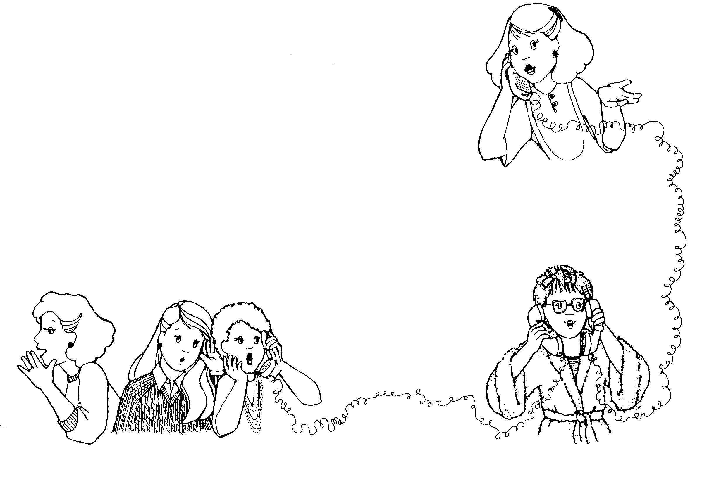

“OMG!!! Did you see that the judge weaved between the handlers to check if they get out of the way?”

“OMG!!! He has known my boy for years and years, but he didn’t award him! WTF?

What’s happening here?

Explain what’s happening in the illustrations
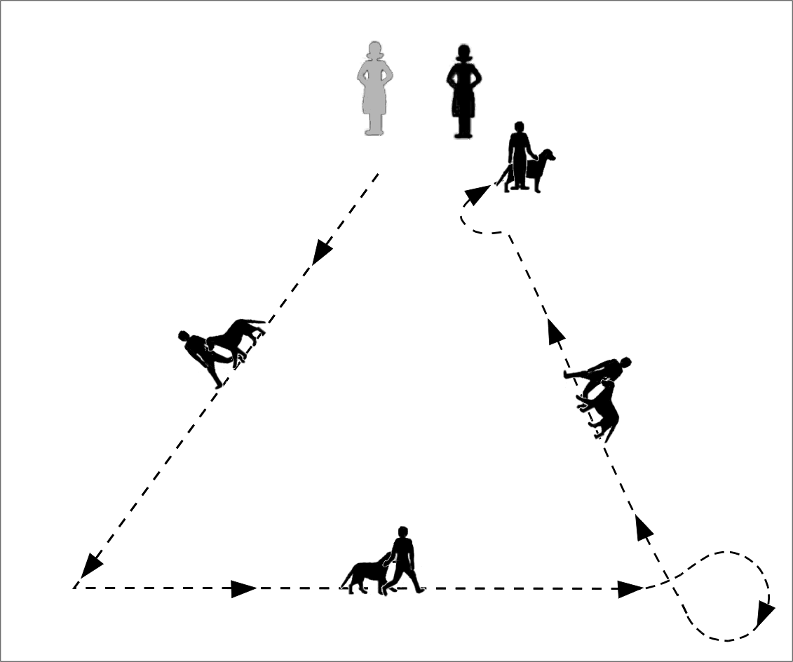 | 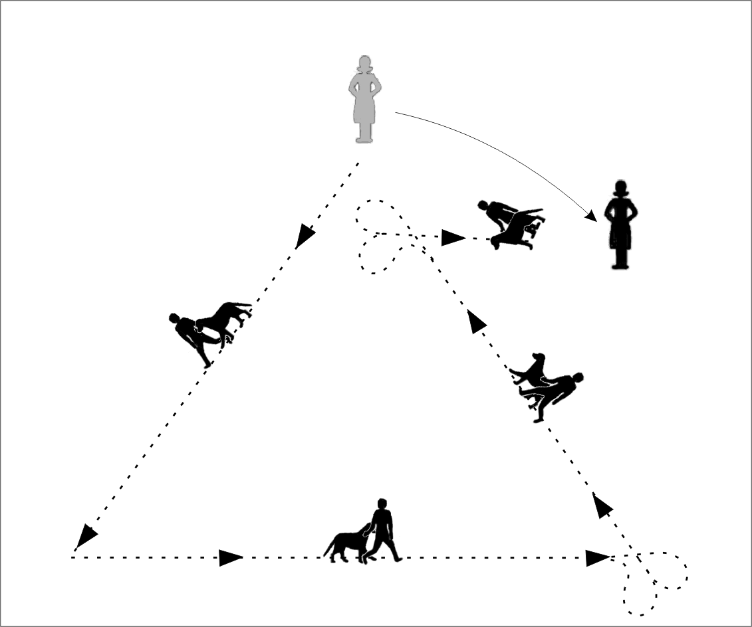

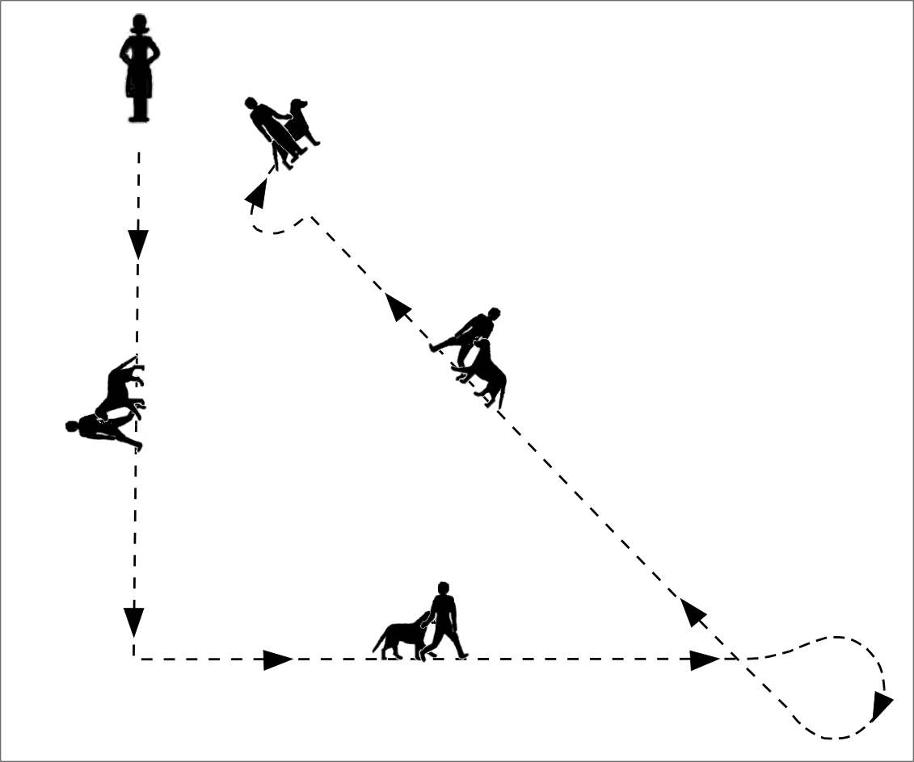 | 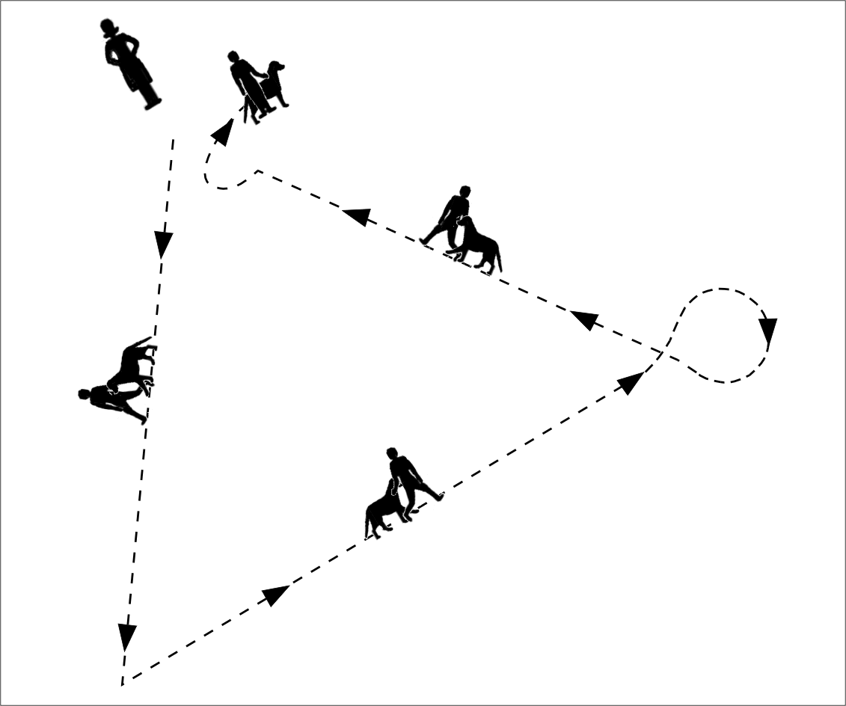

Feedback with kindness

Let’s say you are speaking to a Handler after the placing her third in the class. She is visibly disappointed, because that is the nature of young children, who have very fragile egos.
Write down your imagined comment to this 9 year-old girl.

“

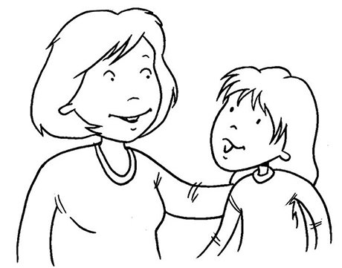

Close observation

How can you evaluate a Handler’s affinity with the dog he/she is handling?
Describe the ways you will see his/her genuine love of dogs.

You can see it:

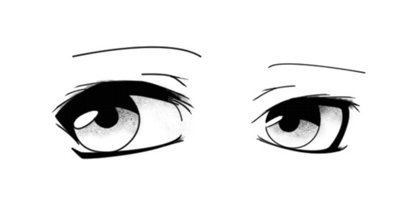

Breed presentation

It’s your task to know the traditions of presenting specific breeds and you need to evaluate if the Handler knows these conventions. Fill in the incompete sentences in the boxes below.

Puli  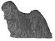 | The tail and feathering .. ..  The tail .. ..
Pug  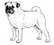 | The tail .. ..  The bite .. ..
Miniature Poodle  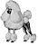 | The head .. ..  The tail .. ..
Australian Shepherd  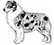 | The ears .. ..  The tail .. ..
Afghan Hound  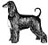 | The head .. ..  The tail .. ..

Ramp or table?

If a ramp is available, exhibitors prefer to present certain breeds on the ramp rather than on the floor.
Enter “ramp” or“table” in the appropriate boxes.

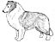  Shetland Sheepdog | 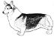  Welsh Corgi | 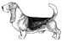  Basset Hound | 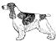  Cocker Spaniel | 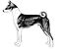  Basenji
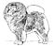  Chow Chow | 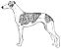  Whippet | 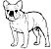  French Bulldog | 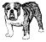  Bulldog | 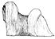  Lhasa Apso

